Screenshot #1: shows the custom columns created

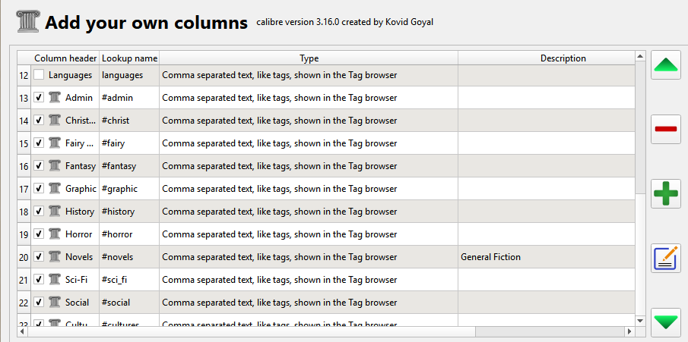

Screenshot #2: shows the tag set as hierarchal

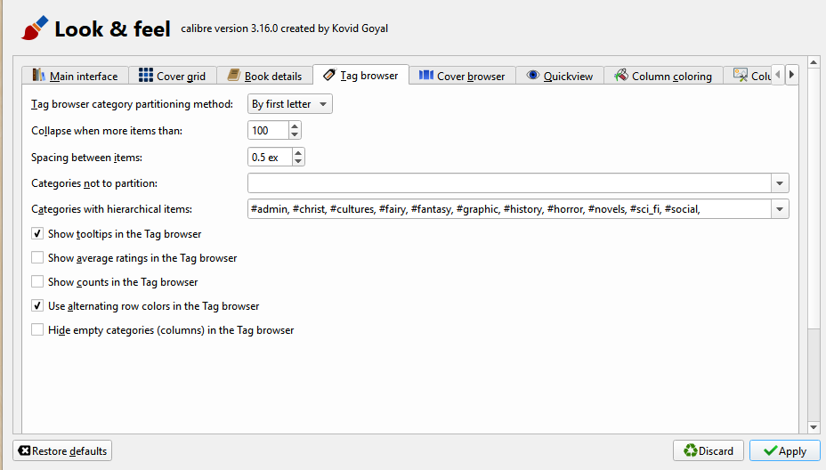

Screenshot #3: shows the list of columns in the main window

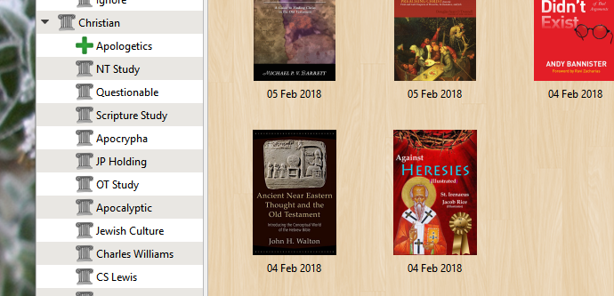

Screenshot #4: shows when I change the category to include a subcategory

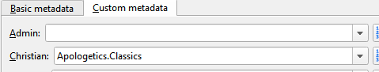

Screenshot #5: shows the results in the main window

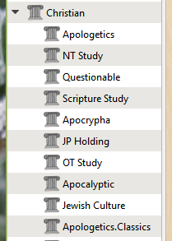

Shows up here as a new category rather than a subcategory of Apologetics