# Painting magnetism on a canvas of graphene

## Hydrogen adatoms can give long-range magnetic order to graphene

*By* **S. M. Hollen** *and* **J. A. Gupta**

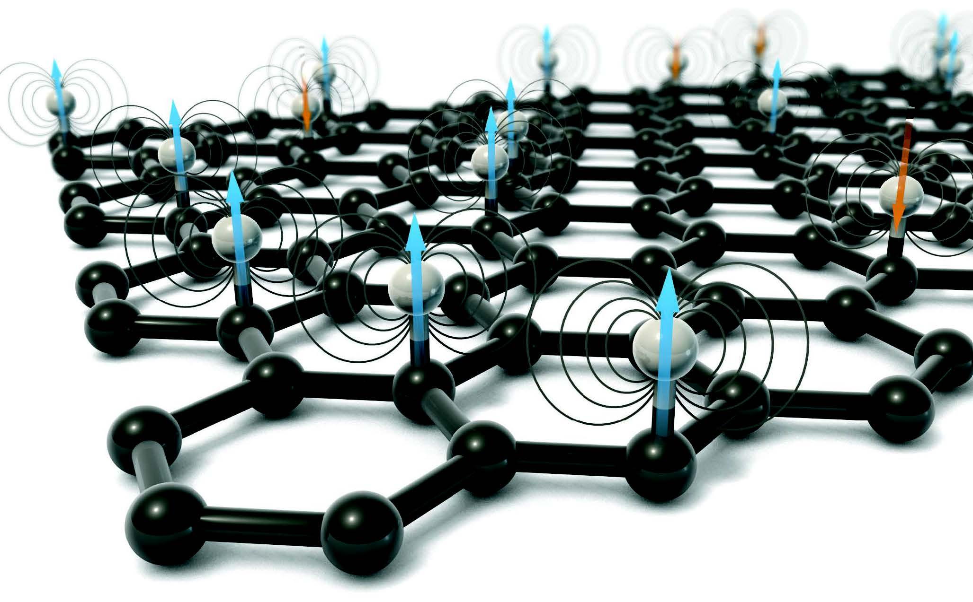An inherent aspect of any two-dimensional (2D) sheet is that all atoms in the material lie on the surface. This leads to a concept of 2D crystals as a “canvas,” where different chemical groups or “ink” on the surface can lead to a palette of distinct materials properties. The most well-studied 2D crystal is graphene, a one-atom-thick sheet of carbon atoms arranged in a honeycomb lattice. Although graphene’s superlative materials properties and novel physical phenomena have led to a variety of applications ([1]), better tunability of these properties is still required. Toward this end, hydrogenated graphene (graphane) was predicted to have a wide band gap and exhibit magnetic order ([2], [3],[4]), in contrast to graphene, which is (semi)metallic and diamagnetic. The chemical stability of graphene makes hydrogenation difcult to control, and this has hampered efforts to tune its electronic or magnetic properties. On page 437 of this issue, González-Herrero *et al.* ([5]) report direct evidence that hydrogen atoms on graphene do indeed yield a magnetic moment and that these moments can order ferromagnetically over relatively large distances. If these methods can be extended to industrial scales, then one can imagine storing information at unprecedented densities by painting magnetic bits on graphene canvases (see the ﬁgure).

**Making graphene magnetic.** Magnetic moments are formed when hydrogen atoms bond to carbon atoms in the honeycomb graphene lattice. The honeycomb lattice comprises two "sublattices," and the moments align ferromagnetically (blue) when on the same sublattice and antiferromagnetically (orange) when on the opposing sublattice.

Magnetism in graphene arises when there is an imbalance in the two hexagonal sublattices that combine to form the overall honeycomb lattice. Although the sublattices are indistinguishable in the ideal, isolated single sheet, the number of atoms in each sublattice can be made unequal because of factors such as point defects or geometric shape. A hydrogen adatom, for example, bonds with the carbon’s pz-orbital, thus removing it from the network responsible for graphene’s band structure. A counting rule emerges, predicting an integer number of spin-polarized states equal to this imbalance, which can lead to magnetism. The experimental search for magnetic carbon has a controversial history, starting ﬁrst in organic materials, then later in graphite and graphene. For example, early reports of ferromagnetism in polymerized C60 ([6]) were later attributed to trace amounts of iron in the samples ([7]). Ferromagnetic graphite, upon proton irradiation ([8]), was difcult to attribute to magnetic impurities, but was not well understood, owing to the variety of defects formed upon high-energy ion bombardment. Graphene was ﬁrst isolated around this time as well, and was quickly incorporated into high-quality spin valve devices, analogous to those used in hard disk drives. Such devices provided additional evidence for magnetic carbon, as a signature of spin scattering was observed due to magnetic moments formed when the graphene was exposed to hydrogen or bombarded to create vacancies ([9]). These results were consistent with magnetometry measurements that showed evidence for paramagnetism ([10]). However, neither of these approaches were able to observe ferromagnetism, and the atomic origin of the moments could not be directly determined. González-Herrero *et al.* study one fundamental building block of this magnetic state—namely, individual hydrogen adatoms and dimers with controlled sublattice site and spacing. Graphene growth, hydrogenation, and characterization were all performed in the same ultrahigh-vacuum chamber, which was critical in overcoming shortcomings of prior approaches. Few layer graphene was grown by heating a SiC single crystal, thus minimizing the possibility of magnetic impurities or contamination from the environment. Relatively low-energy atomic hydrogen from thermal cracking of H2 yielded a low surface coverage of a single class of defect, rather than the variety of defects and complexes produced by high-energy ion irradiation. Lastly, in situ scanning tunneling microscopy (STM) was used to characterize the quality of the sample before and after hydrogenation and to directly probe the electronic states associated with individual hydrogen atoms on the surface. This method avoids the ensemble averaging typical of more conventional magnetic characterization techniques.

To prove that the hydrogen adatoms were magnetic, the authors drew insight from the Anderson model of impurity magnetism, a model that predicts sensitivity to doping. This was observed by the collapse of a spin-split doublet of states into a single state, upon n-type or p-type doping of the graphene. More quantitative density functional theory (DFT) calculations validated this interpretation and provided insight into magnetic ordering between adatoms. Experimentally, González-Herrero *et al.* were able to directly probe interactions by using STM atomic manipulation to form hydrogen dimers with varying spacing and sublattice site. As explained by the DFT calculations, and realized experimentally, dimers on the same sublattice create an imbalance and order ferromagnetically, whereas dimers on opposing sublattices maintain the balance and are nonmagnetic. These interactions persist at relatively large separations compared to conventional magnets based on more localized atomic orbitals.

There are several key challenges toward realizing robust magnetic graphene for applications. First, the sensitivity of the magnetic state to doping offers the opportunity for control with a gate electrode, but may be problematic in typical graphene devices, where charged impurities in a SiO2 substrate create random puddles of n- and p-doping. Future work could probe whether wide band-gap graphane is as vulnerable to charge puddles, or reduce their inﬂuence through sandwich structures of other 2D materials, such as boron nitride. Second, although longer-range magnetic ordering is promising, it also places a premium on control over the hydrogen adsorption site. This atomic-scale precision is very difﬁcult to realize on a large scale, though preferential adsorption may be possible by breaking the degeneracy of the sublattices through interactions with other graphene layers or other 2D materials in close registry. Ferromagnetic ordering above room temperature has been predicted for magnetic graphene, but it remains to be seen if this target can be realized experimentally. If these challenges can be met while preserving the intrinsic quality of graphene for electron and spin transport, then graphene may indeed become a leading candidate material in the roadmap for next-generation information technologies based on electron spin.

**REFERENCES**

***Toward single-atom memory***

Single holmium atoms can be used as a stable magnetic memory

*By* **Alexander Ako Khajetoorians** *and* **Andreas J. Heinrich**

Storing information in an ensemble of single-atom magnets represents the ultimate miniaturization of data storage technology, in which two speciﬁc orientations of each atomic magnetic moment represent a bit (a 0 or 1) of information (see the ﬁgure, panel A). The inherent dilemma in using a single-atom magnet is keeping it magnetized—or, in other words, being able to hold the information in one of the bit states without an external magnetic ﬁeld for a useful amount of time and at practical temperatures ([11],[12]). This phenomenon of magnetic remanence is difficult to realize from a single atom, in part because diminished robustness against ﬂuctuations from the environment can unintentionally ﬂip the magnetic state, thus wiping out the magnetic memory. A recent attempt to observe remanence in a single atom ([13]) proved premature, as the results were incompatible with the magnetic ground state of that system ([14]) and could not be reproduced (4, [15]). Hence, the question of whether this deﬁning property of a single-atom magnet can actually be achieved has remained an open question until now. On page 318 of this issue, Donati *et al.* ([16]) demonstrate that single holmium atoms exhibit magnetic remanence up to temperatures of 40 K, much higher than previous records of atomic-scale magnets composed of 3 to 12 atoms (1, 2, 5)—a record in both size and stability for any magnet.

A requirement for remanence in an atom adsorbed on a single surface is a large energy barrier that separates two distinct magnetic ground states. This so-called magnetic anisotropy energy (MAE) (see the ﬁgure, panel B) was shown to be large for single Co atoms, relative to the bulk, adsorbed on a Pt surface ([17]). At a temperature on the order of the MAE, the magnetic moment should “freeze” on one side of the barrier. This discovery paved a decade-long path, based on x-ray absorption spectroscopy (XAS) and spin-resolved scanning tunneling microscopy (STM), toward realizing magnetic remanence at sufficiently low temperatures ([18]). Although the MAE of a single Co atom has been boosted to the theoretical limit ([19]), the observation of remanence in a single-atom magnet has remained elusive because of the pronounced quantum nature of single-atom spins.

Quantum mechanics restricts the magnetic moment to discrete orientations related to the quantum number *Jz*, and the energy of each discrete state (see the ﬁgure, panel B) is dictated by the local environment or crystal ﬁeld. In certain cases where the crystal ﬁeld symmetry is relatively low, shortcuts can be made through the barrier (dashed blue arrow in the ﬁgure). This makes the magnetic moment exquisitely sensitive to interactions with electrons and phonons (lattice vibrations), which can exchange angular momentum and connect a ground state with *Jz* states on the other side of the MAE barrier. For two-fold symmetry (1, 2, [20]), ground-state reversal can occur with just one electron, even in the presence of a large MAE. Therefore, in addition to decoupling the atomic moment from electron and phonon reservoirs, it is necessary to engineer an energy landscape where the magnetic ground states are insensitive to such electron processes (10).

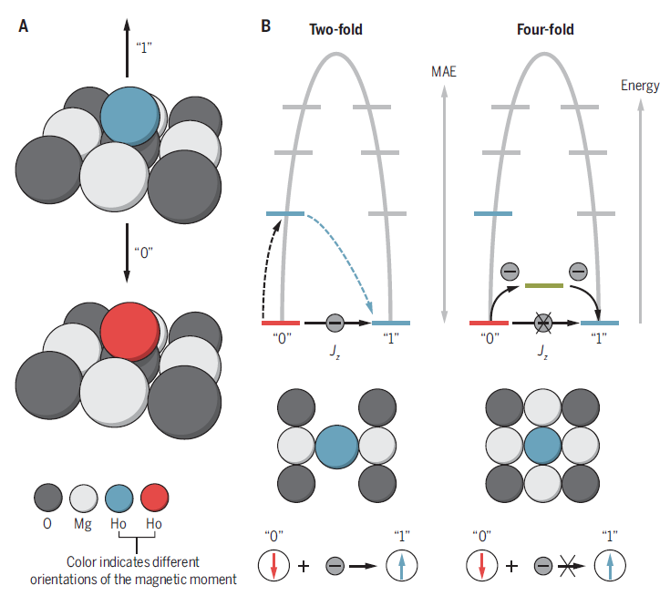**A single-atom memory.** (**A**) The orientation of the magnetic moment is represented at a 0 or 1 state. (**B**) The energy barriers, def ned by the magnetic anisotropy energy (MAE) for a single magnetic atom in a two-fold and fourfold symmetric environment. For a two-fold environment, a single electron can induce a reversal of the magnetic state bypassing the barrier, whereas the four-fold environment protects against such reversal because two or more electrons are needed.

Donati et al. create such an energy landscape in the form of a four-fold symmetric environment for Ho atoms on MgO. By using circularly polarized XAS and magnetic circular dichroism (XMCD), which is sensitive to the magnetic orientation of the spins in a given magnetic ﬁeld, they observe a magnetic hysteresis and remanence of an ensemble of Ho atoms. In combination with calculations, they convincingly demonstrate that the observed remanence results from the protection of the Ho ground states from single-electron processes by the four-fold symmetry (see the ﬁgure, panel B), which only allows for higher-order processes involving two or more electrons—an observation that they corroborate with measurements on varying thicknesses of the MgO insulating layer. The localized nature of its 4ƒ orbitals and a few atomic layers of MgO are sufcient to decouple the Ho moment from the silver metallic electrode, making electron scattering processes as well as phonon excitations highly improbable and thereby establishing a single-atom magnet.

The stability of a single Ho atom on MgO is more robust than one of the best-known molecular magnets ([21]). Theoretically, the symmetry protection shown here is not element-speciﬁc, necessitating further investigations with both XMCD and down to an individual atom with spin-resolved STM. It will be imperative to investigate whether remanence can be seen at higher temperatures for viable application, and whether single atoms can be read and written one at a time with electrical current (1, 2). Toward this end, experiments focusing on the dynamical manipulation of an individual atomic spin will be central to eforts to develop single-atom magnets for quantum memory and processing technology ([22]). The present work strongly suggests that arrays of single-atom magnets may be used for future memory devices. Such work could also be extended to spin-logic operations with single atoms ([23]), provided that a suitable route toward magnetic coupling between such spin centers can be engineered.

**REFERENCES**

1. C. Ferrari *et al., Nanoscale 7*, 4598 (2014).
2. J. Sofo,A. Chaudhari, G. Barber, *Phys. Rev. B 75*, 153401 (2007).
3. O.V.Yazyev, *Rep. Prog. Phys.* 73, 056501 (2010).
4. J. Zhou *et al., Nano Letters* 9, 3867 (2009).
5. H. González-Herrero, *Science* 352, 437 (2016).
6. T. L. Makarova *et al., Nature* 413, 716 (2001).
7. T. L. Makarova *et al., Nature* 440, 707 (2006).
8. P. Esquinazi *et al., Phys. Rev. Lett.* 91, 227201 (2003).
9. K. M. McCreary *et al., Phys. Rev. Lett.* 109, 186604 (2012).
10. R. R. Nair *et al., Nature Phys.* 8, 199 (2012).
11. A. Khajetoorians *et al., Science* 339, 55 (2013).
12. S. Loth, S. Baumann, C. P. Lutz, D. M. Eigler, A. J. Heinrich, *Science* 335, 196 (2012).
13. T. Miyamachi *et al., Nature* 503, 242 (2013).
14. F. Donati *et al., Phys. Rev. Lett.* 113, 237201 (2014).
15. M. Steinbrecher *et al., Nat. Commun.* 10.1038/ncomms10454 (2016).
16. F. Donati *et al., Science* 352, 318 (2016).
17. P. Gambardella *et al., Science* 300, 1130 (2003).
18. F. Meier, L. Zhou, J. Wiebe, R. Wiesendanger, *Science* 320, 82 (2008).
19. G. Rau *et al., Science* 344, 988 (2014).
20. Hübner, B. Baxevanis, A. A. Khajetoorians, D. Pfannkuche, *Phys. Rev.* *B* 90, 155134 (2014).
21. K. R. Meihaus, J. R. Long, *J. Am. Chem. Soc.* 135, 17952 (2013).
22. S. Baumann *et al., Science* 350, 417 (2015).
23. A. Khajetoorians, J. Wiebe, B. Chilian, R. Wiesendanger, *Science* 332, 1062 (2011).