***Detected version:*** EPUB 2.0.1

***Results:***The following problems were found in *Sample_-_Edie_Claire[1].epub*:

| [**Type**](http://validator.idpf.org/application/validate) | [**File**](http://validator.idpf.org/application/validate) | [**Line**](http://validator.idpf.org/application/validate) | [**Position**](http://validator.idpf.org/application/validate) | [**Message**](http://validator.idpf.org/application/validate) |
| --- | --- | --- | --- | --- |
| ERROR | Sample_split_002.html | 10 | 4 | Error while parsing file 'element "a" not allowed here; expected element "address", "blockquote", "del", "div", "dl", "h1", "h2", "h3", "h4", "h5", "h6", "hr", "ins", "noscript", "ns:svg", "ol", "p", "pre", "script", "table" or "ul" (with xmlns:ns="http://www.w3.org/2000/svg")'. |
| ERROR | Sample_split_002.html | 12 | 40 | Error while parsing file 'element "p" not allowed here; expected the element end-tag, text or element "a", "abbr", "acronym", "applet", "b", "bdo", "big", "br", "cite", "code", "del", "dfn", "em", "i", "iframe", "img", "ins", "kbd", "map", "noscript", "ns:svg", "object", "q", "samp", "script", "small", "span", "strong", "sub", "sup", "tt" or "var" (with xmlns:ns="http://www.w3.org/2000/svg")'. |
| ERROR | Sample_split_002.html | 14 | 22 | Error while parsing file 'element "p" not allowed here; expected the element end-tag, text or element "a", "abbr", "acronym", "applet", "b", "bdo", "big", "br", "cite", "code", "del", "dfn", "em", "i", "iframe", "img", "ins", "kbd", "map", "noscript", "ns:svg", "object", "q", "samp", "script", "small", "span", "strong", "sub", "sup", "tt" or "var" (with xmlns:ns="http://www.w3.org/2000/svg")'. |
| ERROR | Sample_split_002.html | 16 | 22 | Error while parsing file 'element "p" not allowed here; expected the element end-tag, text or element "a", "abbr", "acronym", "applet", "b", "bdo", "big", "br", "cite", "code", "del", "dfn", "em", "i", "iframe", "img", "ins", "kbd", "map", "noscript", "ns:svg", "object", "q", "samp", "script", "small", "span", "strong", "sub", "sup", "tt" or "var" (with xmlns:ns="http://www.w3.org/2000/svg")'. |
| ERROR | Sample_split_002.html | 17 | 22 | Error while parsing file 'element "p" not allowed here; expected the element end-tag, text or element "a", "abbr", "acronym", "applet", "b", "bdo", "big", "br", "cite", "code", "del", "dfn", "em", "i", "iframe", "img", "ins", "kbd", "map", "noscript", "ns:svg", "object", "q", "samp", "script", "small", "span", "strong", "sub", "sup", "tt" or "var" (with xmlns:ns="http://www.w3.org/2000/svg")'. |
| ERROR | Sample_split_002.html | 19 | 22 | Error while parsing file 'element "p" not allowed here; expected the element end-tag, text or element "a", "abbr", "acronym", "applet", "b", "bdo", "big", "br", "cite", "code", "del", "dfn", "em", "i", "iframe", "img", "ins", "kbd", "map", "noscript", "ns:svg", "object", "q", "samp", "script", "small", "span", "strong", "sub", "sup", "tt" or "var" (with xmlns:ns="http://www.w3.org/2000/svg")'. |
| ERROR | Sample_split_002.html | 21 | 22 | Error while parsing file 'element "p" not allowed here; expected the element end-tag, text or element "a", "abbr", "acronym", "applet", "b", "bdo", "big", "br", "cite", "code", "del", "dfn", "em", "i", "iframe", "img", "ins", "kbd", "map", "noscript", "ns:svg", "object", "q", "samp", "script", "small", "span", "strong", "sub", "sup", "tt" or "var" (with xmlns:ns="http://www.w3.org/2000/svg")'. |
| ERROR | Sample_split_002.html | 23 | 41 | Error while parsing file 'element "div" not allowed here; expected the element end-tag, text or element "a", "abbr", "acronym", "applet", "b", "bdo", "big", "br", "cite", "code", "del", "dfn", "em", "i", "iframe", "img", "ins", "kbd", "map", "noscript", "ns:svg", "object", "q", "samp", "script", "small", "span", "strong", "sub", "sup", "tt" or "var" (with xmlns:ns="http://www.w3.org/2000/svg")'. |
| ERROR | Sample_split_002.html | 24 | 12 | Error while parsing file 'element "body" incomplete; expected element "address", "blockquote", "del", "div", "dl", "h1", "h2", "h3", "h4", "h5", "h6", "hr", "ins", "noscript", "ns:svg", "ol", "p", "pre", "script", "table" or "ul" (with xmlns:ns="http://www.w3.org/2000/svg")'. |
| ERROR | Sample_split_003.html | 10 | 4 | Error while parsing file 'element "a" not allowed here; expected element "address", "blockquote", "del", "div", "dl", "h1", "h2", "h3", "h4", "h5", "h6", "hr", "ins", "noscript", "ns:svg", "ol", "p", "pre", "script", "table" or "ul" (with xmlns:ns="http://www.w3.org/2000/svg")'. |
| ERROR | Sample_split_003.html | 11 | 39 | Error while parsing file 'element "p" not allowed here; expected the element end-tag, text or element "a", "abbr", "acronym", "applet", "b", "bdo", "big", "br", "cite", "code", "del", "dfn", "em", "i", "iframe", "img", "ins", "kbd", "map", "noscript", "ns:svg", "object", "q", "samp", "script", "small", "span", "strong", "sub", "sup", "tt" or "var" (with xmlns:ns="http://www.w3.org/2000/svg")'. |
| ERROR | Sample_split_003.html | 13 | 22 | Error while parsing file 'element "p" not allowed here; expected the element end-tag, text or element "a", "abbr", "acronym", "applet", "b", "bdo", "big", "br", "cite", "code", "del", "dfn", "em", "i", "iframe", "img", "ins", "kbd", "map", "noscript", "ns:svg", "object", "q", "samp", "script", "small", "span", "strong", "sub", "sup", "tt" or "var" (with xmlns:ns="http://www.w3.org/2000/svg")'. |
| ERROR | Sample_split_003.html | 15 | 41 | Error while parsing file 'element "div" not allowed here; expected the element end-tag, text or element "a", "abbr", "acronym", "applet", "b", "bdo", "big", "br", "cite", "code", "del", "dfn", "em", "i", "iframe", "img", "ins", "kbd", "map", "noscript", "ns:svg", "object", "q", "samp", "script", "small", "span", "strong", "sub", "sup", "tt" or "var" (with xmlns:ns="http://www.w3.org/2000/svg")'. |
| ERROR | Sample_split_003.html | 16 | 12 | Error while parsing file 'element "body" incomplete; expected element "address", "blockquote", "del", "div", "dl", "h1", "h2", "h3", "h4", "h5", "h6", "hr", "ins", "noscript", "ns:svg", "ol", "p", "pre", "script", "table" or "ul" (with xmlns:ns="http://www.w3.org/2000/svg")'. |
| ERROR | Sample_split_004.html | 10 | 4 | Error while parsing file 'element "a" not allowed here; expected element "address", "blockquote", "del", "div", "dl", "h1", "h2", "h3", "h4", "h5", "h6", "hr", "ins", "noscript", "ns:svg", "ol", "p", "pre", "script", "table" or "ul" (with xmlns:ns="http://www.w3.org/2000/svg")'. |
| ERROR | Sample_split_004.html | 11 | 39 | Error while parsing file 'element "p" not allowed here; expected the element end-tag, text or element "a", "abbr", "acronym", "applet", "b", "bdo", "big", "br", "cite", "code", "del", "dfn", "em", "i", "iframe", "img", "ins", "kbd", "map", "noscript", "ns:svg", "object", "q", "samp", "script", "small", "span", "strong", "sub", "sup", "tt" or "var" (with xmlns:ns="http://www.w3.org/2000/svg")'. |
| ERROR | Sample_split_004.html | 13 | 21 | Error while parsing file 'element "p" not allowed here; expected the element end-tag, text or element "a", "abbr", "acronym", "applet", "b", "bdo", "big", "br", "cite", "code", "del", "dfn", "em", "i", "iframe", "img", "ins", "kbd", "map", "noscript", "ns:svg", "object", "q", "samp", "script", "small", "span", "strong", "sub", "sup", "tt" or "var" (with xmlns:ns="http://www.w3.org/2000/svg")'. |
| ERROR | Sample_split_004.html | 14 | 21 | Error while parsing file 'element "p" not allowed here; expected the element end-tag, text or element "a", "abbr", "acronym", "applet", "b", "bdo", "big", "br", "cite", "code", "del", "dfn", "em", "i", "iframe", "img", "ins", "kbd", "map", "noscript", "ns:svg", "object", "q", "samp", "script", "small", "span", "strong", "sub", "sup", "tt" or "var" (with xmlns:ns="http://www.w3.org/2000/svg")'. |
| ERROR | Sample_split_004.html | 15 | 21 | Error while parsing file 'element "p" not allowed here; expected the element end-tag, text or element "a", "abbr", "acronym", "applet", "b", "bdo", "big", "br", "cite", "code", "del", "dfn", "em", "i", "iframe", "img", "ins", "kbd", "map", "noscript", "ns:svg", "object", "q", "samp", "script", "small", "span", "strong", "sub", "sup", "tt" or "var" (with xmlns:ns="http://www.w3.org/2000/svg")'. |
| ERROR | Sample_split_004.html | 17 | 41 | Error while parsing file 'element "div" not allowed here; expected the element end-tag, text or element "a", "abbr", "acronym", "applet", "b", "bdo", "big", "br", "cite", "code", "del", "dfn", "em", "i", "iframe", "img", "ins", "kbd", "map", "noscript", "ns:svg", "object", "q", "samp", "script", "small", "span", "strong", "sub", "sup", "tt" or "var" (with xmlns:ns="http://www.w3.org/2000/svg")'. |
| ERROR | Sample_split_004.html | 18 | 12 | Error while parsing file 'element "body" incomplete; expected element "address", "blockquote", "del", "div", "dl", "h1", "h2", "h3", "h4", "h5", "h6", "hr", "ins", "noscript", "ns:svg", "ol", "p", "pre", "script", "table" or "ul" (with xmlns:ns="http://www.w3.org/2000/svg")'. |
| ERROR | Sample_split_005.html | 10 | 4 | Error while parsing file 'element "a" not allowed here; expected element "address", "blockquote", "del", "div", "dl", "h1", "h2", "h3", "h4", "h5", "h6", "hr", "ins", "noscript", "ns:svg", "ol", "p", "pre", "script", "table" or "ul" (with xmlns:ns="http://www.w3.org/2000/svg")'. |
| ERROR | Sample_split_005.html | 11 | 39 | Error while parsing file 'element "p" not allowed here; expected the element end-tag, text or element "a", "abbr", "acronym", "applet", "b", "bdo", "big", "br", "cite", "code", "del", "dfn", "em", "i", "iframe", "img", "ins", "kbd", "map", "noscript", "ns:svg", "object", "q", "samp", "script", "small", "span", "strong", "sub", "sup", "tt" or "var" (with xmlns:ns="http://www.w3.org/2000/svg")'. |
| ERROR | Sample_split_005.html | 13 | 22 | Error while parsing file 'element "p" not allowed here; expected the element end-tag, text or element "a", "abbr", "acronym", "applet", "b", "bdo", "big", "br", "cite", "code", "del", "dfn", "em", "i", "iframe", "img", "ins", "kbd", "map", "noscript", "ns:svg", "object", "q", "samp", "script", "small", "span", "strong", "sub", "sup", "tt" or "var" (with xmlns:ns="http://www.w3.org/2000/svg")'. |
| ERROR | Sample_split_005.html | 15 | 21 | Error while parsing file 'element "p" not allowed here; expected the element end-tag, text or element "a", "abbr", "acronym", "applet", "b", "bdo", "big", "br", "cite", "code", "del", "dfn", "em", "i", "iframe", "img", "ins", "kbd", "map", "noscript", "ns:svg", "object", "q", "samp", "script", "small", "span", "strong", "sub", "sup", "tt" or "var" (with xmlns:ns="http://www.w3.org/2000/svg")'. |
| ERROR | Sample_split_005.html | 16 | 21 | Error while parsing file 'element "p" not allowed here; expected the element end-tag, text or element "a", "abbr", "acronym", "applet", "b", "bdo", "big", "br", "cite", "code", "del", "dfn", "em", "i", "iframe", "img", "ins", "kbd", "map", "noscript", "ns:svg", "object", "q", "samp", "script", "small", "span", "strong", "sub", "sup", "tt" or "var" (with xmlns:ns="http://www.w3.org/2000/svg")'. |
| ERROR | Sample_split_005.html | 18 | 12 | Error while parsing file 'element "body" incomplete; expected element "address", "blockquote", "del", "div", "dl", "h1", "h2", "h3", "h4", "h5", "h6", "hr", "ins", "noscript", "ns:svg", "ol", "p", "pre", "script", "table" or "ul" (with xmlns:ns="http://www.w3.org/2000/svg")'. |

Validated using [EpubCheck](https://github.com/idpf/epubcheck" \o "EpubCheck project on github) version 4.0.2.

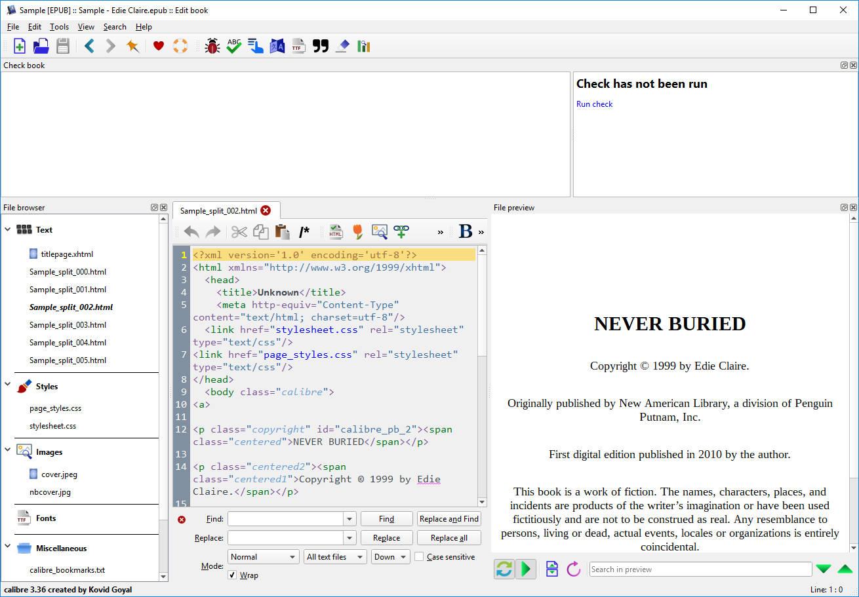

<a> tag above (and matching </a> immediately before next </body>) must be manually removed to fix validation errors.

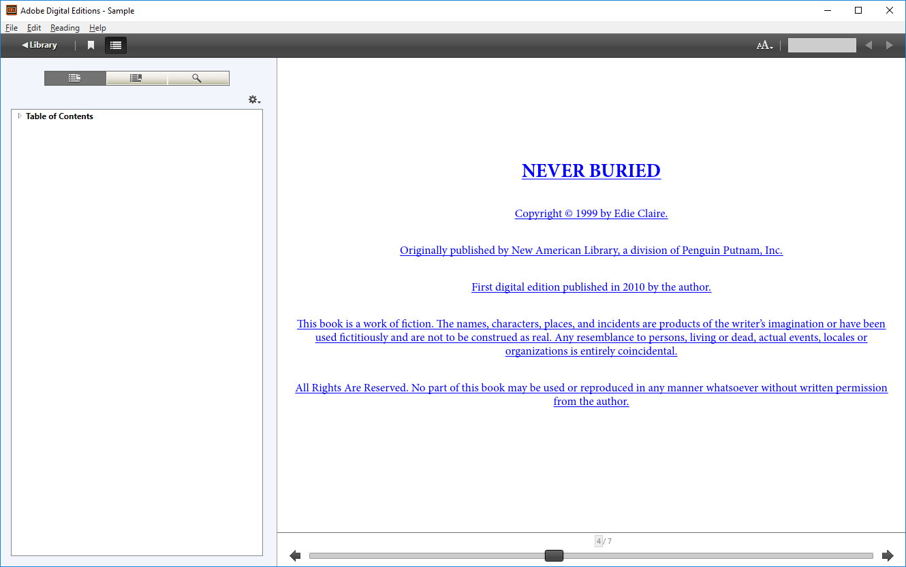

View on Adobe Digital Editions