Android 9.0 Flashing Guide for BOOX Note Pro and Nova Pro

Hi BOOX users, before you start the Android 9.0 Flashing process, please make sure you’ve carefully read this Android 9.0 flashing guide (Guide) and fully understand the risks and process of upgrading your **Note Pro** and **Nova Pro** to Android 9.0.

## The Risks and Differences of Upgrading to Android 9.0

**By starting the Android 9.0 Flashing process, you understand and agree to accept the risks of upgrading Android 6.0 to Android 9.0:**

* Your BOOX will not be able to restore to Android 6.0 once you’ve upgraded it to Android 9.0.
* If the flashing process fails, your device will not work properly and it cannot be restored to the original standard version.
* If your device is bricked in the flashing process, you’ll need to send it to our repair center in the US, China or Europe (Poland) and cover the back and forth shipping fees and customs.

If you cannot decide whether to upgrade your device from Android 6.0 to Android 9.0, you can check out their main differences as follows. **If Android 6.0 with the latest firmware can meet most of your needs, you’re suggested to avoid the risks of upgrading your device’s Android version.**

|  |  |  |
| --- | --- | --- |
| **Android 9.0 vs Android 6.0** | | |
| Example Model: Note Pro | Android 9.0 | Android 6.0 |
| System Status Bar | New pull-down menu | Original style |
| Split-screen for third-party apps | Yes | N/A |
| Custom Gestures | Yes | N/A |
| Keep Wifi/Bluetooth active during sleep mode | To be offered | N/A |
| Gallery | Yes | N/A |
| Screensavers | New screensaver types | Original screensavers |
| Others | New Built-in Apps: Clock, Music | Original built-in apps |

## Android 9.0 Flashing Process

### Data Backup

1. Flashing will erase all data. Please back up all your data before flashing.
2. **Notes:** You can sync all your notes to the Onyx Cloud, or back up all your data locally first and then transfer to your PC to store. (**How to back up notes**: On the notes page - Notes Sync Settings located on the upper right corner / Onyx Cloud Notes / Note Cloud Backup / Back and Restore). Local backup directory: Storage\note\backup\local folder\xxx.zip
3. The Reading Statistics of NeoReader cannot be backed up currently. Except for the embedded data in PDF, the reading data of other formats will be cleared and cannot be restored. Please operate with caution. If there is important reading data, it is not recommended to flash your BOOX.
4. Please copy and save the local files in the storage to the computer;

### Preparations

1. One Win10 computer (MacBook can not be supported. Win7 PC could not be guaranteed.)
2. If you use a desktop computer, please use the rear USB interface to ensure stable USB interface connection. If you use a notebook computer/laptop, please make sure that it is connected to the power supply and the power supply is stable;
3. An original USB cable - Please make sure that the USB cable is working to avoid disconnection during the flashing process which would result in flashing failure.
4. Please make sure to use the right flashing package for your BOOX model. Wrong flashing packages would result in flashing failure.
5. Please ensure more than 50% battery of your BOOX.
6. Please do not shut down, force power off, unplug the USB cable, turn off the computer, close the flashing software, and exit the software in the middle of the flashing process. All those abnormal operations would cause flashing failure and your BOOX would not be able to reboot.

### Devices and Flash Tools

* Your Android 6.0 BOOX device (Note Pro / Nova Pro)
* Updater.rar
* The correct flashing package update.oyx for your model
* A Windows 10 PC
* An original USB cable

### Flashing Process

1. Unzip the **Updater.rar** in a Windows 10 PC.
2. In the unzipped folder, go to **Updater\DriverAssitant_v4.5***,* and double-click **DriverInstall.exe** to initiate the Rockchip Microdrive Assistant.​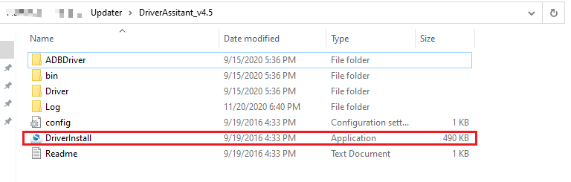
3. The Rockchip Microdrive Assistant will uninstall related drivers of the current system.

* (The manufacturer of The Rockchip Microdrive Assistant only provides the tool in Chinese and there is no English version. Please follow the instructions in the picture)

1. Click “驱动卸载“ （**the framed text in the right**）

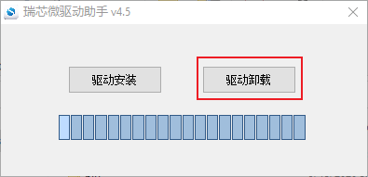

1. Waiting for the uninstallation. After the uninstallation is successful, a window will pop up, then click "**确定/OK**".

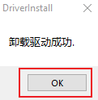​

​

1. Click the cross in the upper right corner to **close the Rockchip Microdrive Assistant program**.

​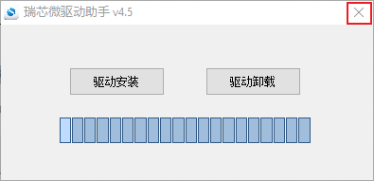

1. Install Onyx device flashing driver
   1. Open the unzipped folder again, go to **Updater\driver**and double-click to open **zadig-2.5.exe**. 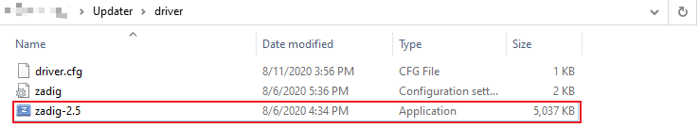
   2. An upgrade notice will pop up and please select "**no**".

​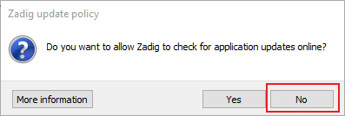

* 1. Then open the dialog box from the menu - **Device \ Load Preset Devic**. ​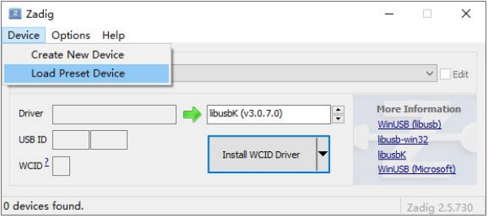
  2. After that, please select the driver.cfg file from the same directory path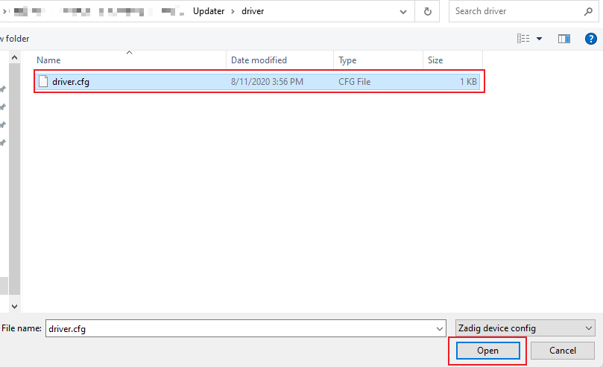
  3. Confirm the underlined **USB ID and Driver**. Click **Install Driver**. 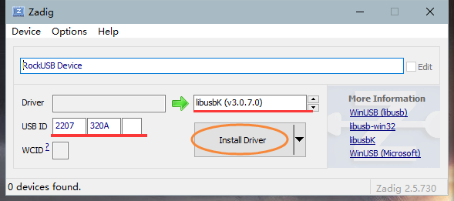
  4. Wait for the notice of successful driver installation and close the notice window.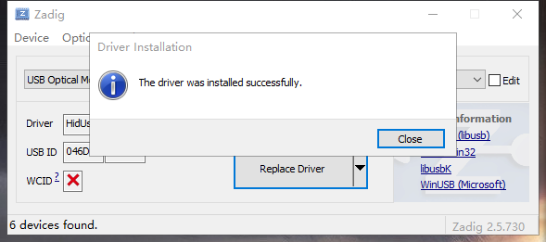
  5. Close the *Zadig-2.5.exe*.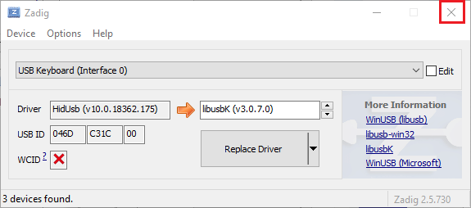

1. After the Onyx device flashing driver is installed successfully, please restart your computer.
2. Copy **update.oyx** to the unzipped folder named Updater. (**Do not change the file name**)
3. Double-click **Updater.exe**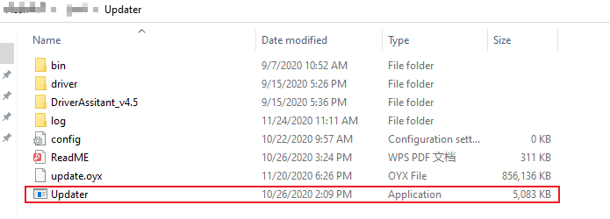​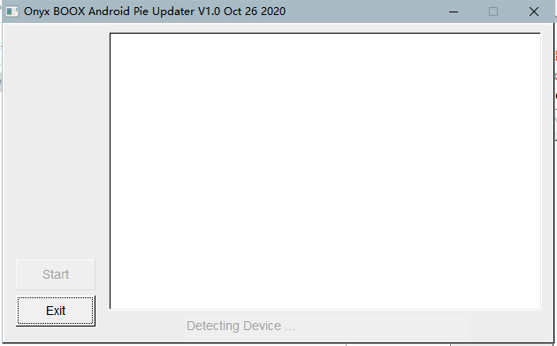
4. Ensure your BOOX is **power-off**. Press and hold **Back button**, then connect it to the Windows 10 PC with an original USB cable to enter Flashing mode. The flashing tool will notify you when it has found a **Loader** device. (see the underlined text). Then click "Start" to start the flashing process. Then you can stop pressing the Back button.  
   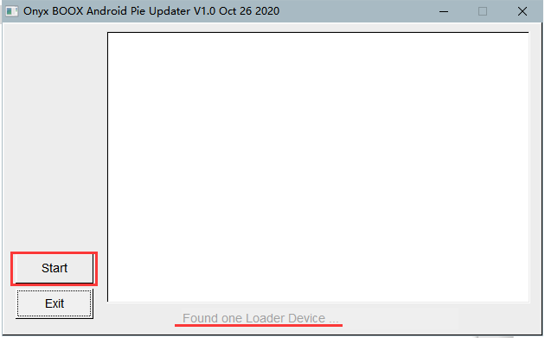​If you find the notice saying “Found one **Maskrom** Device”, please **do not** click “Start”. Click “Exit”, disconnect your device, and long press the **power button** to power it on and off again. Then you can change a USB cable (an original USB cable in the BOOX package is recommended) and try Step 11 again.
5. There will be progressing details during the flashing process. After the flashing process has been completed, your BOOX will restart automatically.   
   (If it doesn't restart automatically, and the tool doesn't give any abnormal notice, you can power on the device manually.)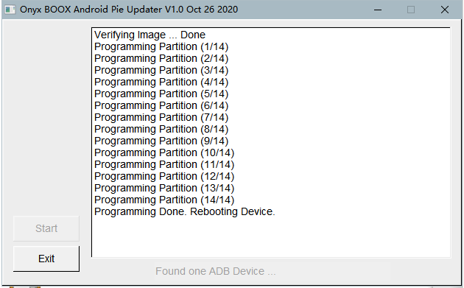

**End of the Guide. Wish you success on the Android 9.0 flash.**