How to use the Ontario Library Service to download e-books
STEP 1: Go to http://downloadcentre.library.on.ca and click “Login”. Then enter your library name then your library card# and PIN as below.
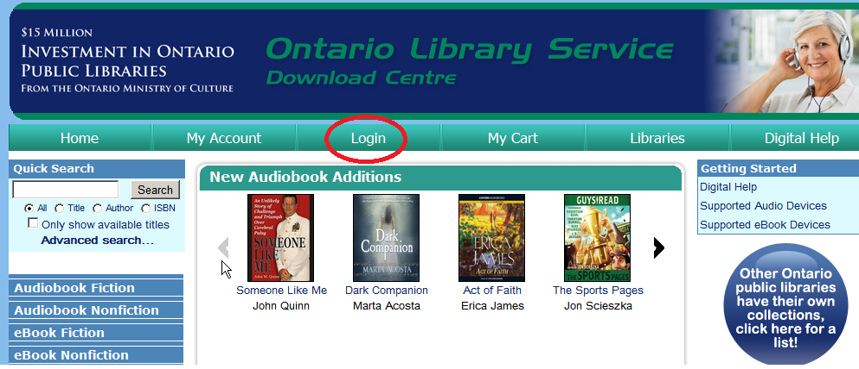

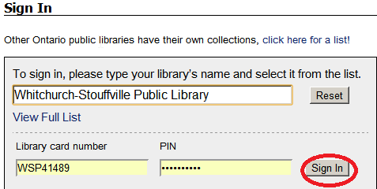

STEP 2: Find the book you want. Either use the “Quick Search” box or choose from the genres below for either eBook Fiction or eBook Nonfiction. If you use Quick Search be sure to check the little box for “Only show available titles”.
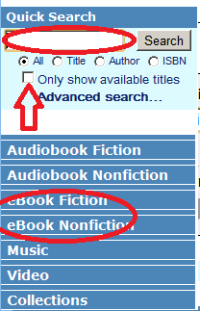
If you use the “eBook Fiction” or “eBook Nonfiction” genre menu make sure on the next screen you select the little checkbox for “Only show titles with copies available”, then click SUBMIT.
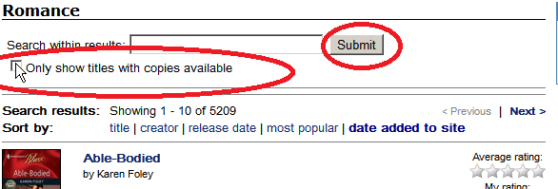

STEP 4: Once you find the book you want then click “add to cart” beside the “Adobe EPUB eBook” option.
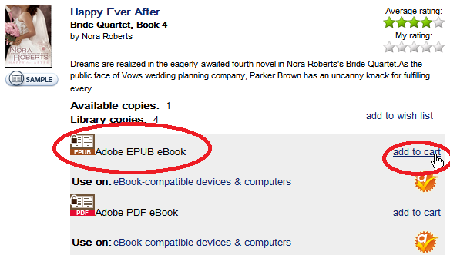

STEP 5: Click “Proceed to Checkout”.
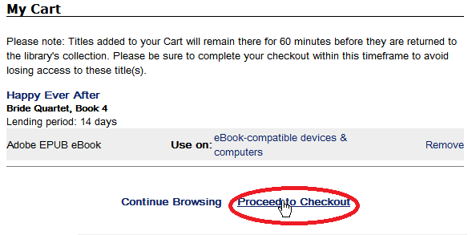

STEP 6: Select how long you want to have the book (once they expire you can’t access them on your reader). Then click “Confirm Check Out”.
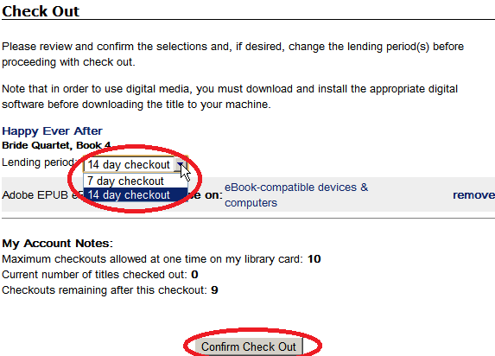

STEP 7: Click the “Download” button
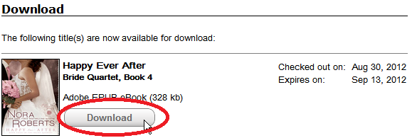

STEP 8: The book should download onto your computer at this point and Adobe Digital Editions should automatically open the book.
Plug in your Kobo and the on the Kobo screen click “Connect” once it is connected to the cable and the cable is connected to your PC.
Once Adobe Digital Editions opens click the icon on the top left that looks like 3 books beside each other to view your “bookshelves”.
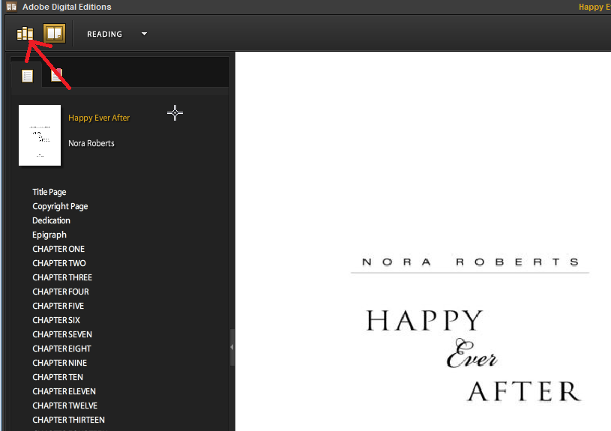

STEP 9: Drag and drop the new book from the right side of the screen onto your Kobo which should be in the list on the left. Once you drag it over top of the Kobo name you should see a green “+” sign appear – let go of the mouse and the book will be copied from your computer over to the Kobo.

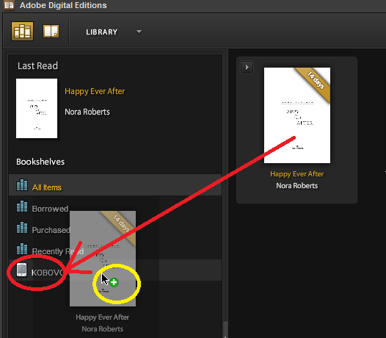

STEP 10: Unplug your Kobo and enjoy your new book

