How to convert a Devnagari(hindi) book in epob ebook-
I tried it with Mangal font and it worked. You can try similarly with other fonts, if it doesn’t work then convert your book’s font into Mangal font and follow the procedure below-
1. I hope your computer have Mangal fonts otherwise download following fonts –
- mangal.ttf
- mangalb.ttf

and install them.
2. Install these fonts (mangal.ttf font and mangalb.ttf font) also in the directory C:\ProgramFiles\Calibre2\resources\fonts\liberation.
3. Make all the changes in the book as per your preference (such as paragraphs, bold headings, letter size, style etc and save as HTML file. When saving as HTML, be sure to use the save as “Web page filtered”option.
4. Convert your file (i.e. book) with Calibre to epob file and save your epob file in your computer.
5. Each device has its own built-in fonts for displaying books. Because we want to use different fonts so we have to embed them and specify how they will be used in your stylesheet. This procedure is called Font embedding. Now open your epub file in Sigil.

6. In Sigil, right click on the “Fonts” folder in the “Book Browser” panel and select “Add Existing Items”, browse to the place where you have stored your fonts and select them(mangal.ttf font and mangalb.ttf font).

You should see something like this:

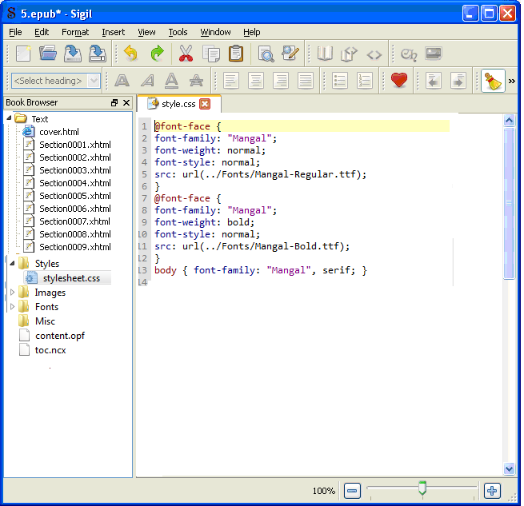

The next step is declaring the fonts in the stylesheet. To do that, click stylesheet.css and just add the following at the top of the page (similarly to the snapshot below):

@font-face {
font-family: "Mangal";
font-weight: normal;
font-style: normal;
src: url(../Fonts/Mangal-Regular.ttf);
}
@font-face {
font-family: "Mangal";
font-weight: bold;
font-style: normal;
src: url(../Fonts/Mangal-Bold.ttf);
}
body { font-family: "Mangal", serif; }

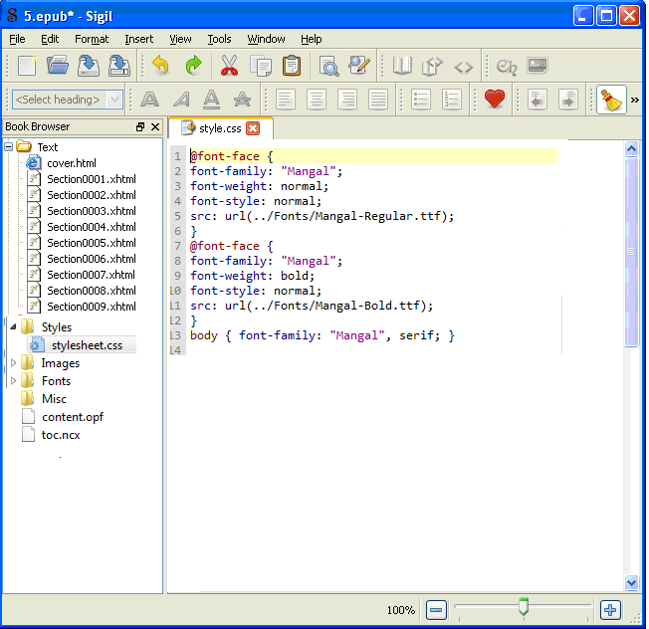

You are done. Save your file . Transfer to your book reader and enjoy reading.

