Calibre 0.8.39

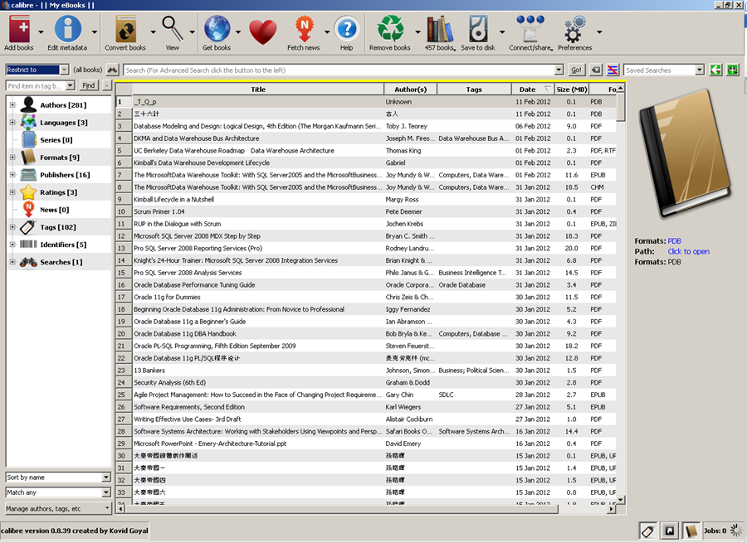

Convert from PDB to EPUB Error Detail
Convert book 1 of 1 (_T_Q_p)
Failed to initialize plugin: u'C:\\Documents and Settings\\Tom\\Application Data\\calibre\\plugins\\HaoDoo PDB Plugin.zip'
Resolved conversion options
calibre version: 0.8.39
{'asciiize': False,
'author_sort': None,
'authors': None,
'base_font_size': 18.0,
'book_producer': None,
'change_justification': u'original',
'chapter': u"///*[((name()='h1' or name()='h2') and re:test(., 'chapter|book|section|part|prologue|epilogue\\s+', 'i')) or @class='part' or @class = 'chapter' or @class='section']",
'chapter_mark': u'pagebreak',
'comments': None,
'cover': None,
'debug_pipeline': None,
'dehyphenate': True,
'delete_blank_paragraphs': True,
'disable_font_rescaling': False,
'dont_split_on_page_breaks': False,
'duplicate_links_in_toc': False,
'enable_heuristics': False,
'epub_flatten': False,
'extra_css': u'<@font-face { \nfont-family: "Arial", "SimSun", "Times New Roman", "MingLiU", "PMingLiU", "Cambria", "Consolas", "DroidFont", serif, sans-serif; \nfont-weight: normal; \nfont-style: normal;\nsrc: url(\'res:///system/fonts/DroidSansFallback.ttf\'); \n} \n@font-face { \nfont-family: "Arial", "SimSun", "Times New Roman", "MingLiU", "PMingLiU", "Cambria", "Consolas", "DroidFont", serif, sans-serif; \nfont-weight: bold; \nfont-style: normal; \nsrc: url(\'res:///system/fonts/DroidSansFallback.ttf\'); \n} \n@font-face { \nfont-family: "Arial", "SimSun", "Times New Roman", "MingLiU", "PMingLiU", "Cambria", "Consolas", "DroidFont", serif, sans-serif; \nfont-weight: normal; \nfont-style: italic; \nsrc: url(\'res:///system/fonts/DroidSansFallback.ttf\'); \n} \n@font-face { \nfont-family: "Arial", "SimSun", "Times New Roman", "MingLiU", "PMingLiU", "Cambria", "Consolas", "DroidFont", serif, sans-serif; \nfont-weight: bold; \nfont-style: italic; \nsrc: url(\'res:///system/fonts/DroidSansFallback.ttf\'); \n}',
'extract_to': None,
'filter_css': u'',
'fix_indents': True,
'flow_size': 260,
'font_size_mapping': None,
'format_scene_breaks': True,
'html_unwrap_factor': 0.4,
'input_encoding': None,
'input_profile': <calibre.customize.profiles.InputProfile object at 0x031BB270>,
'insert_blank_line': False,
'insert_blank_line_size': 0.5,
'insert_metadata': False,
'isbn': None,
'italicize_common_cases': True,
'keep_ligatures': False,
'language': None,
'level1_toc': u"//*[@class = 'part']",
'level2_toc': u"//*[@class = 'chapter']",
'level3_toc': u"//*[@class = 'section']",
'line_height': 0.0,
'linearize_tables': False,
'margin_bottom': 5.0,
'margin_left': 10.0,
'margin_right': 10.0,
'margin_top': 5.0,
'markup_chapter_headings': True,
'max_toc_links': 50,
'minimum_line_height': 120.0,
'no_chapters_in_toc': False,
'no_default_epub_cover': False,
'no_inline_navbars': False,
'no_svg_cover': False,
'output_profile': <calibre.customize.profiles.NookColorOutput object at 0x031BB670>,
'page_breaks_before': u"//*[name()='h1' or name()='h2']",
'prefer_metadata_cover': False,
'preserve_cover_aspect_ratio': False,
'pretty_print': True,
'pubdate': None,
'publisher': None,
'rating': None,
'read_metadata_from_opf': 'c:\\docume~1\\tom\\locals~1\\temp\\calibre_0.8.39_tmp_1cvof1\\wvtete.opf',
'remove_fake_margins': True,
'remove_first_image': False,
'remove_paragraph_spacing': False,
'remove_paragraph_spacing_indent_size': 1.5,
'renumber_headings': True,
'replace_scene_breaks': u'',
'series': None,
'series_index': None,
'smarten_punctuation': False,
'sr1_replace': None,
'sr1_search': None,
'sr2_replace': None,
'sr2_search': None,
'sr3_replace': None,
'sr3_search': None,
'tags': None,
'timestamp': None,
'title': None,
'title_sort': None,
'toc_filter': None,
'toc_threshold': 6,
'unsmarten_punctuation': False,
'unwrap_lines': True,
'use_auto_toc': False,
'verbose': 2}
InputFormatPlugin: PDB Input running
on c:\docume~1\tom\locals~1\temp\calibre_0.8.39_tmp_1cvof1\cq7fkb.pdb
Python function terminated unexpectedly
No reader available for format within container.
Identity is BOOKMTIT. Book type is Unknown (Error Code: 1)
Traceback (most recent call last):
File "site.py", line 132, in main
File "site.py", line 109, in run_entry_point
File "site-packages\calibre\utils\ipc\worker.py", line 191, in main
File "site-packages\calibre\gui2\convert\gui_conversion.py", line 31, in gui_convert_override
File "site-packages\calibre\gui2\convert\gui_conversion.py", line 25, in gui_convert
File "site-packages\calibre\ebooks\conversion\plumber.py", line 960, in run
File "site-packages\calibre\customize\conversion.py", line 204, in __call__
File "site-packages\calibre\ebooks\conversion\plugins\pdb_input.py", line 27, in convert
calibre.ebooks.pdb.PDBError: No reader available for format within container.
Identity is BOOKMTIT. Book type is Unknown

