How to show extended metadata-information on your device

By following these steps, the information on your device will look like this:

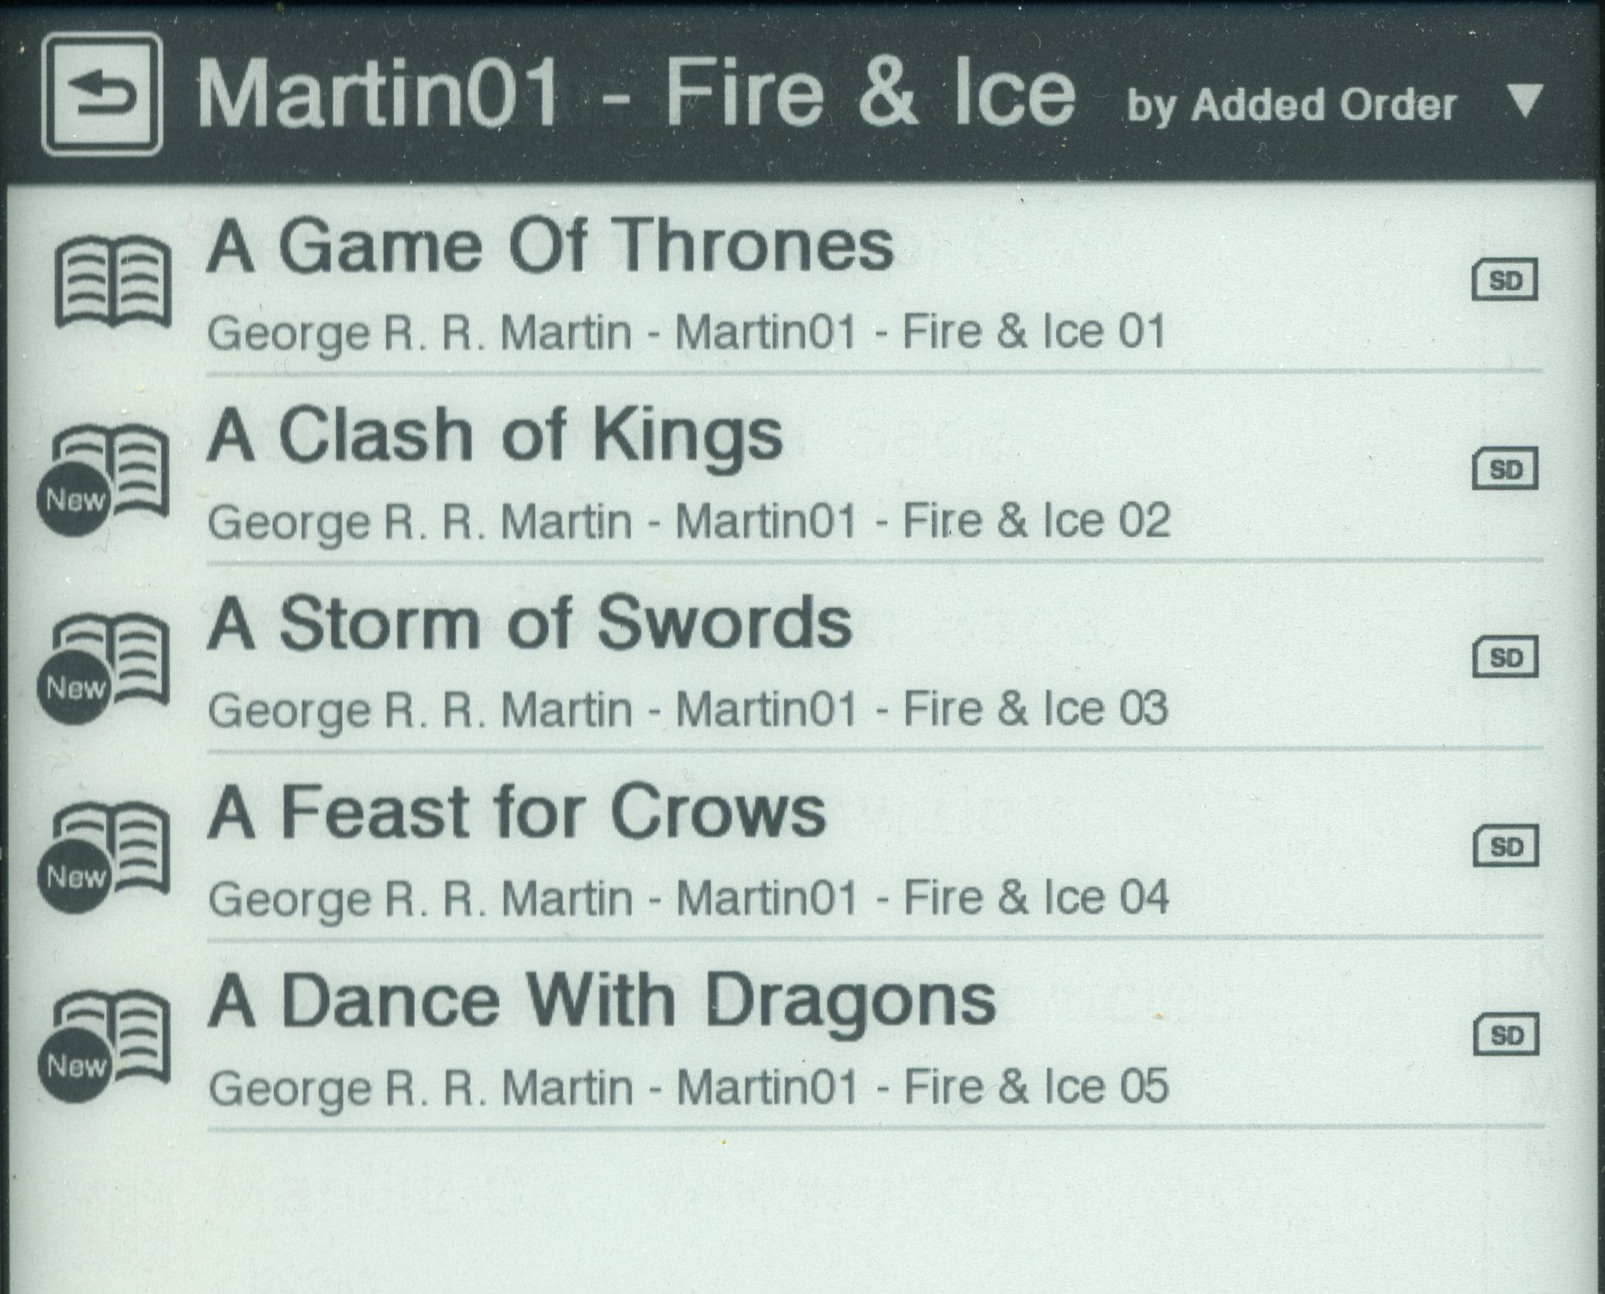

(I’m using ‘FirstName – LastName’ for the author, but it is also possible to use ‘LastName – FirstName’.)

Author: George R. R. Martin
Series: Martin01 – Fire & Ice
Series-index-number: 01, 02, 03, 04, 05

- First, update your Calibre-software to the latest version.
- Go to ‘Preferences’ – ‘Sending books to devices’.
- Set ‘Metadata management’ on ‘Automatic management’.
- Set ‘Save template’ to {series}-{series_index}: {title} - {authors}. (Use {authors_sort} if you want the format ‘LastName – FirstName’.)
- Click ‘Apply’.
- Staying in ‘Preferences’, go to ‘Plugins’ – ‘Device Interface plugins’, choose the ‘Sony Device Interface plugin’ and click ‘Customize plugin’.
- Uncheck the box ‘Use author sort for author’. (Sounds not logical if you want the format ‘LastName – FirstName’, but otherwise the combination of settings will not work. By using specific tags later on, you will be able to get the format ‘LastName – FirstName’)
- Set ‘Save template’ to {series}-{series_index}: {title} - {authors}. (Again, use {authors_sort} if you want the format ‘LastName – FirstName’.) Whatever format you use, make sure the content of both ‘Save template’-boxes is the same!
- Click ‘OK’, followed by ‘Apply’.
- Staying in ‘Preferences’, go to ‘Tweaks’ and choose the ‘Specify how Sony collections are sorted’-tweak.
- Set the tweak to sony_collection_sorting_rules = [(['series'], 'series_index')].
- Click ‘Apply’ in the lower right corner of the screen and (I’m not sure but I think also) ‘Apply’ in the upper left corner of the screen. You will be told you need to restart Calibre to make this work. We’ll do that later on.
- Staying in ‘Preferences’, now go to ‘Metadata plugboards’ and fill in the screen as below:
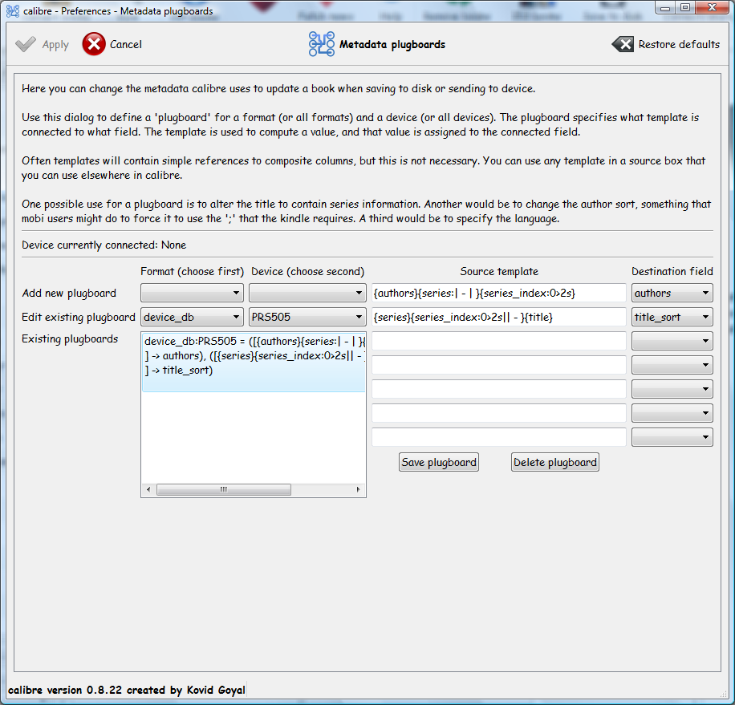
Note: I already have an existing plugboard, therefore it shows under ‘Edit existing plugboard’ and the field/box ‘Existing plugboards’ is filled.
You need to use the drop-down-boxes for ‘Add new plugboard’.

- Fill in both lines in ‘Source template’ and choose ‘Destination field’ as shown. (If you want the format ‘LastName – FirstName’, replace {authors} in the upper ‘Source template’ with {author_sort}. Do NOT change the ‘Destination field’!
- Click ‘Save plugboard’ and then ‘Apply’.
- Close ‘Preferences’.
- Close Calibre and then start it again. (Because of step 12, you’ll need to restart Calibre.)
- Now, connect your device with your computer. Calibre will take a moment to detect your device and then metadata-update will take place automatically; visible by the ‘spinning Jobs-wheel’ in the lower right corner of your screen.
Because Calibre is now set to ‘Automatic Metadata management’, all the books on your device will now show this new format of information. You can now disconnect your device again.
Check the books on your device; no matter how you do this (via ‘See all books’ or ‘Collections’, and no matter how the list is then sorted) you will now see title (big and bold) and underneath this, author (in your chosen format), series-information and series-index-number!

