Firmware Update for Alex from the memory card micro SD
- Memory card.
- Rewrite the firmware files on the memory card:
boot_nontrust.bin
total.img
(We can immediately write directly to memory card using a card reader or connect to a PC via a cable USB, select the removable disk)
- Install a memory card micro SD in Highscreen Alex.
- At el. book Highscreen Alex off (long press of the button "POWER"
- Press and hold the "right" and "Left", then click on the button "Power
- Displayed on the LCD menu engineering BootLoader
(Office through the menu buttons "left" and "return" to confirm the selection-button synchronization.)

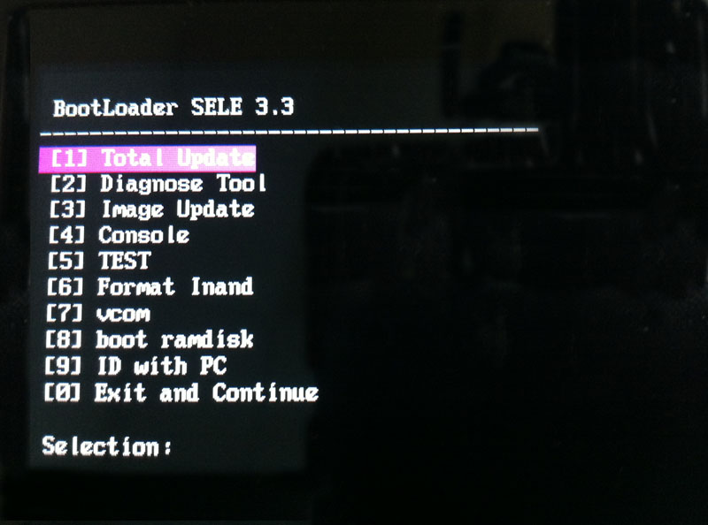
7. BOOTLOADER Update◊ SDMMC update ◊Update BOOT, to do this, select the third
menu item "Image Update
8. After the update restart the device (you can not do, and re-enter the engineering menu BootLoader combination described above).
9. Choose the 1 st item «Total Update» and wait until the end of the firmware update, then press any key to reboot.
10. Next, you need to make a Hard Reset. To do this, choose one of two ways:
1-st method
Press and hold the "right" and "return". Wait for the menu utilities Android System Recovery.
- Select «Factory Reset»
(Choice by the buttons "right" and "food" to confirm - button "Return").
Wait for the inscription «Data wipe complete.»
- Select «Reboot now»
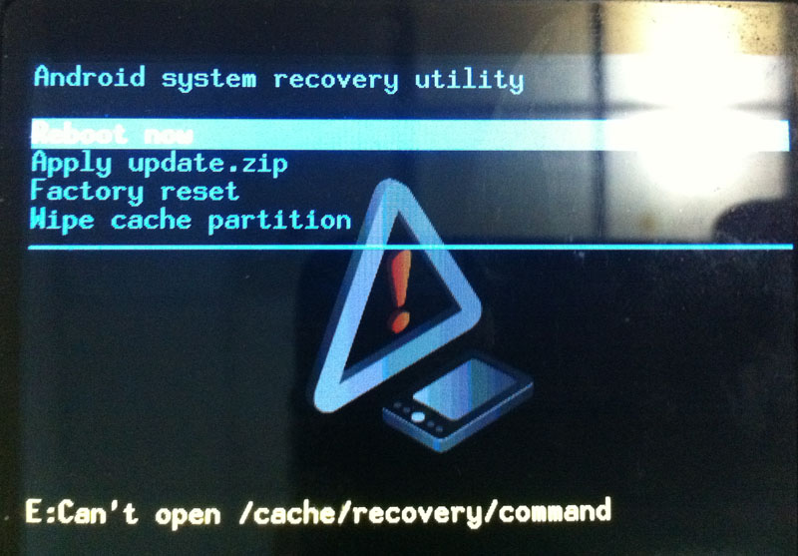
2-nd way
Include e-mail. Book Highscreen Alex and wait for the download.
- Click "Settings"
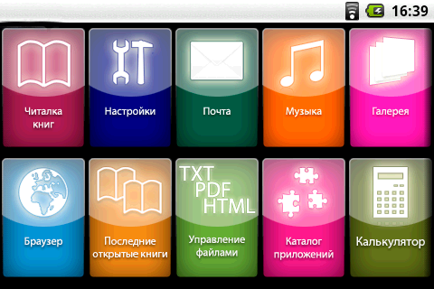
- Select "Memory card and e-RAM. Book
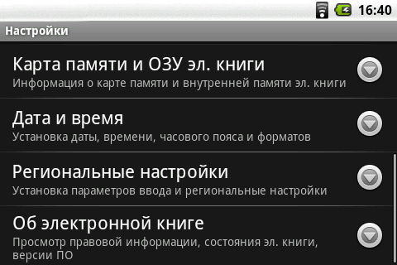
- Click "Return to factory settings."
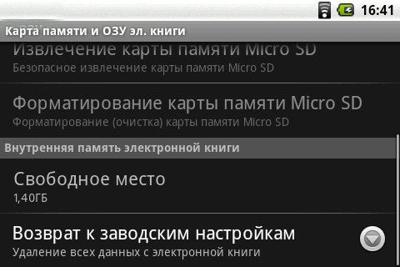
- Press "Reboot device"
11. EBook Highscreen Alex is ready to work.

