eBook Conversion & Kindle Management 101
Introduction / eBook Overview
This guide is meant for beginner Kindle users, who are not very tech savvy and are new to the world of ebooks. This does, however, assume that you know your basic way around a computer. This is NOT meant to be an all-inclusive guide with tons of shiny tips and tricks – it’s a basic how-to guide for the beginner that will hopefully get you started.
First things first – regardless of what kind of ebook reader you own, you need to know that ebooks come in lots of different formats. You also need to know that some ebooks come protected by DRM (Digital Rights Management), also known as a way to “lock” books and prevent them from being passed around for free without being paid for. This guide will NOT tell you how to get around DRM. (although you may want to visit http://apprenticealf.wordpress.com/2011/01/13/ebooks-formats-drm-and-you-%E2%80%94-a-guide-for-the-perplexed/ to learn how to remove DRM)
So – ebook formats. There are a lot of them, and some are used more than others. Think of an ebook format like a book written in a different language. It’s the exact same book regardless of what language it’s written in, but you can only understand an ebook written in a language that you know. eBook readers all come with the ability to read several different format types (“languages”) but if it’s not able to understand the format type that the book comes naturally in, you’ll need to find a way to convert and interpret the different language that your ebook reader doesn’t know.
You can tell what book format the book comes in by looking at the properties of the book, or looking at the file extension (usually the last 3 or 4 letters in the filename after the period). The most common ebook formats are listed below:
- .txt – basic text file, can be opened and read in Notepad
- .html – website format, can be read in a web browser
- .azw – format specific to the Amazon Kindle
- .pdf – Adobe Portable Document format, shows images of the pages of the book
- .lit – Microsoft reader format, very similar to .txt
- .mobi – popular ebook format, can be read by the Kindle
- .epub – very popular ebook format that most libraries carry books in, cannot be read by the Kindle
- .doc or .docx – Microsoft Word format
Those are the most popular ones that you really have to worry about. Basically, ebooks come in a lot of different formats, and if your ebook reader can’t “read” or “understand” that format, then you will need to convert that file to a format that your ebook reader can understand. If you don’t know what formats your ebook reader can understand, try looking it up here:
http://wiki.mobileread.com/wiki/E-book_Reader_Matrix
http://wiki.mobileread.com/wiki/Older_E-book_Reader_Matrix

Finding Free eBooks
There are a lot of websites out there where you can get free ebooks. Here are a few to start with:
http://www.hongkiat.com/blog/20-best-websites-to-download-free-e-books/
http://mashable.com/2010/12/25/free-kindle-books/
http://www.amazon.com/s/?node=2279458011
http://www.booklending.com/
Personally, I find it easiest to download a torrent sharing program (such as BitTorrent, located at http://www.bittorrent.com/) and download torrents (which are kind of like a bunch of ebooks zipped together in one big file). If you know that you’re looking for a particular author, you can google for the torrent and just download all of the author’s works.
When you find an ebook that you like/want, I highly recommend saving it to your computer – create a folder on your desktop and put all of your ebooks in it, regardless of format.
Downloading eBook Management Tools – Calibre & Collections Plug-In
Now that you understand ebook formats and the need for format conversion, you’ll need to download a few tools. By far, the best ebook management tool for beginners is Calibre. Go to http://calibre-ebook.com/download, select the operating system you use, and save the file to your desktop. Then click on the file and install the Calibre tool.
Then, go to: http://www.mobileread.com/forums/showthread.php?t=118635 and install the Calibre plug-in to manage Kindle Collections. To do this:
- Download the attached zip file at the bottom of the post - do not unzip it (the Safari browser may automatically unzip files so use another browser)
- In Calibre select Preferences->Plugins
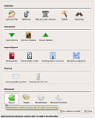
- Click the "Add new plugin" button
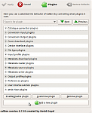
- Browse to and select the Kindle Collections.zip file, then click OK, followed by Apply then Close
  - You will be prompted to add the plugin to the toolbar if you have not installed it before. Select where to put the plugin, e.g. "The main toolbar when a device is connected" and press OK. You can edit this under Preferences->Toolbar later.
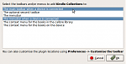
- Restart Calibre
Adding Books to Your Calibre Library
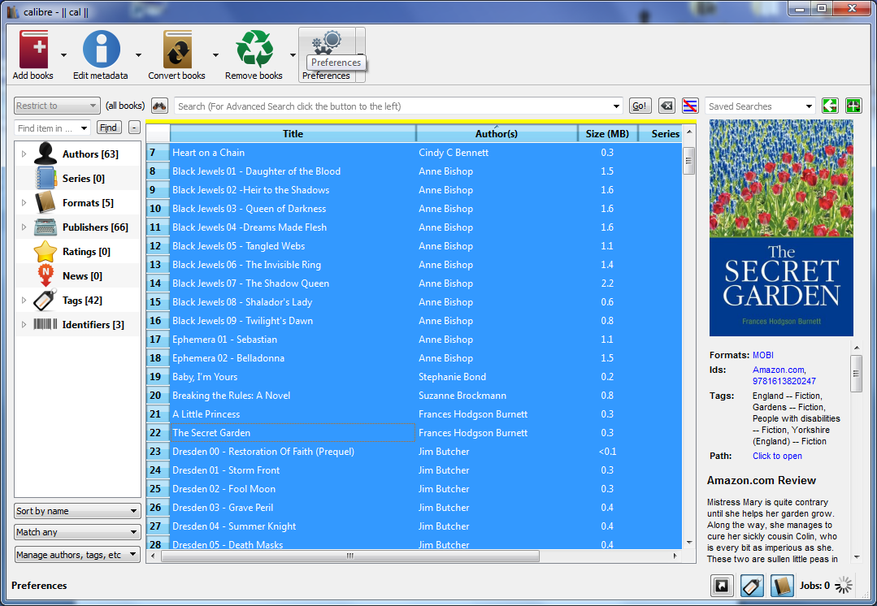
The first think that you’re going to want to do is take all of those lovely ebooks that you’ve saved to your computer, and add them to your Calibre library. Why? Because you’re going to be using Calibre to manage those ebooks, and it just makes it easier this way. Trust me – you’re going to want all of your ebooks in your Calibre library – especially if you’re a beginner. To add a book to your Calibre library, click on the red ‘add books’ button on the top left Calibre toolbar,
browse to where the book is located, and double click on it:
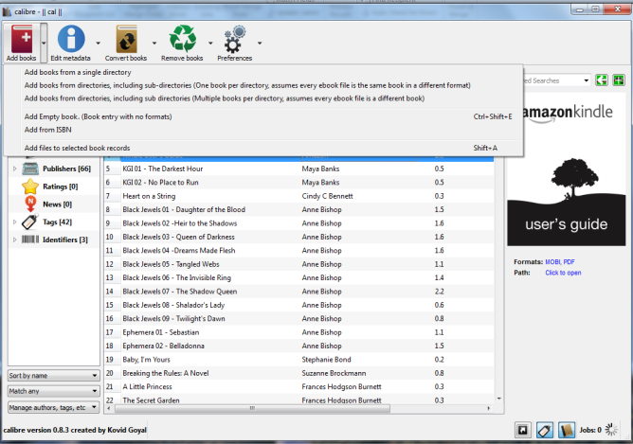
Calibre also gives you the option of adding multiple books or entire folders of books to your library at once as well. Just click on the little ‘down’ arrow to the right of the red ‘add books’ button and choose ‘Add books from directories, including subdirectories’

Editing Metadata and Organizing your Calibre Library
Your Calibre library will now look a little bit like this:
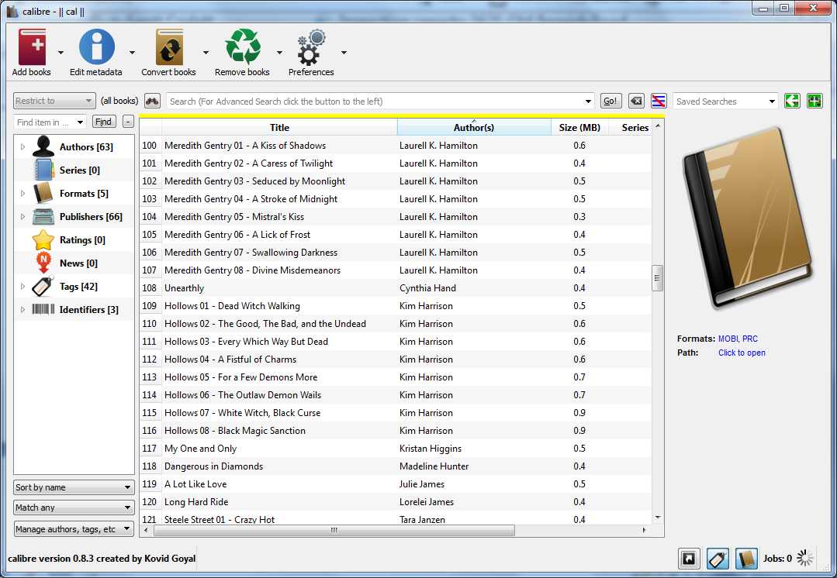
In my opinion, taking just a little bit more effort and time to organize your books and ensure accurate information saves you a lot of aggravation in the long run. Each book contains something called ‘metadata’ – essentially some ‘background’ data that includes author name, book title, and book cover that goes along with each book. Click on any of your books, then click on the blue ‘Edit Metadata’ button in the top left corner. You’ll see a screen that looks like this:
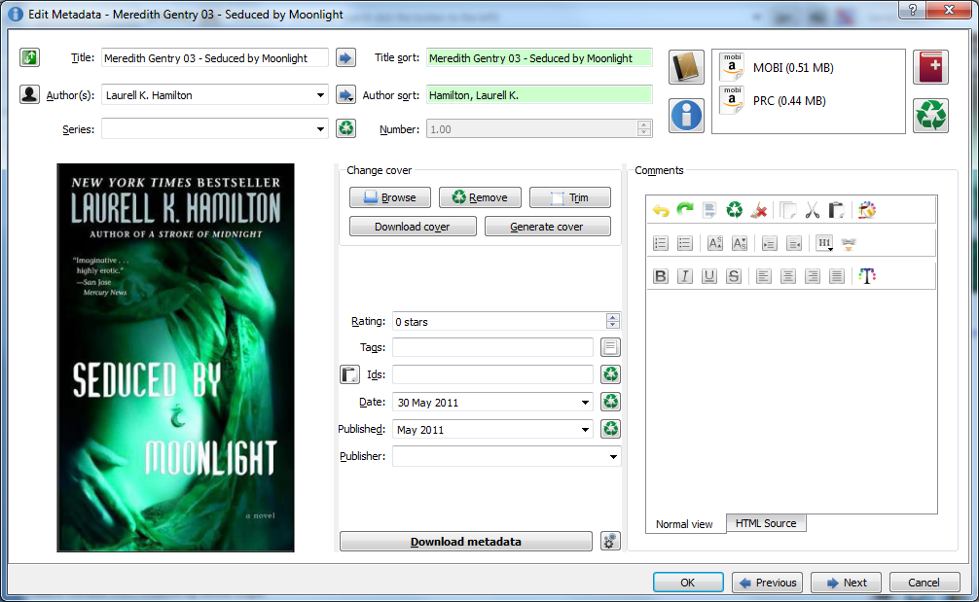
At the top, you can change the title of the book if you want to, as well as the author. I read a lot of books in series, so I like to create names for books that include what series they’re in and what book in the series it is (for example, Series XYZ, Book 1) so that when it’s on my Kindle, I know what order they go in. You can also edit the author’s name if it’s spelled incorrectly, or to match the rest of your naming conventions. I always like to edit authors to have first name, last name. After you edit the title and author, click on the two blue arrows pointing to the right ( → ) next to those fields. This will generate an automatic ‘sort’ order for your books and authors. If the book that you have doesn’t have a cover, you can also browse the internet for a picture of the cover and add it to your metadata, or just have Calibre generate a generic cover.
The metadata information that you’re editing right now is the way it will show up on your Kindle, so if you have a particular preference for naming your books, now’s the time to do it.
If you have a ton of books by the same author, you can also highlight multiple books at the same time (by using Ctrl + click) and choose the down arrow to the right of ‘Edit metadata’. Click on the option to ‘Edit metadata in bulk’ and any changes you make will apply to all of the books that you have highlighted.

Converting eBooks to Different Formats
Right now you have a bunch of books (in various formats) in your Calibre library. You’ve organized them, renamed their titles so they make sense to you, added covers, and verified author name spelling. Your library looks all nice and pretty.
The next step is converting them all into a file that you can actually read on your Kindle (or ebook reader device). Thanks to the geniuses over at Calibre, this is actually pretty easy to do, although it might sound complicated.
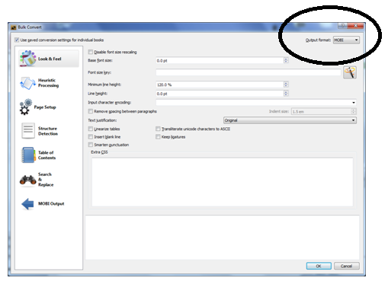
The fastest and easiest thing to do is convert them all at once (bulk convert). Just highlight all of the books in your Calibre library (clicking on a book and using the Ctrl + A shortcut will work too). Then, click on the ‘Convert books’ icon:
You should get a screen that looks like this:
Choose what format you would like to convert all of your books into by choosing the format in the dropdown box on the top right of the screen (circled). Since I have a kindle, I usually convert all my books to .mobi format.
Click on ‘OK’ and Calibre will start the conversion process. You can click on the word ‘Jobs: 1’ on the bottom right of the Calibre screen to watch the process and see how long it will take. Just let it go until it’s done. If you have a DRM (protected book), it will generate an alert that says Calibre is not able to convert it. Just hit ‘ok’.

Moving Books to your Kindle (or other device):
You’re now ready to move your (newly formatted) books onto your Kindle (or other reading device). Connect your Kindle to your computer, using the cord that has been provided. If you have password protected your Kindle, you’ll need to type in your password.
You should get a little window popup that looks like this:
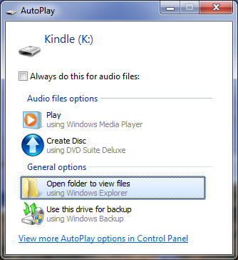
Don’t worry about it – just click on the red X in the top right corner to exit out of it.
Your Calibre library screen should look a little bit different at the top now. You’ll notice that you have two additional icons at the top, one named ‘Kindle Collections’ and one named ‘Send to device’.
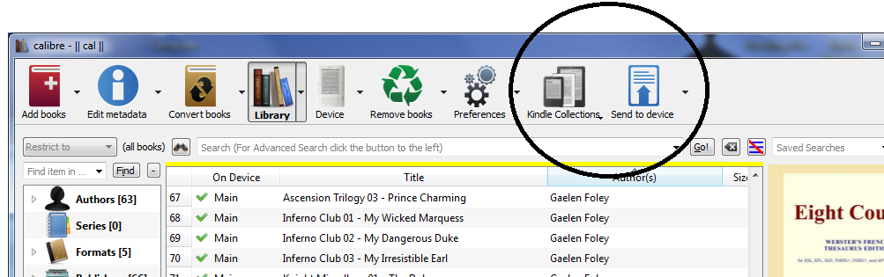
Highlight all of the books you’d like to send to your Kindle by Ctrl + clicking on them, or if you want to send them all to your Kindle, using Ctrl + A shortcut will work too. Then, click on the arrow next to the blue ‘Send to device’ icon and choose ‘Send specific format to Main Memory’.
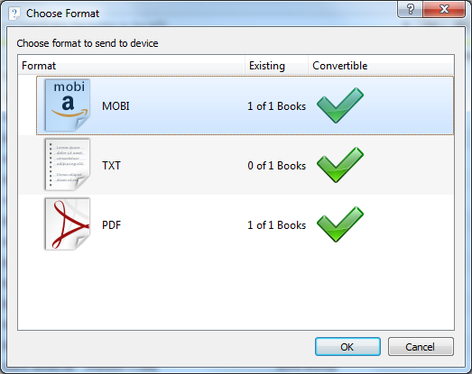
You will then get a popup window that looks like this:
Click on the .mobi icon (highlighted in the picture above) and click OK. You’ll see that a job is being processed in the bottom right hand corner of Calibre again so you’ll know it’s working.
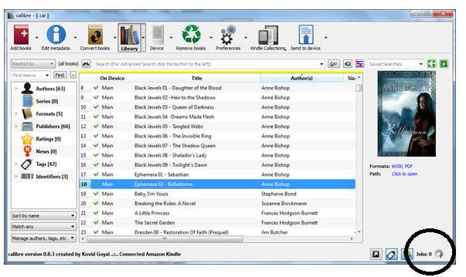
Your books should all now be on your Kindle! Congratulations!!

Organizing your Kindle Collections
So now you have tons of books on your Kindle, but they aren’t organized. This is where the 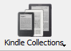 icon comes in. Click on ‘Customize Collections to Create from Calibre’. You should see the following screen pop up:
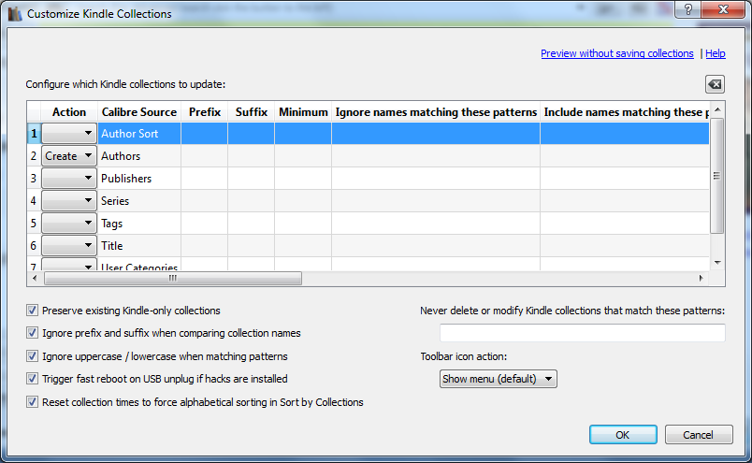
On the left hand side, use the drop down box to specify ‘Create’ for whichever collections you’d like to create. In my case, I like to organize my Kindle by author, so I chose ‘Create’ next to the ‘Authors’ row. Then, click ‘ok’.
Then, click on the arrow next to the icon again and choose ‘Create Collections on Kindle from Calibre’. Give it a few minutes and let it do its thing – you should see the little icon on the bottom right telling you that it’s processing a ‘Job’.
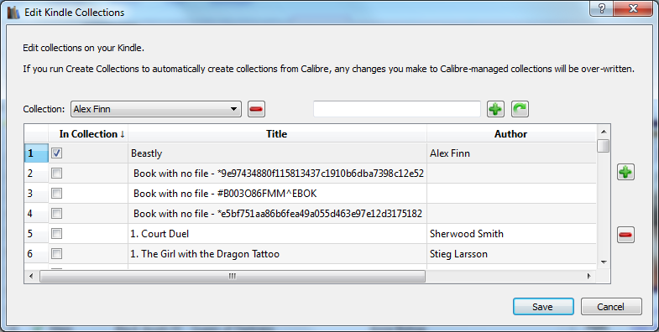
Once that’s done, you can also tweak your collections. Click on the arrow next to the icon and choose ‘Edit Kindle collections manually’. The following screen should appear:

Use the red ‘minus’ sign at the top to delete collections, or put checkmarks next to books to add them to the collection shown at the top. You can also type in a new collection name in the blank box and click on the plus sign to create a new collection.
Once you are done fiddling with automatically and manually creating your collections, eject the device (screenshot below):
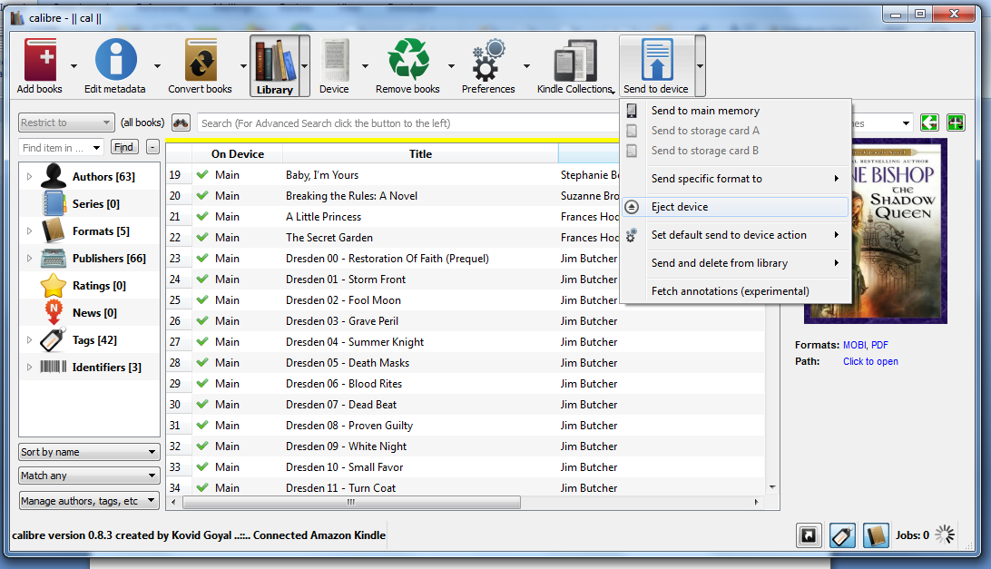
Then, you must restart your Kindle to load the new collections. (Note: this is not the same as using the power on/off switch). On the Kindle, press the Home key, then press Menu, select Settings, then press Menu again and select Restart.
Your new collections should show up on your Kindle now.
For more information regarding Kindle Collection management with the Calibre plug-in:
http://www.mobileread.com/forums/showthread.php?t=118635

