Typed in baldacci and hit enter - as you can see there are several Baldacci books in the list. (search highlighting turned on)
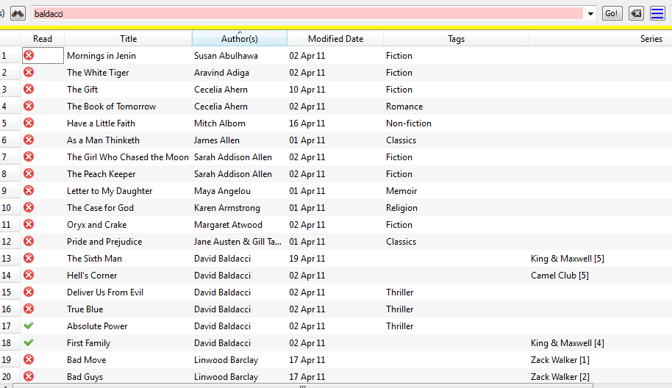

Second try with search hightlighting turned off.
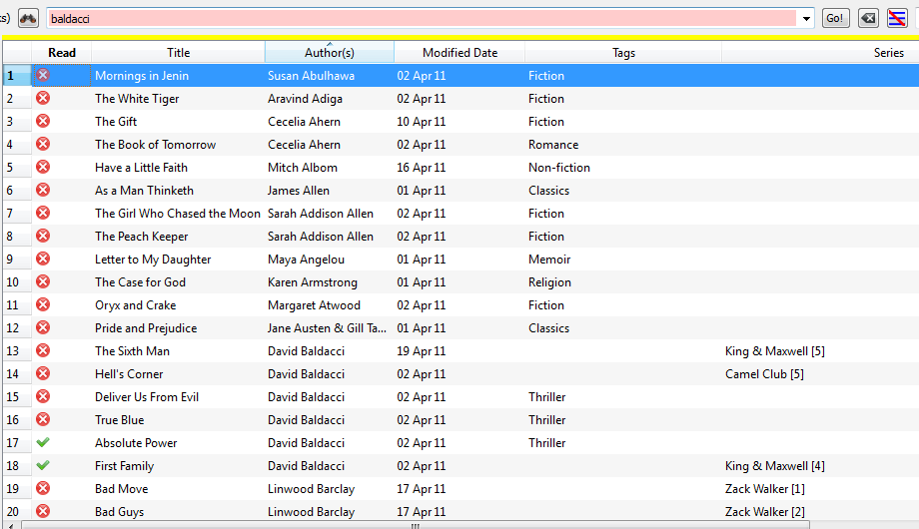
Using advanced search
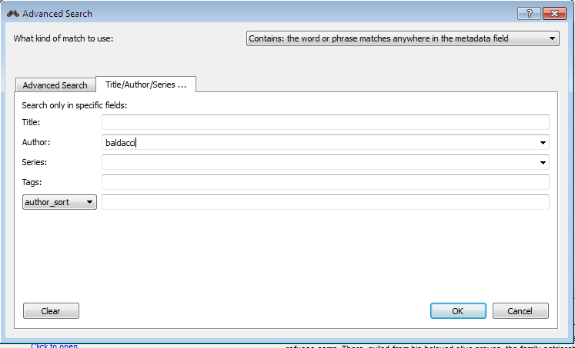
I used to get these same results just by typing baldacci in the search field.
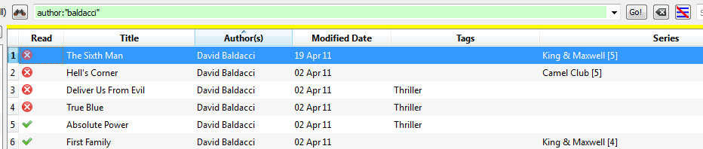
Search options in Preferences:
