
User Guide

PocketBook Pro 903

CONTENTS
2
PRECAUTIONS 6
APPEARANCE AND CONTROLS POCKETBOOK PRO 903 10
Front: 10
Rear: 11
Controls and Indicators 1912
SPECIFICATIONS PocketBook Pro 903 14
GETTING STARTED POCKETBOOK PRO 903 15
Step 1. Charging the battery 15
Step 2. Turning the machine 15
Step 3. Setting 16
Step 4. Customizing the Touch Pad 16
Step 5. Reading books 16
Step 6. Installing the USIM card for 3G Internet 16
User Guide 16
Functions Software 18
Main Menu 18
Latest Open Books 19
Main panel 20
Widgets elements
21main panel 22
Library 22
E-library «Bookland» 24
Notes 25
Selected 25
photos 27
Glossary 29
Appendix 30
Music 31
Search 32
Settings 33
1. Device Information 33
2. Language / Language 33
3. Keyboard 33
4. Exterior 33
5. Shortcuts 34
6. Date / Time 36
7. When you switch to open 36
8. Communications 36
9. Reading out the text 37
10. Service 37
REINFORCEMENTS LIBRARIES AND READING OF ELECTRONIC BOOKS 1938
Listening to music 40
network connection settingsInternet 41
Setting up a wirelessconnection via Bluetooth: 42
Setting wireless WI-FI 43
Configuring Wireless 3G 44
Work with the keyboard 45
shortcuts, 1946
Search 46
to 47
Votes 47
Notes 48
Selected 48
on page 49
Settings 49
Glossary 49
Turn of the book 50
Scale 50
active content of 51
POTENTIAL PROBLEMS AND THEIR ELIMINATION 52
SERVICESERVICE 55
UPDATE SOFTWARE 56
COMPLIANCE WITH INTERNATIONAL STANDARDS 58
Thank you for purchasing PocketBook Pro 903!

Before operating PocketBook Pro 903 be sure to read the manual. You'll learn how to ensure your safety and prolong the life of your device.
In case if you have not complied with the following precautions, or there are signs of problems, be sure to contact an authorized service center for testing the device. Failure to do so may result in failure of the device.

PRECAUTIONS

He expose the unit to extreme high or low temperatures. Keep it away from direct sunlight. Do not expose the battery to strong heating or cooling. A hot battery might cause burns. Remember: the operating temperature of the device is from 0 ° C to 40 ° C.

Aboutberegayte device to open flames or smoke (a lit cigarette lighter, fire, etc.).

He expose the unit to liquid or moisture (read in the rain on the street at high humidity, near water, etc.). Do not let it liquid or moisture - this can cause a short circuit and damage the battery. If the equipment is exposed to liquid, immediately remove the battery pack and contact an authorized service center.

He leave the unit for a long time in places with poor ventilation, such as a car or a tightly closed container.

He expose the unit to strong electromagnetic fields.

He drop or try to bend the device. In cases of damage to the device, contact an authorized service center.

Do not disassemble or modify it. By the execution of works are allowed only employees authorized service center.

DThis device is not waterproof, it can not be used underwater. If the appliance falls into water immediately, contact an authorized service center.

He use the device if it has damaged the battery, charger (broken housing, is poor, broken power cord) or SD-card. When the battery is damaged (cracked housing, follows the electrolyte, has lost form, etc.) should be replaced immediately.

He replace the battery yourself. Using home-made or modified batteries may cause explosion and failure of the device.

Warning: Do not dispose of batteries in a fire - Explosive!

Warning: The screen is made on a glass substrate and is a fragile piece. Its surface is covered with a layer of flexible transparent material. Characteristic sign of mechanical damage to the screen area is that by changing the images are not of this site is updated, with visible cracks may not be. In the event of such symptoms, contact an authorized service center.

AndAvoid using mechanical pressure to screen more than 1H. Keep the screen objects that could scratch or damage it. To protect the screen, the transfer device in a protective cover or hardcover.
Do not use to clean the screen and body, organic and inorganic solvents such as benzene, etc. To remove dust from the surface of the device, use a soft cloth. To eliminate contamination, drip a few drops of distilled water. To get rid of stubborn stains, consult an authorized service center.

He expose the screen effects of electrostatic charge, artificial sources of electromagnetic radiation of ultraviolet frequencies.

He leave the cables near sources of heat. When heating is possible deformation of the cable or melting of insulation, which can cause fire or electric shock.

He be disturbed connectors and the device keys. This can lead to a deterioration of their functioning and ultimately to failure.

Intilizatsiya Electrical and Electronic Equipment (Applicable in the European Union and other European countries where there are separate collection systems)

Hepravilnaya disposal of this product may cause a negative impact on the environment and human health. To prevent such consequences must fulfill special requirements for disposal of the device. The recycling of materials will help conserve natural resources. For more information about recycling device please contact your local city office, your household waste disposal service, shop where you purchased the device, or an authorized service center.

Abouttklyuchayte wireless connection in places where the posters are available to "turn off two-way radio." Do not use a wireless connection on board and in the hospital, it may interfere with the aircraft or medical equipment. In addition, you can not use this device in areas where cellular communication is prohibited.

DThis device receives and emits radio frequency energy and may cause interference to radio communications and other electronic equipment. When using personal medical devices (such as pacemakers and hearing aids), please consult with a physician or the manufacturer to find out whether they are protected from external RF signals.

Keep out of reach of children.
APPEARANCE AND CONTROLS POCKETBOOK PRO 903

In this section you'll find a common device of your PocketBook Pro 903, its function keys, and then can immediately begin working with him.

Front View:
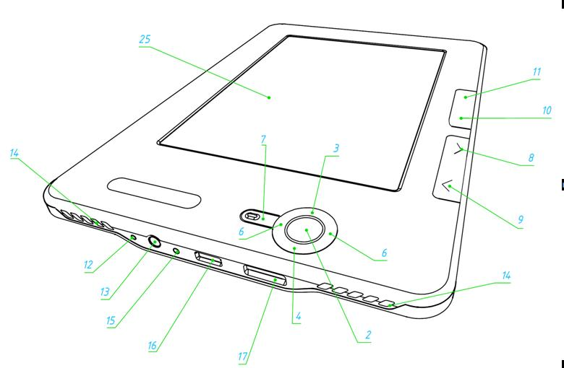
Rear view:

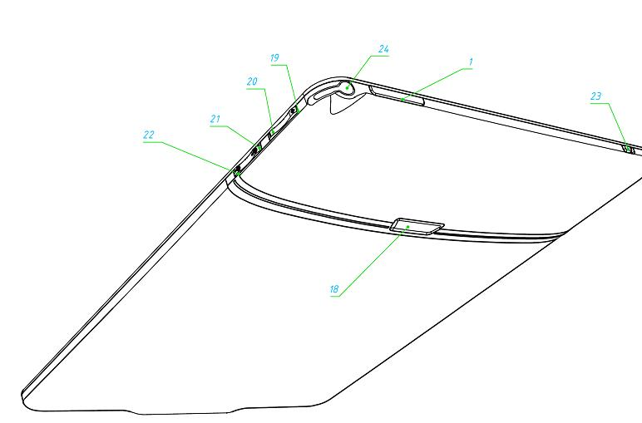
Controls andindicators:

- Key "On / Off" - turn on / off devices (long press);
- "OK" button - confirm selection, call the shortcut or context menu,
- the "up" - navigation button,
- button "Down" - navigation key,
- key " Left - navigation button,
- button, "Right" - navigation button,
- button "Return" - a return to the previous menu, closing the book. Long press - forced the closure of the program;
- Keys"Forward" - to the next page;
- Keys"Back" - go to the previous page,
- key "Menu" - to call the context menu
- key "Home" - reaching the device's main menu;
- Key Reset "- restart the device;
- headphone jack - for connecting headphones with a jack 3,5 mm.
- Speakers - 2 speakers on 0,5 are designed to play audio files,
- color indicator - is designed to display the status of the device when connected to a computer. Flashing orange - charging, green permanent - the battery is charged;
Connector Micro-USB - forconnecting devices to a computer or a charger with a cable Micro USB (charger supplied optional)
- Slot MicroSD - designed to connect external memory MicroSD. (MicroSD-card will beoptional),
- BatteryCover,
- Button "Volume +" - increase the volume;
- key "Volume -" - decrease volume;
- key "Increasing +" - zoom;
- key "Reducing - -zoom out;
- 3G on / off. - On / Off button wireless 3G connection, and
- stylus - used to control device via the touch panel,
touch panel.
SPECIFICATIONS PocketBook Pro 903

Display | 9,7''E-Ink ® Vizplex 1200x825, 155 dpi, B / W
Touch Pad | EMR (E-Writing, pen touch module)
Processor | 533 MHz
Memory | Operational: 256 MB  Standing: 2 GB
Operating System | Linux ®
Communications | Wi- Fi ® (b / g); Bluetooth ® 2.1; Micro USB (480 Mb / s)
Memory Slot | MicroSD up to 32 GB
Audio | The stereo headphone jack 3,5 mm, 2 speakers on 0,5 W
accelerometer | has the
format of books | PDF (ADOBE DRM ), EPUB (ADOBE DRM), PDF, EPUB, FB2, TXT, DJVU, RTF, HTML, CHM, DOC, TCR, FB2.ZIP
Image Formats | JPEG, BMP, PNG, TIFF
formatsaudio | MP3
battery | Lithium-Polymer, 3, 7 B, 1530 mAh
Size | 193x263x11, 5 mm
Weight | 530 g
GETTING STARTED POCKETBOOK PRO 903

Step 1. Charge the battery
for the first time to recharge your device off from 8 to 12 hours. Charge the battery PocketBook Pro 903 in the following ways:
- from the computer using USB-cable,
- from the network, using the USB-device charger (supplied optionally).
To charge the device for the first time, follow these steps.
- Ensure that the device is turned off and not lit . If it is turned on, press and hold a few seconds, press the "On / Off."
- Connect the device to your computer / network with the right cable.
- The indicator lights amber when charging starts.
- The indicator lights green or turns off when the battery is fully charged.
- Now you can unplug the device and turn it on for first use.
If the device stays on during charging, the screen PocketBook you are asked to choose an action - charging the battery or the connection for data transfer. Charging starts, only if you select the appropriate mode.

Step 2.activate the device
Toinclude a device, press and hold the On / Off. "About two seconds. While turning on the screen saver appears. When the device is ready for use, the image will change the main menu, which presents the
latest open books, widgets, and the main features PocketBook Pro 903.

Step 3. Setting
Follow the wizard's settings to configure the basic parameters before using the device. To select Use the arrow keys Up, Down, Right, Left and confirm pressing OK.

Step 4. Customizing the Touch Pad
Go to the Settings item in the Start menu, then Service⇨ calibrate the touch panel. Sequentially press the stylus on the point of these programs on your screen.

Step 5. Reading books
on PocketBook Pro 903 have downloaded 1000 books of different genres and styles in different languages. To learn how to fill up your library, see "UPDATING THE LIBRARY and reading electronic books."

Step 6. Installing the USIM card to use 3G internet
in PocketBook Pro 603 integrated 3G module, which enables you to connect to the Internet at any point where there coverage 3G. To install the USIM card is necessary to remove the back cover of the machine, loosen the mounting batteries, remove the battery itself, and then put into the opened slot USIM card.
To set the 3G internet see Settings⇨ Communication.

User Guide
User Guide is loaded into internal memory, it can drop at any moment and find a detailed description of the necessary functions you need.
Open the "Library". This displays a list of books available for reading. Open the book - the text immediately appears on the screen. To change the font size, press the "Up". Thus changes among 5 possible font sizes. To turn pages, use the arrow keys Left, Right, Back, Forward.
"Fulluser guide is also on the official website of the company PocketBook: http://pocketbook-int.com/support/pocketbook-Pro 903 /

Note: while the book opens, some features are unavailable. This is because there is a calculation the number of pages.
SOFTWARE FUNCTIONS
The main menu
After starting the device and download the screen displays the main menu.

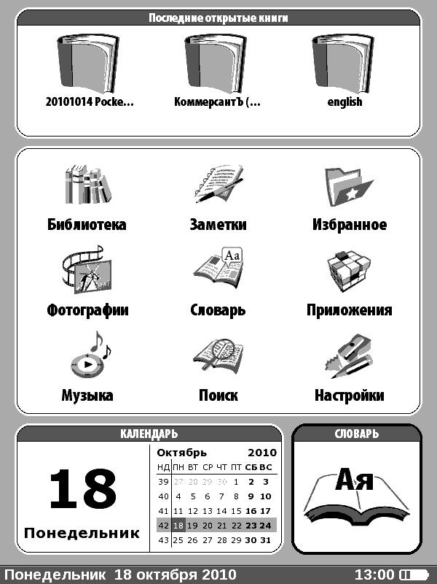

Main menu - it is an element of software, which displays the basic functionality and control sections, allowing comfortable use device:

- Open last book,
- the main panel;
- Widgets.
To quickly access the main menu while using the device, press "Menu" on its front panel or in sequence, press "Reset".

Open last book



Displays a list of recently opened documents. The number of displayed documents depends on the type of layout, the main menu.
Main panel

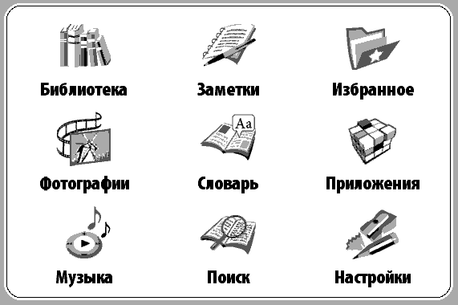

At this point the Main menu soderzhatcya core functionality and control sections of the device:

- "Library,"
- "Notes,"
- "Favorites,"
- "Applications,"
- "Search,"

- "Music,""Photographsand
- drawings,"
- "Dictionary,""Settings".

Detailed information about each section of the main panel, see below.
Widgets

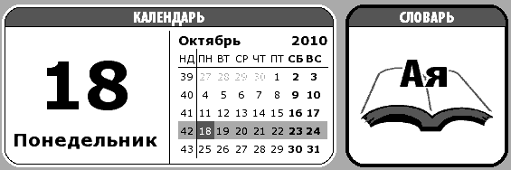

Widget - is the main menu items. Its main task - display current / interesting information and a quick transition to full information. Number and type of widgets may vary depending on the type of layout, the main menu. Manage this element can be made in the "Preferences" Under "Appearance."
The standard set of widgets that can be displayed in the Main Menu:
- clock;
- calendar,
- play sudoku,
- dictionary,
- music player,
- calculator,
- information about the user.
Elements of the main Libraries
panel



In the "Library" displays all the books, magazines and other documents are loaded into internal memory and MicroSD-card (ifinserted).

Main features of the section: the
- search for and discovery of books and other documents in read mode,
- content management interface using the context menu
- entry to an electronic library «Bookland».

Navigation:
- press Up, Down, Right, Left - move through the list,
- press "Next", "Back" - a quick switch to previous / next page,
- the key "return" - a return to the previous menu
- button "OK" - confirm the selection. Pressing and holding down the "OK" for a few seconds causes the popup menu.

Available menu commands in the "Library":

- Open;
- Information;
- Mark as read / uncheck;
- Add to Favorites,
- File:
  - Rename,
  - Move to folder,
  - Copy to SD-card;
  - Move to SD-card,
  - Delete,
  - Mark group;
- View:
  - List,
  - Thumbnails,
  - Advanced;
  - Names in list:
    - The book's title,
    - name of the file;
  - Filter:
    - No,
    - only the internal memory,
    - SD-only card,
  - screen orientation;
- Ordering:
  - By title,
  - by author,
  - by series,
  - by creation date,
- find the book.
E-library «Bookland»

PocketBook Pro 903 allows you to browse and download books from the library e-bookshop «BookLand». The device gets access to library services through a wireless Internet connection (via Wi-Fi or Bluetooth).
To go into an electronic library, in the "Library" then click «BookLand».

To Note:access the library «BookLand» to establish a wireless connection to the Internet via WiFi or Bluetooth. More information about setting up and activating the connection, see the section "Customize".

Key features:
- user login and registration at the library,
- review and management of bookshelves and books to them,
- access to new, popular books in the store or library, free,
- search for books in the catalog,
- an overview of popular authors,
a review of how to replenish the balance in the library «Bookland» .
Notes



In this section, kept notes, you can create while reading through "shortcuts". Learn more about "shortcuts" on page 29.

Favorites



In this section are selected books or other documents that were added using the context menu under "Library".

Main features of the section: the
- search for and discovery of selected books or other documents in read mode,
- content management interface using the context menu.

Navigation:
- press Up, Down, Right, Left - move through the list,
- press "Next", "Back" - a quick switch to previous / next page,
the key "return" - a return to the previous menu
- button "OK" the exercise of choice. Pressing and holding down the "OK" for a few seconds causes the popup menu.

Available menu commands in the "Favorites":
- Open;
- Information;
- Mark as read / Unmark;
- Delete. The "Delete" in this section removes the book just from your favorites list, the book itself is not deleted;
- Create Category;
- Move category;
- View:
  - List,
  - Thumbnails,
  - Advanced;
  - names on the list:
    - The book's title,
    - name of the file;
  - Filter:
    - No;
    - Only the internal memory,
    - only SD-card;
  - screen orientation;
- Sort
  - by:name;
  - By author,
  - by series,
  - by creation date,
- find the book.

Photos



In this section you can view photos and images in formats JPG, BMP, PNG and TIFF.

Section menu consists of two paragraphs.
- Photos. Contains all the images stored in permanent memory device or on the MicroSD-card (if inserted).
- Screens. In this section you can view pictures taken with the device's screen.

Main features of the section:
- view photos and images;
- content management interface using the context menu.

Navigation:
- press Up, Down, Right, Left - move through the list,
- press "Next", "Back" - a quick switch to previous / next page,
- the key "return" - a return to the previous menu
- button "OK" the exercise of choice. Pressing and holding down the "OK" for a few seconds causes the popup menu.
Available menu commands, see "Photos:
- Open;
- Information;
- Delete;
- View:
  - List,
  - Thumbnails,
  - Advanced;
  - names on the list:
    - The book's title,
    - name of the file;
  - Filter:
    - No,
    - only the internal memory,
    - SD-only card,
  - screen orientation;
- Sort
  - by:name;
  - by creation date.
Dictionary



This section provides a translation of the words with the help of installed dictionaries. To convert your favorite word, enter it using the onscreen keyboard, then the program will find its translation.
For convenience, use full-screen mode - to do so, press and hold a few seconds, "OK" button. In this mode, you can browse the dictionary page by pressing "Right" and "Left". Press "OK" again to return to the input word.
If the device has multiple dictionaries, you can switch between them by pressing the "Menu".

Main features of the section:
- translate words using dictionaries installed.

Navigation:
- press Up, Down, Right, Left - move on the icon letters on the keyboard,
- the key "OK" - selection of letters,
- press "Next", "Back" - a quick transition to the previous / next page,
- the key "return" - a return to the previous menu.

Applications

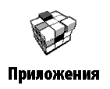

This section contains games and additional software.

Main features of the section:
- start additional programs and games.

Navigation:
- Keys: Up, Down - move by title applications;
- key "OK" - running applications,
- the key "return" - a return to the previous menu;

List of appendices:
- Calculator - a simple calculator that allows you to perform four basic arithmetic functions, calculate the percentage and square root;
- Clock - an application that eventually turns into a convenient PocketBook desktop digital clock,
- Chess - The classic game of Chess. You can play with electronic opponent or another person;
- Solitaire - Solitaire,
- Sea Battle - The Game of Battleship;
- Sudoku - a Japanese puzzle game "Sudoku";
- Snake - a game "Snake".
Music


This section of the "Main Menu" is used to listen to your favorite music in MP3.

Key features sections:
- listening to music in MP3 format, the
- choice of playing modes.

Navigation:
- press Up, Down, Right, Left "," OK "- control the music player,
- the key" return "- a return to the previous menu.

Note: the music player is the most energy-intensive device applications. When he runs in the bottom right corner of the screen icon notes.
Search



With this section, you can perform a quick search for books on your device.

Main features of the section: the
- search for books / documents on the device PocketBook Pro 903.

Navigation:
- press Up, Down, Right, Left - move on the icon letters on the keyboard,
- the key "OK" - selection of letters,
- press "Next", "Back" - a quick transition to the previous / next page,
- the key "return" - a return to the previous menu;

Search. When you log into this section appears on the screen keyboard, which you enter the name of the book or its author (see "Working with the keyboard). When finished turn on the "Search". To move the found book, use the keys "Down" and "Up", respectively. To exit the "Search", press "Menu" or "Return".

Settings



In this section you can configure the software, as well as view information about the device.

Main features of the section:
- device settings PocketBook Pro 903.

Navigation:
- press Up, Down, Right, Left - move the elements of the section;
- key "OK" - input selection;
- key "Return" - a return to the previous menu.

The main points of product
- information. The screen displays the model name, serial number, code of the hardware platform, firmware, full and free internal memory and microSD-memory card.
- Language /Language. Changing the language interface PocketBook Pro 903.
- Keyboard. Changing the layout keyboard. Changes take effect after you exit the section "Settings."
- Appearance. Contains the following:
- Subject. Changing the topic of software;
- Note: New themes can be downloaded from the website: http://www.pocketbook-int.com.
Font interface. At the bottom of the screen, a dialog box appears with a list of available fonts and preview the selected font. Select the font and exit the"Settings"to change to take effect.
- Kind of a bookshelf. Changing the look of the bookshelf. The
- orientation of the screen. Choice Auto, portrait, landscape 90 °, 270 ° landscape or portrait orientation of the screen 180 °.
- Saver at startup. Selecting wallpaper that will appear on the screen while powering the device.
- saver when turned off. The choice of screen saver, which will appear on the screen during the shutdown device.
- The text display. Select the desired display text (without smoothing, with smoothing or saturated).
- Shortcuts. To change modes, press the keystroke string with the correct key and then set the action from the popup list.
  - For the "short press the On / Off", you can assign the following actions:
- Locking the keypad;
- main menu,
- exit,
- open last book;
- Screenshot ;
- profile;
- Open player;
- Off.
  - For the other buttons and modes are available such action:
- Quick Menu,
Jump:
  - Back,
  - Forward,
  - Prev. Page,
  - et seq. Page;
  - -10 pages
  - 10 pages;
  - page ...;
  - Home;
  - End;
  - Prev. Section it should
  - andbe.Section;
- Bookmarks:
  - Show bookmarks
  - Set bookmark;
- Notes:
  - Take notes,
  - save the page;
  - Open Notebook;
- Links:
  - mode options;
  - Back on the link, the
- content,
- Search,
- Dictionary
- of the book,
- type:
  - Enlarge the font,
  - font Reduce,
  - Rotate,
  - Mode view PDF;
- Hide panel;
MP3 Player:
  - Open player;
  - Pause / Play,
- Volume +,
- Volume -,
- System:
  - Main Menu,
  - Exit,
- Date /Time. In this section you can configure the following elements:
- Set current time and date;
- update mode clock :
- when paging,
- while navigating through (without shading);
- constantly, do
- not display a clock.
- Keypad Lock:
- off;
- block after 5 minutes;
- block in 10 minutes.
- Mode switch off the device:
- turn off,
- turn off the device via 10/20/30/60 minutes .
- When you turn toopen. At this point, you can choose which item appears when you turn on the device: the
- main menu, the
- latter an open book.
- Communication. You can adjust the settings for the device. This item consists of the following elements: the
- device name,
- access mode network
- connection is preferred;
Wireless connection Bluetooth;
- Wireless WI-FI
- Wireless 3G;
- Connecting via USB port
- connection to PC,
- charging;
- ask on connection.
- Mode USB-host
- Off;
- included.
- Reading out thetext. Settings voiceover text. You can:
- Choose a language and voice,
- choose the speed of sound Text:
- slow,
- normal,
- fast,
- Choose scoring tone of the text:
- 50%
- 75%
- 100%
- 125%,
- 150%.
- Service. You can:
- format internal memory,
- clean condition,
- calibrate the touch panel;
- gyroscopic sensor to calibrate,
remove authorization ADE.
REPLENISHMENT OF LIBRARIES AND READING OF ELECTRONIC BOOKS

The device allows reading books in formats FB2, FB2.zip, TXT, PDF, RTF, HTML, PRC, CHM, DJVU, DOC, EPUB, TCR.

Preliminary steps.
- Download a book in memory PocketBook Pro 903:
- With the help of a computer. Connect your device to your computer using microUSB-cable. The internal device memory and MicroSD-card appear in Windows Explorer as the two new drives. Using Windows Explorer or other programs, copy books into the desired folder in the device memory or on SD-card.
- With e-library «Bookland». Go to "Library" tab in the «Bookland». Be sure to connect to the Internet via available networks Wi-Fi, Bluetooth or 3G. In the window that appears you need to register and then you can download free and paid books, which will automatically fall into your library.

- Open the book in the "Reading."
To open a book, go to the Library and using the "Up, Down, Left, Right" and "OK", select the desired book. If it is one of the last open book, it can be accessed from the main menu. If you have already read the book, it opens to the page on which it was closed for the last time.

At the bottom of the screen shows the number of open pages, the total number of pages, current time and battery power. After the discovery of some formats are counting the number of pages. Before the end of the conversion to the bottom of the screen instead of the current page number and number of pages you will see the sign "...", and some functions will be temporarily unavailable.
LISTENING TO MUSIC

To listen to music on the device, follow these steps.
- Download the audio files in MP3 format:
- Connect the device to the computer with microUSB-cable.
- Immediately after the connection Select the type of connection - "Charging the Battery" or "Mobile PC". Select the "Mobile PC"
- internal memory and Memory card MicroSD (if available) will appear in Windows Explorer as a new drive. Copy files to Music folder.
- Open the "Music" in the Main Menu.
- Select the song you want to listen first, and then press "OK".
- Select the playback mode:
- one song,
- all songs in the queue,
all the songs in random order.
SETTINGS Connection to Internet

To connect to the Internet, follow these steps:
- In the Main Menu go to "Settings", click "Communication";

- Specify the name of thedevice:
- press the "OK" on the appropriate line,
- appear on-screen keyboard,
- enter the name that will be used to connect PocketBook Pro 903 with other
- devices,press the "OK" to save the changes and "Cancel" tominimize the on-screen keyboard.

- Set the mode of access to thenetwork.Click "OK" button on the bar, and select one of the following modes:
- off,
- on;
- request permission.

- Select your preferred compound. A pop-up list will list all available connections. Select the desired.
Setting up a wireless connection via Bluetooth:
  - Press the "OK" on the item «Bluetooth» and select the connection you want to configure. By default unconfigured soedineniya called <Connecting № ...>.
  - Click "Connection Name", will appear on-screen keyboard, enter the name that will be used to connect PocketBook Pro 903 with Bluetooth.
  - Specify the type of connection - an external modem (to enter the four PIN-code to connect via Bluetooth);
  - Set the access point, enter the name,
- enter your user name,
- enter a password,
- click Open the "Disconnect if not active (minutes) and select from the drop-down list one of:
- 5,
- 10,
- 20, 30,

- 60.
- Set proxy server. To do so, click "Proxy Settings" and using the onscreen keyboard, set the connection settings:
- Proxy Server,
- Proxy Port,
- Proxy username,
- password proxy.
Be sure to install the connection. To do this, click Test connection. A message "Establishing connection". If the connection fails you will be able to see the event log.
Configuring wireless WI-FI
- Open the list of wireless connections and select the appropriate. By default unconfigured soedineniya called <wirelessly № ...>.
- Click "Connection Name", will appear on-screen keyboard, enter the name that will be used to connect PocketBook Pro 903 with Wi-Fi. Then press the "OK" to save changes and press "Cancel" to minimize on-screen keyboard.
- Enter the network name (SSID) is similar to part b.
- Specify the type of protection, selecting from the drop-down list one of the
- values: none;
- simple (
- WEP);
- WPA-Enterprise;WPA-PSK.
- Open the item "Network Preferences, click" OK "button on the item" Configure IP-address ", and from the popup menu:
- DHCP;
- manually.
- Configure a proxy server. To do so, click "Proxy Settings", and using the onscreen keyboard, set all proxy connections:
- proxy server,
- Proxy Port,
- Proxy username,
- password proxy.
In conclusion, check the connection setting. To do this, click Test connection. A message "Establishing connection". If the connection fails you will be able to see the event log.
Configuring Wireless 3G

- Click "OK" button to select "Wireless 3G» and select the connection you want to configure. By default unconfigured compound called <Connecting № ...>.
- Click on "Connection Name", will appear on-screen keyboard, enter the name that will be used to connect PocketBook Pro 603 with 3G.
- Specify the type of connection;
- Set the access point, enter the name,
- enter the name user
- Enter password
- Set up a proxy server. To do so, click "Configure Proxy" and using the onscreen keyboard, set the connection parameters.
Be sure to install the connection. To do this, click Test connection. A message "Establishing connection". If the connection fails you will be able to see the event log.
Work with the keyboard

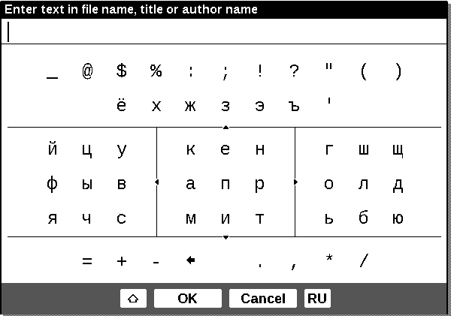

To work with the keyboard using keys Up, Down, Left, Right and press «OK». To speed up the keyboard all the characters are divided into 5 zones. The first press performs a rapid transition in the middle of the zone selected, you can then select the desired character of the area. To switch the keyboard into Russian, Ukrainian and English languages, use the keys "RUS", "RBM" and «ENG», located on the bottom panel, or key language switch, located on the bottom right.
Long press the "left" is deleting the last entered symbol, the "up" - to delete all entered text.
shortcuts

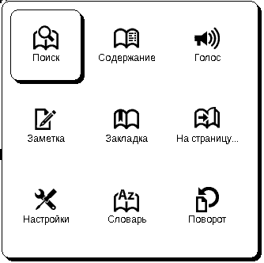

Shortcut menu invoked by clicking and holding down the "OK" in a book reading mode. You will see the following items:

Search


Allows you to quickly find a word in the book or its parts. After selecting the item from the shortcut menu appears on the screen keyboard, which you can enter the word (see "Working with the keyboard). After you enter the right word to select "Search", and in the lower right corner of the screen icon with a magnifying glass.
To move to found words backward or forward, use the "left" and "Right", respectively. Found words will be highlighted. To exit the "Search", press the «OK». Search mode is not available for books in a format DJVU.

Contents

Go to the contents of the book. This feature is available to book in FB2, PDF, CHM, and only if the book is structured content.

Voice
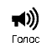
This menu item launches the Quick Access feature TTS (Text To Speech), so you can listen to the text. That part of the text, which reads speaker, will be highlighted.
To change the volume, stop / resume play or disable this feature, press and hold "OK" in the listening mode of the text.
To return to the main menu, press "Menu", or sequentially, press "Return".

Note: To change the "Language / Voice", "Speed of speech" and "The tone of sound Text, go to Settings» → «Reading out the text and set the necessary parameters.

Notes

Sometimes it is useful to keep the selection of the book in a separate notebook.
To create a new record in read-only mode, do the following:
- Click the menu item shortcuts "Notes."
- At the top of the screen bar appears to separate text. Press the "Up" and "Down, go to the top notes, and then click" OK"to assign an upper bound.
- Similarly mark the end of the note.
- Select a notebook to save the new note. A menu appears select: add a note to the existing notebook, or create a new one.
- If you create a new notebook, the screen displays a keyboard. Enter a name for your new notebook / notes.
See notes can be made from the "Main Menu" (under "Notes"). Pressing the "OK" to view notes moves to a place in the book where it was made. In addition, notes can be viewed in the content of the book.

Bookmarks

In each book, you can create up to 30 bookmarks. Select "Bookmarks" from the shortcut menu. In the upper right corner of the page will appear the sign of a bookmark.
View and delete bookmarks you can from the contents of the book, which displays the actual content, bookmarks and notes.
Page

This menu shortcut opens a window for selecting pages. Enter the number of the desired page and click "OK". You can quickly jump to the first or last page of the book using the "Forward" or "Back."

Settings

For books in the format of FB2, TXT, RTF, HTML, PRC, and CHM, and PDF mode «Reflow» You can find the most comfortable settings for reading - the kind and size of font, line spacing, page margins, as well as the file encoding for the books TXT format and HTML.

Dictionary

This feature allows you to translate the selected word while reading. Keys Up, Down, Right, Left "are used to select words on the page," OK "to switch between text window and the window dictionary.
Furthermore, to translate the words you can use the virtual keyboard. The device pre-installed English-Russian dictionary N. Queen. Additional dictionaries are available at: http://www.pocketbook-int.com.Moreover, a converter is available, which will create a custom dictionary from a variety of free dictionaries available on the Internet.

Rotation of the book

This menu item shortcuts will set a convenient orientation of the screen. Rotation takes place in accordance with the selected icon. Selections are made by pressing the Up, Right, Down, Left. " "OK" includes automatic detection of image orientation.

Scale
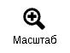
In the books of the PDF and DJVU You can zoom the page in the shortcut menu.
Press the "Right", "Left" to select the desired display mode, the "up", "Down" set the scale.
The following modes:
- "4 pages" "9 pages" - a preview mode, multiple pages per sheet,
- "normal" - one page on the screen with the ability to scale,
- "columns" - designed for reading books with columns on a page. To move a page in the "Columns" Use Up, Down, when the lower edge of the sheet will move to the next column,
- "Layout» (Reflow) increases the readability of large format documents. In this mode, the text is formatted to the width of the device's screen. You can change the font size of the keys Up, Down. In the "arrangement" can not display tables and some pictures.
Active content

Active content includes sections of the book, made while reading the book bookmarks and notes (in the content they are in the wrong section, where they were created).
Use the "Up", "Down the transition between the points of the active content. Use the "Left", "Right" takes you to the previous / next page of active content. When you press "Menu" on the point of active content menu appears with functions:
- removal;
- open,
- rename,
- edit text,
- delete,
- configure,
- deploy para.
In the active content by default, all items (sections) are collapsed (next to them is a sign «+»). To expand / collapse item, press and hold "OK" or "Menu" and on the shortcut menu, click:
- launch point;
- collapse point.

The transition to structured content (FB2, PDF, CHM)
To go to the contents of the book, then click the"Contents" from the shortcut menu.

Note: this feature is supported only for books in formats FB2, PDF, CHM with structured content.
POTENTIAL PROBLEMS AND THEIR ELIMINATION

Problem: Unit does not turn a device include, but are only upload SPLASH
Possible cause: The battery is discharged.
Solution: Recharge the battery.

Problem: BOOK DO NOT OPEN - the message "possible that your book is damaged or PROTECTED" or just nothing happens.
Possible cause: The book file is corrupted.
Solution: If your book is uploaded to the website, boot it up again. If the file is opened on a PC, but does not open on the device, save the workbook in a different format.

Problem: book in HTML opens, but not display correctly.
For example, displays blank pages, some text is missing, etc.
Possible cause: HTML-files contain non-textual elements (frames, JAVA-script, flash elements).
Remedy: save Page format TXT.

Problem: The book opens, but instead RUSSIAN LETTERS The screen displays the different symbols, question mark and TP
Possible cause: incorrect encoding of the document.
Remedy: a book reading mode, choose "Settings" and change the encoding of the document.

Problem: The device does not respond to keystrokes.
Possible cause: in some cases (for example, when downloading the damaged or too bulky books) may "freeze" the device.
Correction: forcibly close the Hanging application by holding down the "Back" 1-2 seconds. If that fails, follow the forced reset the device by pressing the "Reset" on the rear panel.

PROBLEM: When connecting to a computer in Windows Explorer WINDOWS DOES NOT APPEAR storage device.
Possible cause: The device is in battery life.
Remedy:Check the USB mode under "Settings" main menu.
Set the "Mobile PC" or "Ask for connected.
"possiblecause: no signal on the line cord.
Remedy: Check for damage USB-cable, and securely it is inserted into the slots. Try to switch the USB-cable to another computer connector.

PROBLEM: NOT CURRENTLY FILLING, Settings, the current file position.
Possible cause: corrupted file system.
Remedy: Connect the device to your PC, then run disk scanning device. To do this, open My Computer, right click on the selected drive, click, select Properties - Tools - Check Disk.
"Probablecause: Internal memory is full.
Remedy: Remove unneeded books, images and / or music.

PROBLEM: FAST discharge the battery.
Possible cause: auto shutdown is inactive.
Solution: From the main menu, open the section "Setting - Time." For the item "Disable the device by, choose the automatic shutdown (10, 20, 30 or 60 minutes).
Possible cause: running in the background music player. It is the most energy-intensive application device. On its activity can be found on the notes icon in the lower right corner.
Solution: Turn off music player.
SERVICE CENTER

Detailed information regarding the service can be found on the official site PocketBookInternational.

Website URL: http://www.pocketbook-int.com/support/.

UPDATE SOFTWARE

To update the software, follow these steps:
- On the official website www.pocketbook-int.com open the section "Products";
- Select PocketBook Pro 903;
- click on "Software andDocumentation,"which is on the right side of the screen,
- the list " firmware, select the latest version of software for PocketBook Pro 903 and download it (for this you need to click the right mouse button on selected file ⇨ «Save Target As ...» ⇨ choose where to save the file ⇨ «Save"),
"On the same page can be found with new additions for your device, install new games, dictionaries, find the user manual.
- "Copythe firmware file«SWUPDATE.BIN »thecard MicroSD (available optionally);
- Remove the computer MicroSD-card with the firmware and insert it into PocketBook Pro 903;
- Restart PocketBook Pro 903 with an inserted MicroSD-card by clicking the "Reset" button at the bottom end device
- in the boot device, press and hold the "Back" and "Next" until the message «Firmware update...»;
- Follow the instructions on-screen device;
- After all the settings, wait for the device is reset,
the firmware version you can check under Settings »⇨« Information about the device.
"MEETSINTERNATIONAL STANDARDS

01. The test equipment must be connected via USB-port to the appropriate source of limited power of a personal computer or laptop.
02. The test equipment must be connected via an adapter limited power source.
AC Power
Producer
FLEET
Model
FCC050100U
Nominal output voltage of
5 VDC. current 1 A

The equipment is marked 0984 and allowed to operate in EU countries.

This marking indicates that the equipment complies with the EU Directive on radio communications and telecommunications terminal equipment 1999/5/EC, as well as the relevant sections of the following technical standards:

EN 300 328 - Electromagnetic compatibility and radio spectrum, broadband transmission systems, data transmission equipment in the range of 2.4 GHz ISM band technology with a distributed spectrum modulation; basic requirements of the European Committee for Electrotechnical Standardization, Art. 3.2 Directive on radio communications and telecommunications terminal equipment.

EN 301 489-17 - Electromagnetic compatibility and radio spectrum, EMC standard for radio equipment and services; Part 17. Specific conditions for wideband transmission systems and high-performance equipment for mobile local area networks of high power HIPERLAN.
EN 60950 - Information technology equipment. Security.
EN 62311: 2008 - Evaluation of electronic and electrical equipment for restrictions on human exposure to electromagnetic fields (0 Hz - 300 GHz).
The label indicates the imposition of restrictions of use.
France: 2,4 GHz (metropolitan France):

In metropolitan France, the following frequency of public or private wireless networks:

Indoor: max. power (equivalent isotropic radiated power *) 100 mW in the range 2400-2483,5 MHz.

Outdoors: Max. power (equivalent isotropic radiated power *) 100 mW for the 2400-2454 MHz and max. power (equivalent isotropic radiated power *) 10 mW for the range of 2454-2483 MHz.

"Contains Reader ® Mobile technology by Adobe Systems Incorporated"

