Zelda's gallery of used and unused avatars

4-29-2009, 12:27 PM
Wetdogeared
Wizard


Posts: 1,886
Karma: 12787
Join Date: Nov 2008
Location: Vancouver, BC
Device: PRS500/700...
System: Vista Ⓦ Firefox
Although the fun is reading all the posts in "Avatar for zelda_pinwheel", here are the images of avatars, excluding text.
Current Attire:
zelda_pinwheel

Also look in Zelda's closet in her What to wear today, what to wear... photo album.
Part I (Click on date to see original post, where you can read any text and possibly enlarge the image.)
NatCh 04-21-2008

vivaldirules 04-21-2008
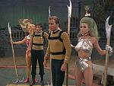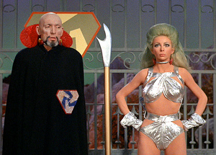
RWood 04-21-2008
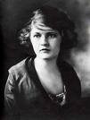
Nate the great 04-21-2008

nrapallo 04-21-2008
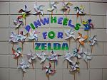
montsnmags 04-21-2008

vivaldirules 04-22-2008

vivaldirules 04-22-2008
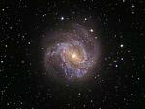
vivaldirules 04-22-2008
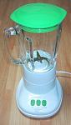
vivaldirules 04-22-2008

nrapallo 04-22-2008

nekokami 04-22-2008

vivaldirules 04-22-2008
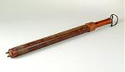
vivaldirules 04-23-2008
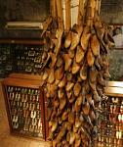
vivaldirules 04-24-2008

Taylor514ce 04-28-2008

Taylor514ce 04-28-2008

montsnmags 05-07-2008 Several links for Cthulhu
http://www.brandfurysf.com/store/ima...hu_victims.jpg
http://sunfox.org/blog/wp-content/up...lo-cthulhu.png
http://call-of-cthulhu.com/Images/ct..._a_new_man.jpg
http://www.dagonindustries.com/image...hufish-adh.jpg
http://www.xradiograph.com/blog/imago/cthulhu.mary.jpg
http://www.badastronomy.com/pix/babl...ulhu_kitty.jpg
http://friendlyatheist.com/wp-conten...hulhu-2008.gif
vivaldirules 05-07-2008

nekokami 05-15-2008
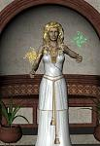
slayda 06-02-2008 Credit to BadGoodDeb

pshrynk 06-09-2008
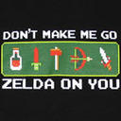
pshrynk 06-09-2008
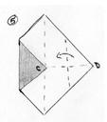
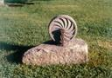
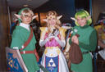
vivaldirules 06-16-2008
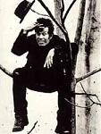
Mindy 06-20-2008

vivaldirules 07-06-2008

Madam Broshkina 07-06-2008 by Andy Warhol
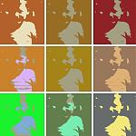

Part II (Click on date to see original post, where you can read any text and possibly enlarge the image.)
montsnmags 07-06-2008 by Jackson Pollock
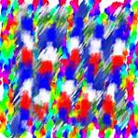
Madam Broshkina 07-06-2008 by Kandinsky

montsnmags 07-06-2008 by Aaron Siskind
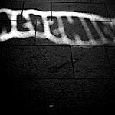
Madam Broshkina 07-06-2008 by Alexander Calder

montsnmags 07-06-2008 by Richard Bach

Madam Broshkina 07-06-2008 by The Beatles
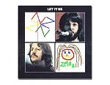
Madam Broshkina 07-06-2008 by Led Zeppelin
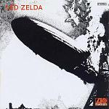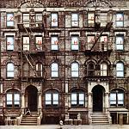
montsnmags 07-07-2008 by KISS

Madam Broshkina 07-07-2008 by Pink Floyd

montsnmags 07-07-2008 by The Beatles
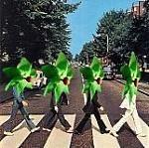
montsnmags 07-07-2008 by Nirvana

tINmOUSE 07-07-2008

Madam Broshkina 07-07-2008 by Scrabble
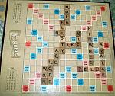
Madam Broshkina 07-07-2008 by Albert Einstein

Madam Broshkina 07-07-2008 by Zombies
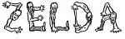
Madam Broshkina 07-07-2008 as subsistence
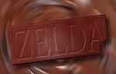
tINmOUSE 07-09-2008
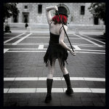
Madam Broshkina 07-10-2008
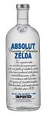
Madam Broshkina 07-10-2008
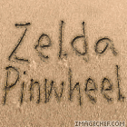
Madam Broshkina 07-10-2008 by Bart Simpson
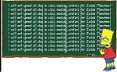
Madam Broshkina 07-13-2008 by Magritte

Madam Broshkina 07-14-2008 by Grant Wood

vivaldirules 07-14-2008 Paul Klee
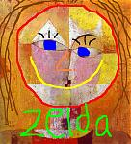
vivaldirules 07-14-2008 by Mark Rothko
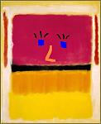
vivaldirules 07-14-2008 Zelda de Milo by Alexandros of Antioch.
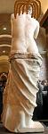
Donnageddon 07-21-2008
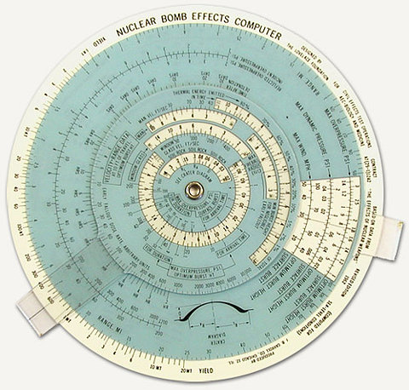
pshrynk 07-22-2008
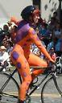
nekokami 07-29-2008
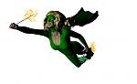

Part III (Click on date to see original post, where you can read any text and possibly enlarge the image.)
badgoodDeb 07-29-2008
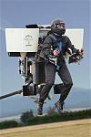
pshrynk 08-04-2008
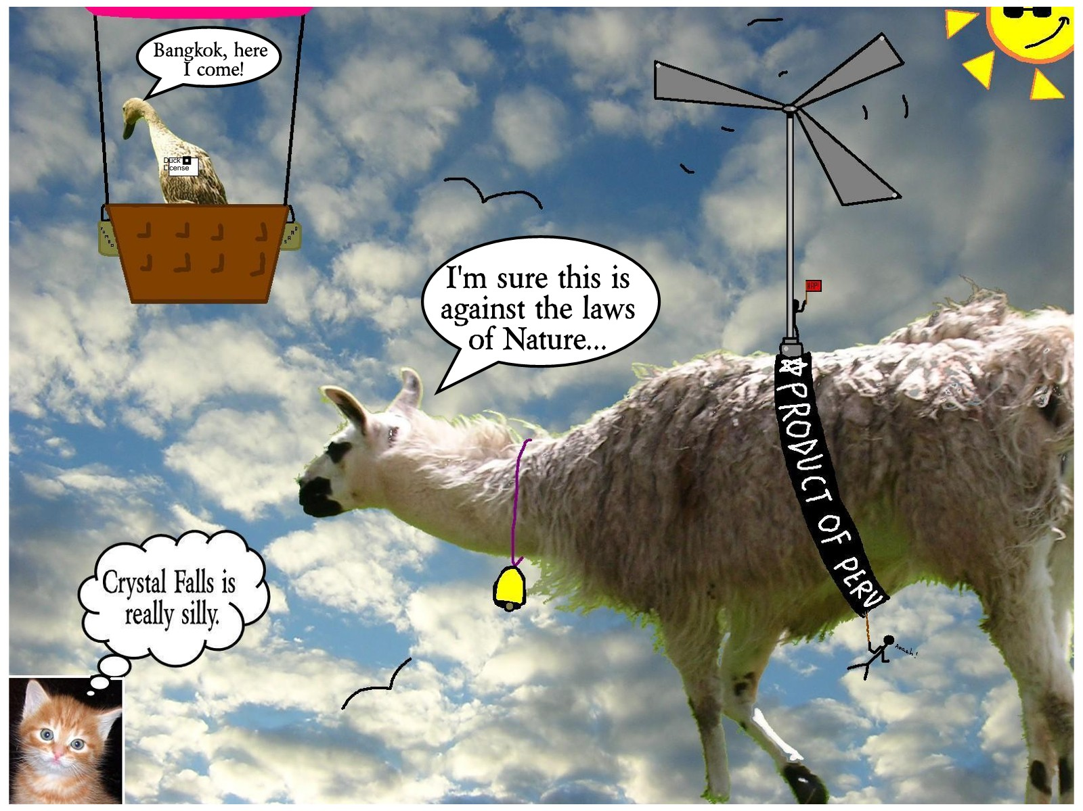
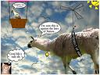
vivaldirules 08-04-2008 by Degas

Taylor514ce 08-05-2008
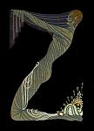
Madam Broshkina 08-10-2008

Madam Broshkina 08-10-2008

Madam Broshkina 08-10-2008

Madam Broshkina 08-11-2008

Madam Broshkina 08-19-2008
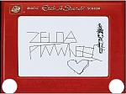
Madam Broshkina 08-20-2008

Madam Broshkina 08-25-2008
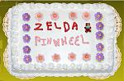
vivaldirules 08-26-2008
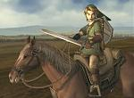
Madam Broshkina 08-26-2008
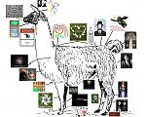
Madam Broshkina 08-28-2008
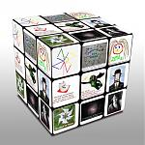
pshrynk 08-29-2008


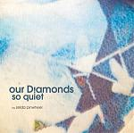

Madam Broshkina 08-30-2008
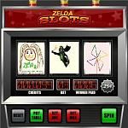
montsnmags 09-04-2008
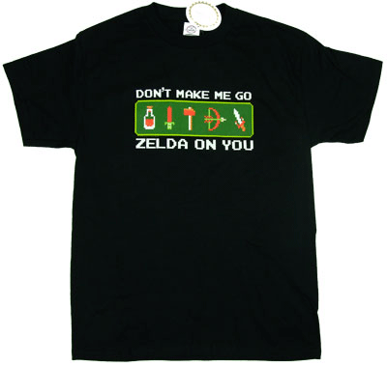
pshrynk 09-09-2008
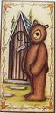
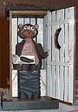
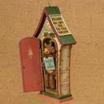
vivaldirules 09-17-2008 by Edwin Austin Abbey

vivaldirules 09-28-2008 by dadaist Man Ray
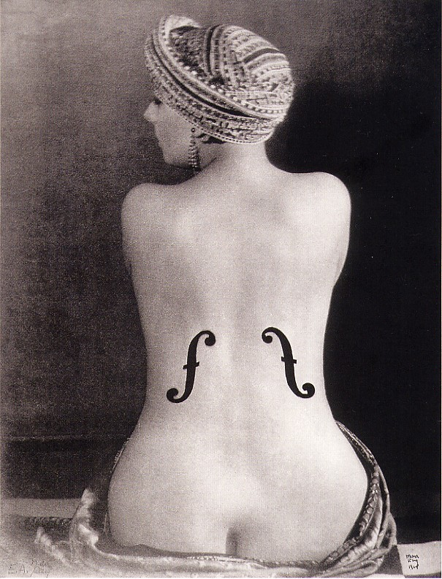
Mindy 10-08-2008

Madam Broshkina 10-17-2008

Madam Broshkina 10-31-2008

Madam Broshkina 11-18-2008
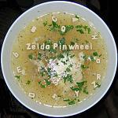

Part IV (Click on date to see original post, where you can read any text and possibly enlarge the image.)
Madam Broshkina 11-18-2008

Madam Broshkina 11-18-2008
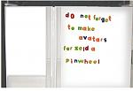
vivaldirules 11-21-2008
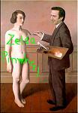
Ralph Sir Edward 11-21-2008
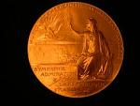
RWood 11-21-2008

Madam Broshkina 11-21-2008

Madam Broshkina 11-25-2008 by Coldplay

Madam Broshkina 11-28-2008

Madam Broshkina 12-06-2008

Madam Broshkina 12-08-2008
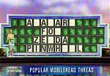
Madam Broshkina 12-15-2008

Madam Broshkina 12-17-2008
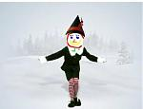
Madam Broshkina 12-19-2008

Madam Broshkina 12-23-2008
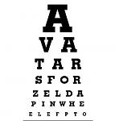
Madam Broshkina 12-23-2008

vivaldirules 12-29-2008
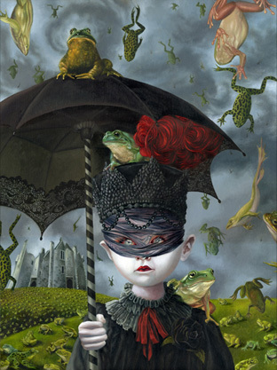
lilac_jive 12-29-2008

ravenne 12-29-2008

Madam Broshkina 12-29-2008
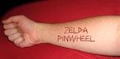
vivaldirules 12-29-2008
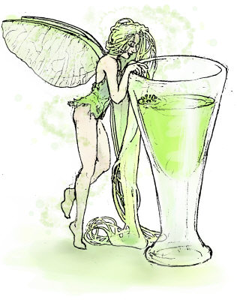
Madam Broshkina 01-08-2009

vivaldirules 01-09-2009
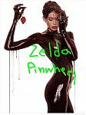
Madam Broshkina 01-12-2009
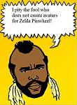
pshrynk 01-30-2009

Madam Broshkina 02-02-2009
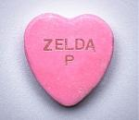
Madam Broshkina 02-19-2009
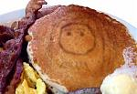
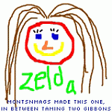
vivaldirules 03-19-2009
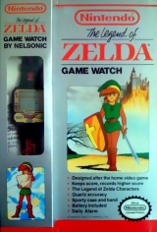

Part V (Click on date to see original post, where you can read any text and possibly enlarge the image.)
pshrynk 03-19-2009

pshrynk 03-19-2009

pshrynk 03-19-2009

pshrynk 03-19-2009

pshrynk 03-19-2009
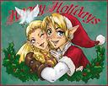
pshrynk 03-19-2009
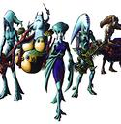
pshrynk 03-19-2009

pshrynk 03-19-2009
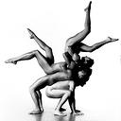
pshrynk 03-19-2009

pshrynk 03-19-2009
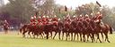
pshrynk 03-19-2009

pshrynk 03-19-2009
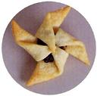
pshrynk 03-19-2009

pshrynk 03-19-2009
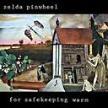
pshrynk 03-19-200

Madam Broshkina 03-19-2009
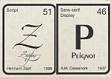
Madam Broshkina 03-19-2009

vivaldirules 03-21-2009

vivaldirules 03-21-2009
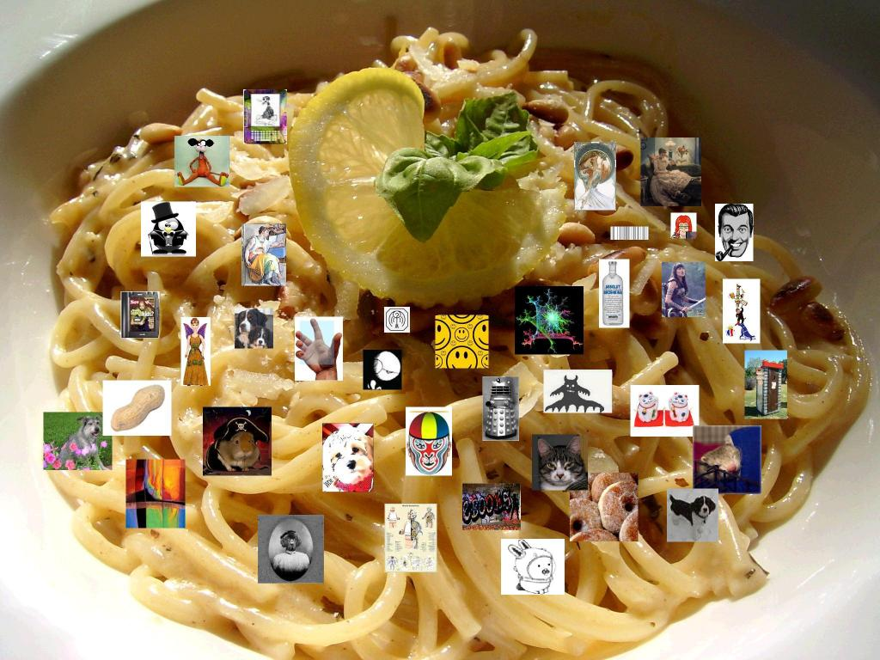
Madam Broshkina 03-24-2009

Wetdogeared 04-06-2009

vivaldirules 04-18-2009

GeoffC 04-28-2009
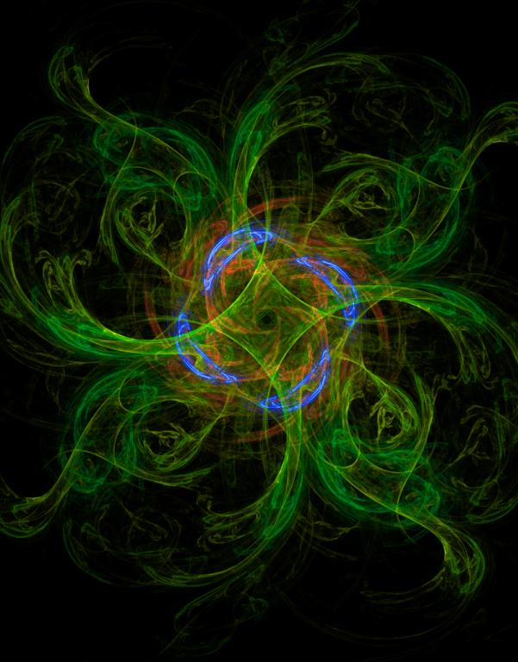
More to come as more are created.... (as of 04-29-2009)
Now go and read the original thread Avatar for zelda_pinwheel!
Extra: http://www.mobileread.com/forums/showthread.php?p=429517#post429517 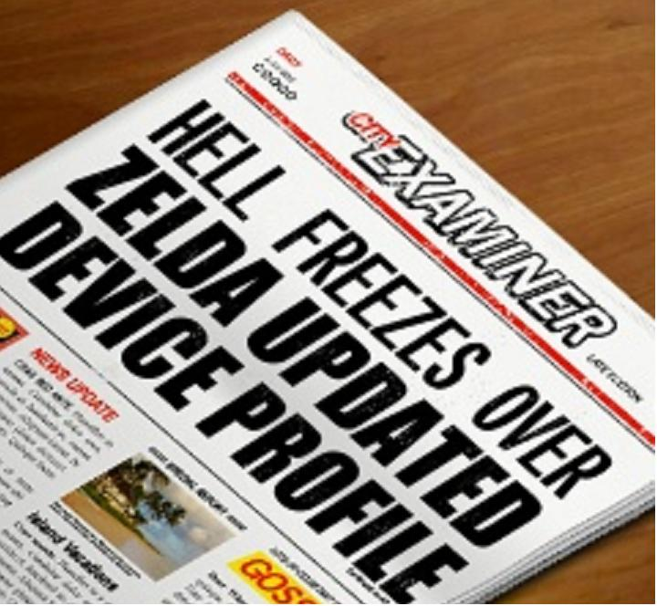
__________________
SЦPPФЯT ДVДTДЯS FФЯ ZЗLDД

;)

