Industry Statistics
US Trade Wholesale Electronic Book Sales
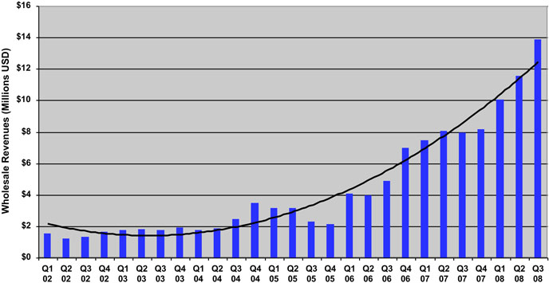
Quarters 2002 through Q3 2008
Quarters | Revenues | Quarters | Revenues
Q1 02 | $1,556,499 | Q3 05 | $2,310,291
Q2 02 | $1,258,989 | Q4 05 | $2,175,131
Q3 02 | $1,329,548 | Q1 06 | $4,100,000
Q4 02 | $1,649,144 | Q2 06 | $4,000,000
Q1 03 | $1,794,544 | Q3 06 | $4,900,000
Q2 03 | $1,842,502 | Q4 06 | $7,000,000
Q3 03 | $1,789,455 | Q1 07 | $7,500,000
Q4 03 | $1,917,384 | Q2 07 | $8,100,000
Q1 04 | $1,794,130 | Q3 07 | $8,000,000
Q2 04 | $1,887,900 | Q4 07 | $8,200,000
Q3 04 | $2,460,343 | Q1 08 | $10,100,000
Q4 04 | $3,477,130 | Q2 08 | $11,600,000
Q1 05 | $3,161,049 | Q3 08 | $13,900,000
Q2 05 | $3,182,499 | Q4 08 (Oct, Nov) | $10,300,000
Important Notes About Collection & The Above Graph
  - AAP Stats 108.3% Nov Year to Year and 63.8% Calendar Year to Date(what they really tell us...trend only and do not reflect the size of the market)
  - Information is supplied from the Association of American Publishers and only US Publisher numbers are supplied.
  - Dollar values cited are wholesale Trade figures, meaning approximately 50% discount has been applied (Retail numbers are approximately double the $ dollars listed)
  - Only 13 US Trade publishers are supplying eBook data at this time and do not even include all the large Trade Publishers in the US. Publishers supplying data list include large and small trade publishers. Many of the large Trade houses are represented, but some large Trade houses do not currently supply eBook sales statistics to the American Association of Publishers.
  - Collectively the 13 Trade Publishers have amassed approximately $45,900,000 wholesale (approx $91,800,000 retail) in the first eleven months of 2008.
  - Library Sales and Higher Education electronic sales figures are not supplied, but are generally agreed to be at least 2 times larger then the Trade Market at this time.
  - Each of the quarters listed on the chart is listing the wholesale trade revenues for those 13 Trade Publishers for the individual quarter.
  - Calendar Year to Date only indicates 64% growth, yet several large trade publishers and distributors have announced increase in the area of 400%

