 | LibraryThing Match User Guide

Quick summary
LibraryThing™ Match is a calibre plug-in for comparing your calibre e-book list with your LibraryThing™ library.

Full summary
LibraryThing™ (LT) is a social cataloging web application for storing and sharing book catalogs and various types of book metadata. It is used by authors, individuals, libraries, and publishers.
LibraryThing Match (LTMatch) is a calibre plug-in for comparing your calibre e-book list with your LT library. It can be used to track which e-books exist in both, and easily identify books missing from either.

Usage
LTMatch uses the currently displayed calibre e-book list to perform its matching. This list could be a virtual library or a saved search. LTMatch also uses the same sort order as the calibre list.
Usage of LTMatch is slightly different for first-time use and ongoing maintenance. The below are suggestions only.

First-time use
For first time use, the calibre list should be sorted by Author then Title, and LTMatch should be configured to return all LT books in the same order. This encourages calibre e-books and LT books to be in roughly the same location in their respective lists.
A typical first time use proceeds as follows:
Once the calibre list is set up in your preferred fashion, click the LTMatch icon in the toolbar (or use the keyboard shortcut Ctrl+Alt+L) to start LTMatch.
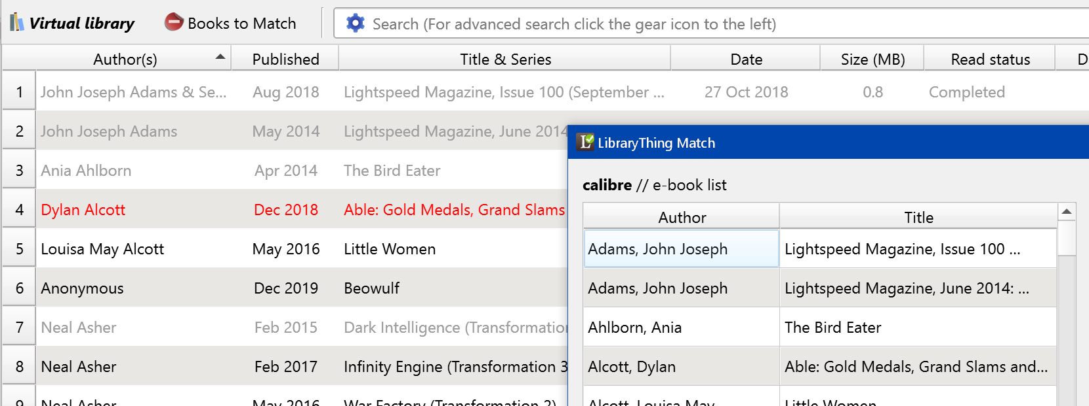
Update the LTMatch configuration if required. (See Configuration below.)
Click "Load LT Books" to load your LT books.
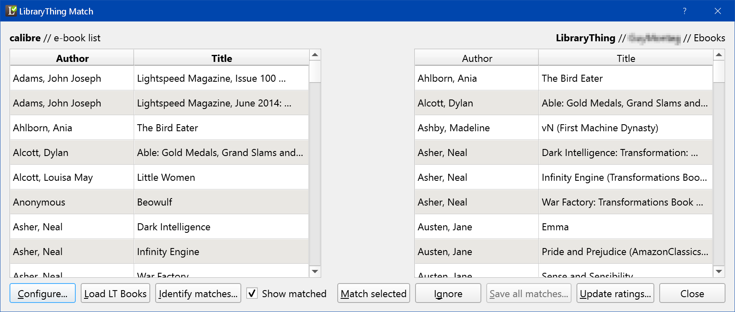
LTMatch will ensure the two lists always contain the same number of rows, so there may be blank rows on one side or the other.
Click "Identify matches..." to compare the two lists and identify possible matches between the two:
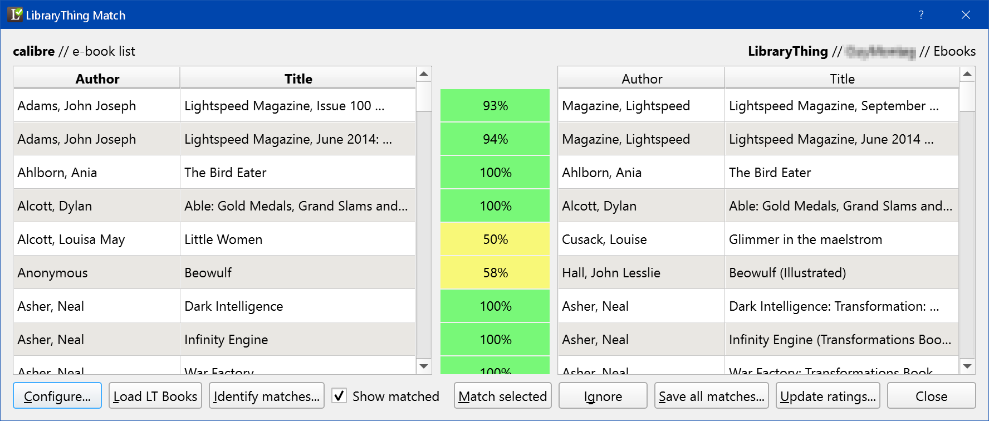
This uses a fuzzy matching algorithm from seatgeek to compare author + title on each side.
LTMatch is quite aggressive about re-sorting the LT list so that matched items are aligned. (Unmatched items are put in the first available row.) LTMatch doesn't re-sort the calibre list.
Green items have a match probability at or above your defined threshold (default 90%); yellow from 50% to the threshold, red from 10% to 50%, and blank have no match.
Once "auto-matching" is complete, review any close matches and manually match them using "Match selected". (For example, Beowulf in the above.)
You should also review any series matches, to ensure the series books are matched correctly. (See Limitations below.)
When you are satisfied with all the "green" matches, hit "Save all matches...", which will save the LT book id for high probability matches in the LibraryThing ID column:
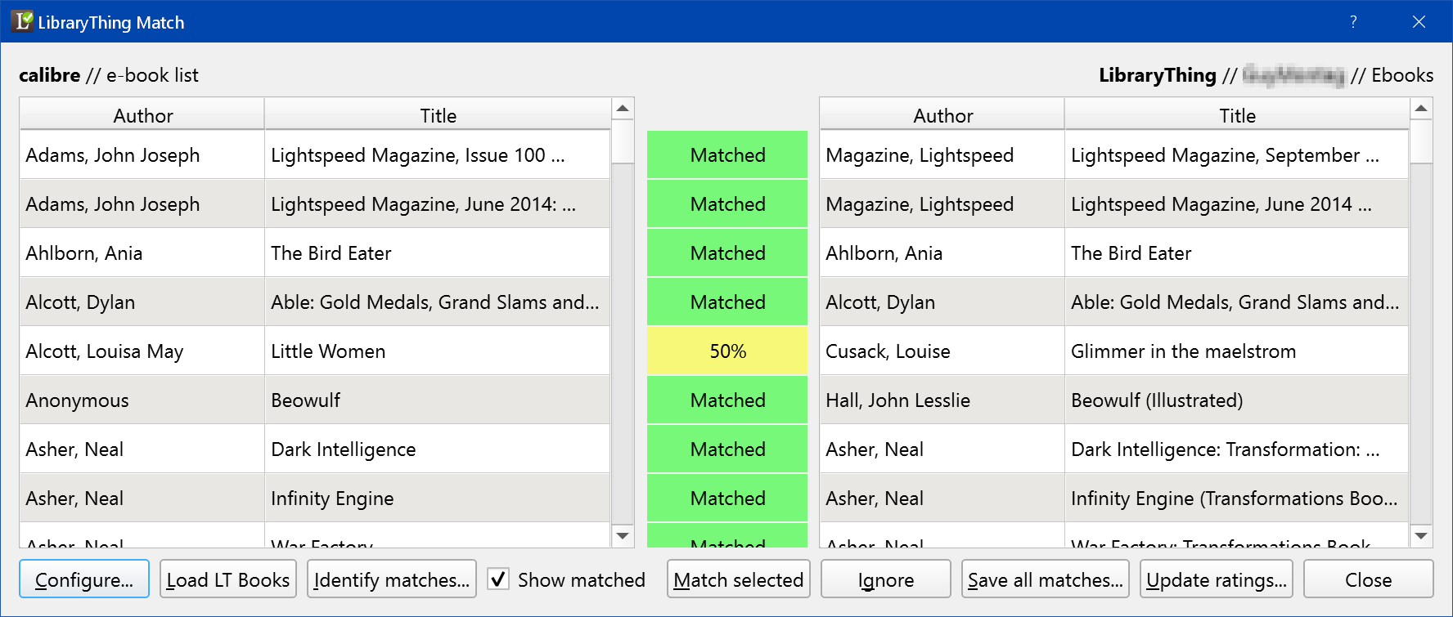
If you have enabled "Use calibre identifier" it will also copy the LT book id into a ltid identifier:

If you have created the LT Rating column, you may now "Update ratings...", which saves the LT ratings in the relevant column:
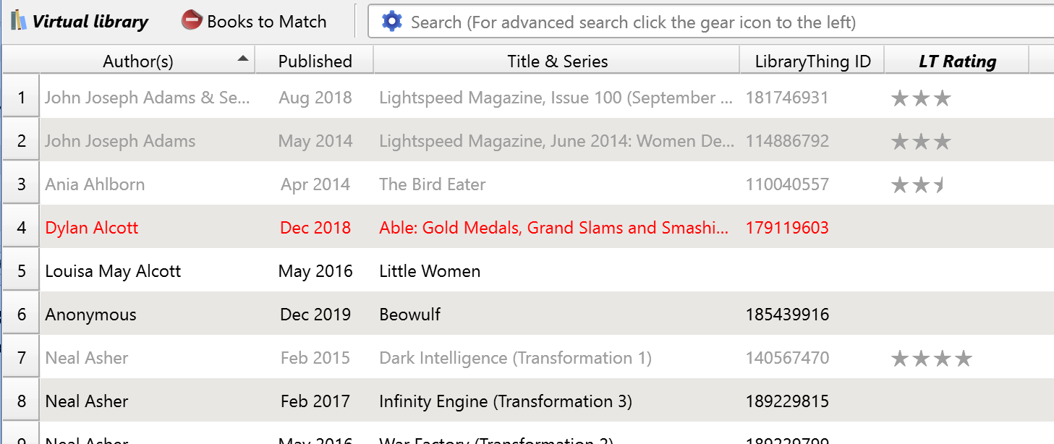

Ongoing maintenance
For ongoing maintenance, you might sort your calibre and LT lists by entry date reversed, and return only a subset of books, e.g. the most recently added 20.
You may also be using tags to manage new books in LT, and searching by tags is fast and efficient in LTMatch.
Once the two lists are set up as required, the process proceeds as above:
- Load LT books
- Identify matches
- Manual matching
- Save all matches
- Update ratings

Configuration
Initial configuration consists of:
- Creating custom columns to hold LTMatch-related information
- Specifying LT-related connection details, such as user, collection, tags
- Ensuring custom columns in "Configure" match those created in the first step
- (Optional) Create a link directly to your book on librarything.com

Creating custom columns
When creating custom columns, it is suggested to use the default names, as this will provide the smoothest "first run" experience.
The "LibraryThing ID" column holds a LT book id for ongoing tracking of books that exist in both sources. This is the core functionality ("matching") of LTMatch, so its use is highly recommended.
The column should be created as shown below, with attention to the "Column type".
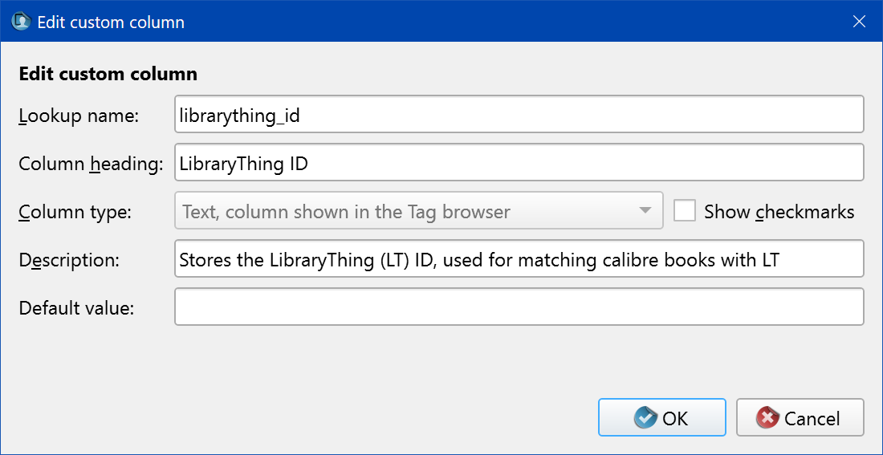

The "LibraryThing Rating" column holds your LT ratings for matching books. As LT uses a half-star rating system, you should ensure the custom column is configured to do so as well. The use of the LT rating column is entirely optional.
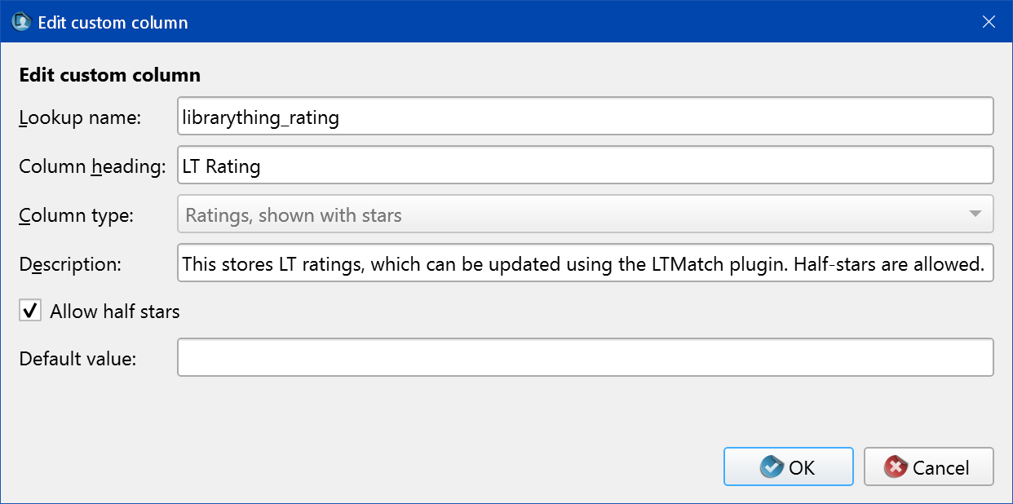

LT Connection Details
LTMatch can be configured from "Customize plugin" in Preferences - Plugins, or from the "Configure..." button in the LTMatch main screen.
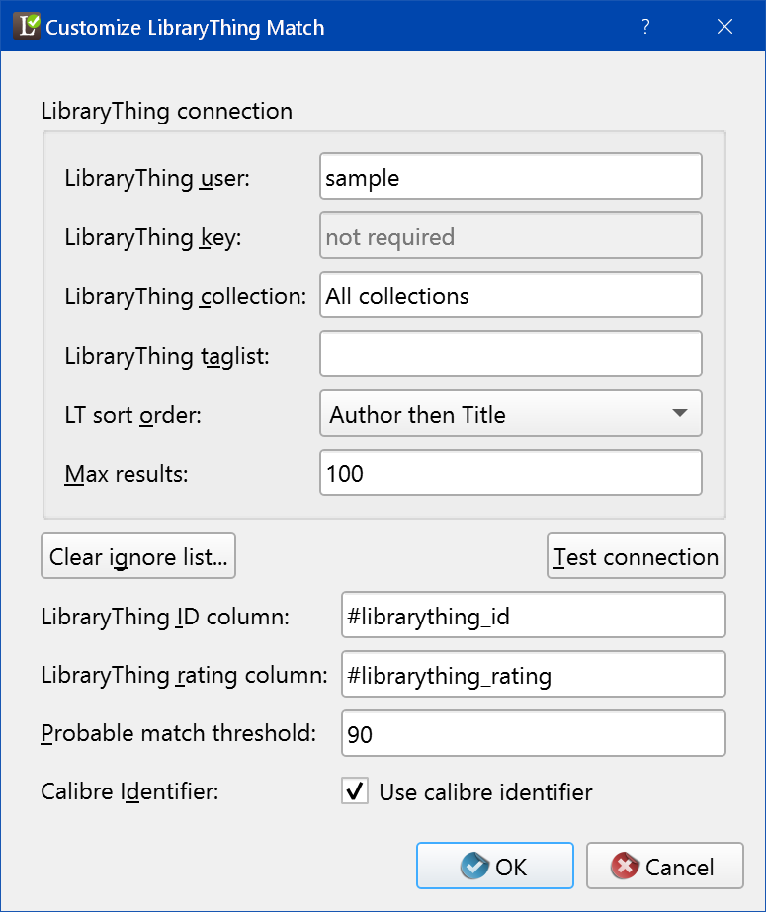
The relevant fields and buttons are:
Field/Button | Purpose
LibraryThing user | Your LT username. Not case-sensitive.
LibraryThing key | Not required.
LibraryThing collection | A LT collection with which to match, e.g. Your library or Ebooks. This field is case-sensitive and can contain spaces. Leave it blank or use All collections to return all books in your LT library.  Note: If using a specific collection, the LT API does not support searching by Collection, so all books have to be returned then filtered by LTMatch. "Max results" should therefore be large enough to encompass your entire LT library. This is a less efficient method of searching LT.
LibraryThing taglist | A comma-separated list of tags for which to search. This field is case-sensitive and can contain spaces, slashes, ampersands, etc. This is the most efficient method of searching LT, as searching is done on the LT server.
LT sort order | The sort order for books returned from LT. This should match your sort order in calibre as closely as possible.
Max results | The number of books to return from LT, respecting the LT sort order set above. (Also known as a TOP N query.)  This parameter might be used for ongoing maintenance of LTMatch, where only the most recently added 20 books are considered.  (See note with respect to "Max results" above.)
Clear ignore list... | LTMatch can permanently ignore specific LT books. This might be useful if a small number of books are not able to be excluded using the filtering above.  LTMatch stores this list in the LTMatch config file. This button will clear the list, restoring all the ignored books.
Test connection | Not surprisingly, this tests the connection to LT using the parameters specified in the above fields.

Custom columns, etc.
The final four parameters should only need a quick review before you start LTMatching:
Field | Purpose
LibraryThing ID column | This should match the name of the "LibraryThing ID" custom column you specified earlier, with a # prepended.
LibraryThing rating column | This should match the name of the "LT Rating" custom column you specified earlier, with a # prepended.
Probable match threshold | This is a percentage value to be used when automatically saving high-probability matches identified by the "Identify matches..." function. Matches with a probability greater than or equal to this amount will be saved.
Use calibre identifier | Select this check box to copy the LibraryThing ID to the calibre identifiers when saving matches. This will aid in downloading metadata from LT using the LibraryThing Metadata plugin*.  The "LibraryThing ID" custom column remains the definitive indication of a match.  * coming soon

Creating a link to librarything.com
There are two ways to create links to LT.

Using "Rules to convert identifiers into links"
If you have enabled the "Use calibre identifier" option, your matched books will include an ltid identifier. You can add a rule for identifiers to create a link to your book on librarything.com. This is done in the preferences on the "Look & Feel" page and then the "Book details" tab. Press the "Create rules to convert..." button.
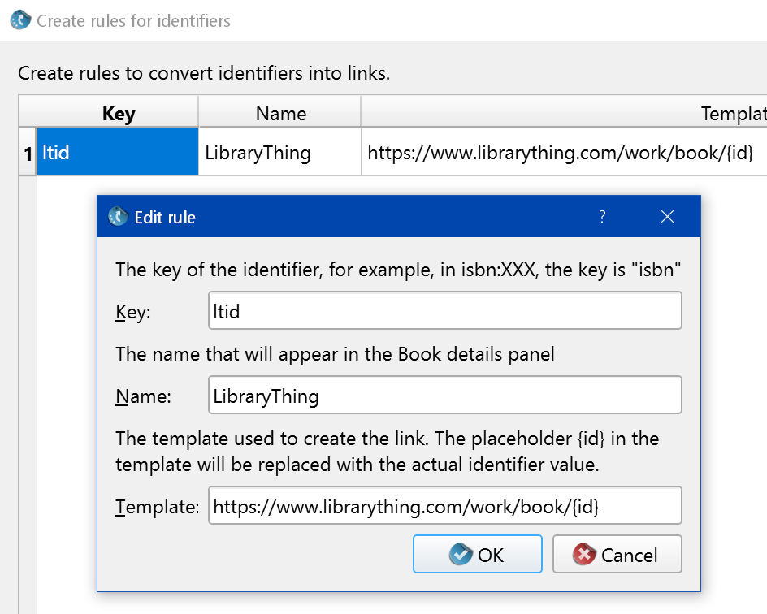

Using a Custom Column
You can create a custom column containing a link to librarything.com. Clicking the link will take you directly to your book on the LT website. Links are also available for books not in your LT catalog, in which case the link performs a "lazy search" using the book title and author.
Create a custom column using the following parameters:
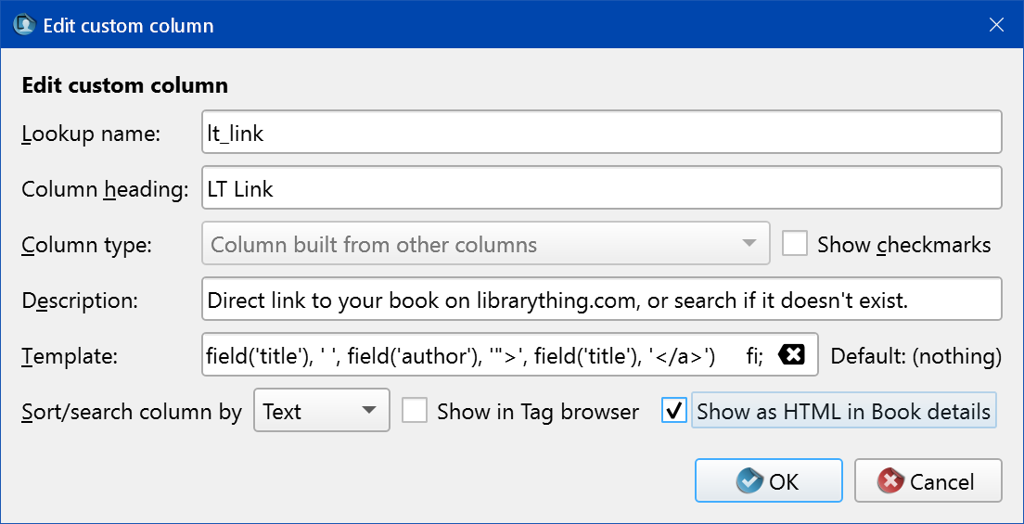
The template text is:
{#librarything_id:'test($, strcat('<a href="https://www.librarything.com/work/book/', $ , '">', field('title'), '</a>'), strcat('<a href="https://www.librarything.com/title/', field('title'), ' ', field('author') , '">', field('title'), '</a>'))'}

Bulk Populating and Undoing calibre identifiers
If you have already performed matching without using a calibre identifier, it is a simple matter to copy the contents of the #librarything_id column into the ltid identifier.

Bulk Populating calibre identifier
You may want to backup your calibre library before performing the below steps.
First, search for all books with a #librarything_id:
#librarything_id:true
Select all results and press E to enter bulk edit mode.
Go to the Search and replace tab and enter values exactly as they appear below, paying particular attention to the following points:
- #librarything_id is the name you chose for the custom column
- Search mode should be set to "Regular expression"
- Mode should be set to "Append to field"
- "Search for" is a circumflex
- "Replace with" is blank
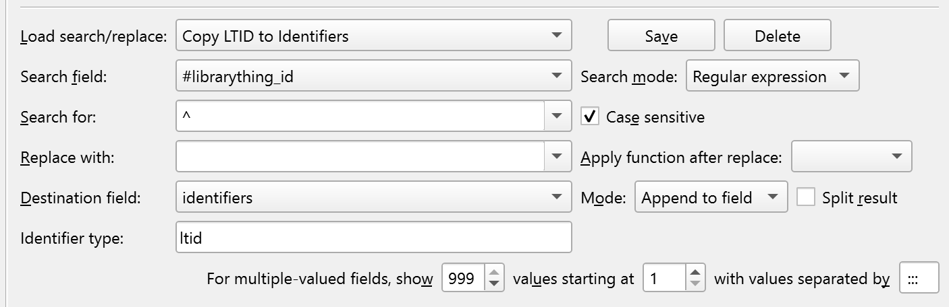
Optionally save.
Click OK.

Clear all ltid identifiers
Per the MobileRead post on the topic, it is a simple matter to clear out a specific identifier from the calibre identifiers field.
You may want to backup your calibre library before performing the below steps.
First, search for all books with a ltid identifier:
identifiers:=ltid:true
Select all results and press E to enter bulk edit mode.
Go to the Search and replace tab and enter values exactly as they appear below, paying particular attention to the following points:
- Select identifiers / ltid twice, i.e. for "Search field" and "Destination field"
- Search mode should be set to "Regular expression"
- Mode should be set to "Replace field"
- "Search for" is dot asterisk
- "Replace with" is blank
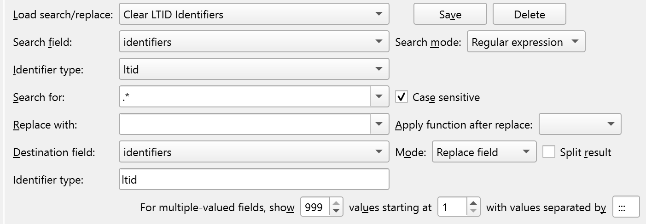
Optionally save.
Click OK.

Limitations

Series
LTMatch may struggle with series where the series name is the same as the first book, e.g. Brandon Sanderson's Legion series:
- Legion
- Legion: Skin Deep
- Legion: Lies of the Beholder
These types of books should be reviewed (and manually matched if necessary) before hitting "Save all matches..."

Performance
LTMatch has been tested with a mid-sized library, about 3500 items on each side. It performs about 7700 matching operations per second. This would equate to almost an hour to match a 5000-item library. Bear in mind that this only applies to the first run, as once books are matched, they are not included in auto-matching in future.

Excludes "Private" books
The LT JSON Books API uses the public version of your LT catalog, so excludes books you have marked as "Private".

