THIS MONTH'S FREE ALBUMS

 |  | March 8 marks International Women's Day 2017, to which we give some musical context by inviting you to take your pick from 3 discs of works by female composers for free downloading. 21st-century concert programmes (and conductor rosters) may sustain the impression that classical music is devoid of female contributors. The Naxos catalogue, however, tells a different story. We hope that our free selection this month will encourage you to explore further the feminine side of our discography, and enjoy to the full its representation of women composers, conductors and performers.  – Klaus Heymann
  

  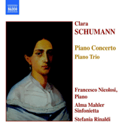
  Despite having to endure many challenges and tragedies, not least her husband Robert’s attempted suicide and breakdown in 1854, and the death of four of her eight children, Clara Schumann was one of the very few artists, either male or female, to be considered the technical equal of Liszt. At the age of 14, Clara began composing the Piano Concerto in A Minor which she performed two years later with the Leipzig Gewandhaus orchestra conducted by Felix Mendelssohn.
  “Naxos has a clear edge, with playing of superior energy and flexibility”
  – Fanfare

  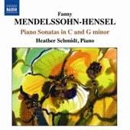
  It is only relatively recently that Fanny Mendelssohn-Hensel has stepped out of the shadow of her more famous sibling Felix. Nearly all of her five hundred or so compositions remained unpublished during her lifetime, despite their undeniable beauty, lyricism and passion. This volume of piano music spans almost her entire adult life, from youthful experiments to music written less than a year before her untimely death, giving the listener a whirlwind tour of a much-underrated composer.
  “…these are very good performances indeed, technically assured in the more challenging works and marvellously poetic everywhere. Schmidt is as close to an ideal interpreter of Fanny Mendelssohn that we are likely to get, and the music itself is so wonderful that this disc recommends itself.”
  – MusicWeb International
  
  “Heather Schmidt’s Mendelssohn-Hensel recital presents a well-contrasted selection of works in large and small forms.”
  – ClassicsToday.com

  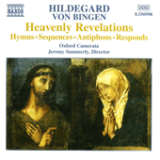
  Called the 'Sybil of the Rhine', the 12th-century Abbess Hildegard of Bingen won a remarkable reputation as a mystic, writer and diplomat and, in a time when women were rarely consulted about anything, she advised bishops, kings and the Pope himself. Her musical legacy, consisting of original monophonic settings of her religious poetry, usually in honour of the saints and the Virgin Mary, still has the power to move those who hear it.
  “Jeremy Summerly approaches Hildegard's outpourings in a thoughtful and mature manner... the whole peaceful recital is never dull or monotonous ... an interesting and thought-provoking disc.”
  – Gramophone

*Clicking this link will redirect you to benefits.naxos.com where you can claim your album of choice.
Offer is available until the end of the current month, and is limited to one album download only.
To learn more, read our Free Album Offer Guide.



