Me, Ms. Dwinnel and the Water Nimf
I know I really shouldn't of played that trick with the cow manure on Ms. Dwinnel. But she was the meanest teacher at the school. She was mean to everybody. I can't say how many recesses she took away from me. And I wasn't the only one either. She is the kind of teacher that makes you feel like a little worm just by looking at you. Her face was all shiny like her hair was tied up too tight in back, and like it stretched her skin out. Her mouth was always puckered up like she just ate a lemon. And she talked through her teeth. I swear it. She never opened her mouth when she talked. She just talked at us kids right through her teeth. When a teacher talks at you like that, you know right off they don't like you very much. And when they don't like you, you don't want to do work for them. I know Dad said I shouldn't think of it that way---that I should do the work for myself. But for me it just don't work that way.
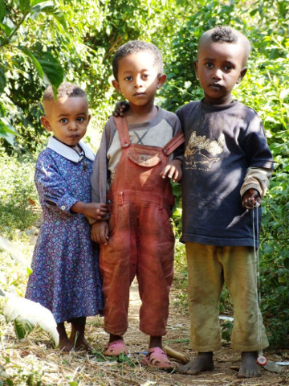
[First 3 friends is 5X7.7 inches in original]
Course the worst thing was that she made me stay back. She told my parents that I wasn't ready for the fifth grade. That was the worst thing that could of happened. Everybody thinks you are stupid when you stay back. Your friends go on to the next grade and you miss them. They are polite still, but you know they think you are stupid and that you aren't one of them anymore.
So, yeah, I was mad. But I wasn't getting even just for myself but for the whole class. For all the kids she's been mean to. "Eric," I said to myself when the idea come to me. "I know you really hate to do this thing, but its sort of your duty. All those kids she's been mean to are depending on you. You owe it to them on account of how they are your friends." I don't know whether that was me talking to me or the devil talking to me. My mama says I got the devil in me an I reckon she's right.
So anyhow this is what I did. It was the last week-end before school was going to start. I was really low. Summer vacation was just about over which was bad enough. But I had to go back to face a whole other year with Ms. Dwinnel. So I went out to the cow pasture and filled up a paper bag with cow manure. It wasn't the dried out kind but the real gooshy stuff. I'm not trying to be gross, but you got to know just how it was to understand what I did.
I took this bag of manure and put some newspaper in it and carried it to Ms. Dwinnel's porch. It was just beginning to get dark. She has a cement porch so I knew it wouldn't catch fire. I wasn't trying to burn her house down. I was just playing a little trick. So I lit the bag on fire and rang the door bell and ran off a little ways. I hid behind a bush in her front yard to watch. The bag was burning real bright and nice when she got to the door. It was just right. Well when she saw that paper burning on her porch she thought it might burn her house down so she started stomping it out with her foot. So of course her foot went right down into the cow manure. I mean that was the whole point of the thing.
I couldn't help myself. I started laughing and jumped up and pointed at her. That was a real dumb thing to do. I knew right off that I had made a big mistake, but I just couldn't help myself.
"But what the heck," I thought. "Whatever punishment I get, it will be worth it." Well it was worth a lot to see her expression when she stomped her foot in that cow stuff. Thats for sure. But my punishment was worse than I thought. I think Mom had to prove to Ms. Dwinnel that she wasn't going to be easy on me. I mean she never took away my privileges for a whole two months before. Except that time I tried to flush that dead squirrel down the toilet and it got stuck and and the stool overflowed and made a horrible mess in the bathroom and leaked through the ceiling down into the kitchen and made a mess there too. She took away my privileges for my whole life, almost, then, but it really only lasted a week and then she forgot about it. But this time she told me my punishment right in front of Ms. Dwinnel who came over and told her about my trick. So I figured she might really do it because Ms. Dwinnel would be checking to see if it was done.
You got to understand why it was so horrible to lose all my privileges for two months. I mean anytime that would be bad. But this two months included Halloween. All summer I had figured on how I was going to make my Halloween costume. I was going to be a Vampire---like Dracula. I knew just how I was going to make big bloody fangs that would look so real you wouldn't believe it. And I was going to make long bloody fingernails. And with a black cape and everything it was going to be real awesome. I figured I would be sure to win a prize at the school Halloween party. And now I was going to miss all that. I just wanted to die. I could see that this was going to be the worst year of my life.

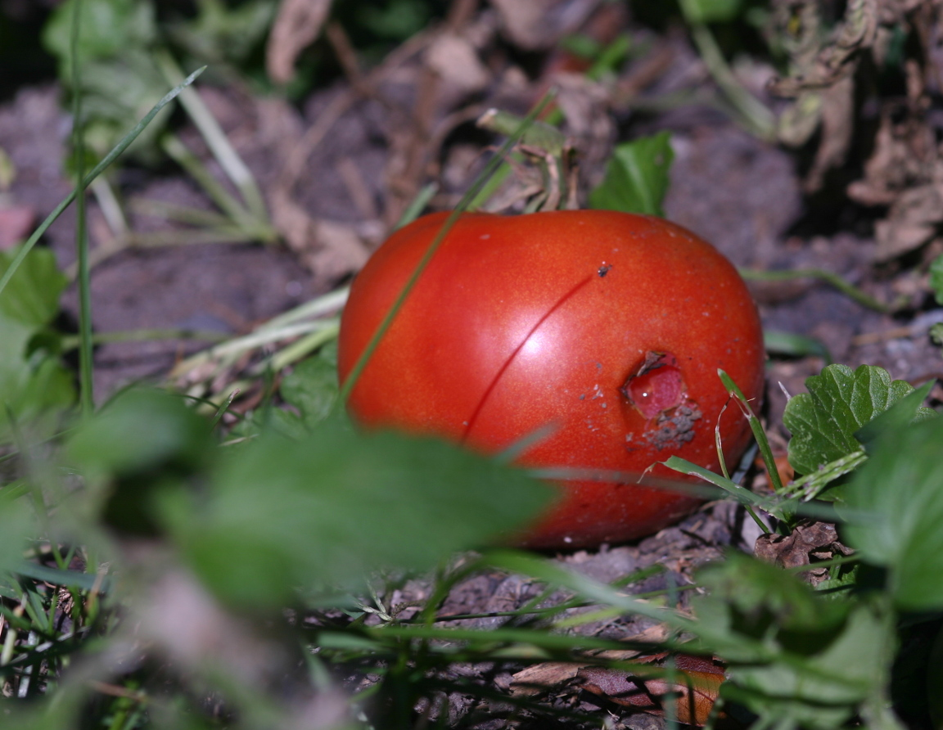
[Original file for tomato was 16X2.4inches in the original. I reduced it here to 6 inches wide.]
I wasn't looking forward to Dad coming home and hearing about what I did. I can tell you that. But when he did hear about it he giggled. I'm not kidding. He really did. Then Mom looked at him real hard and he stopped giggling and said, "This is very serious, Son."
"I know it is, Dad," I said.
Dad said that the punishment that Mom and Ms. Dwinnel decided on was what I deserved. But he talked to me alone about it later that night.
"Why did you do it?" he asked.
"Because Ms. Dwinnel is so mean," I said.
"I know she seems mean to you," he said. "But sometimes when people act mean it is because are unhappy."
"What can I do about that, Dad?" I asked.
"Sometimes if you are nice to them it makes them not so mean," he said.
"I don't think I could do that," I said.
"Not many can," he agreed.
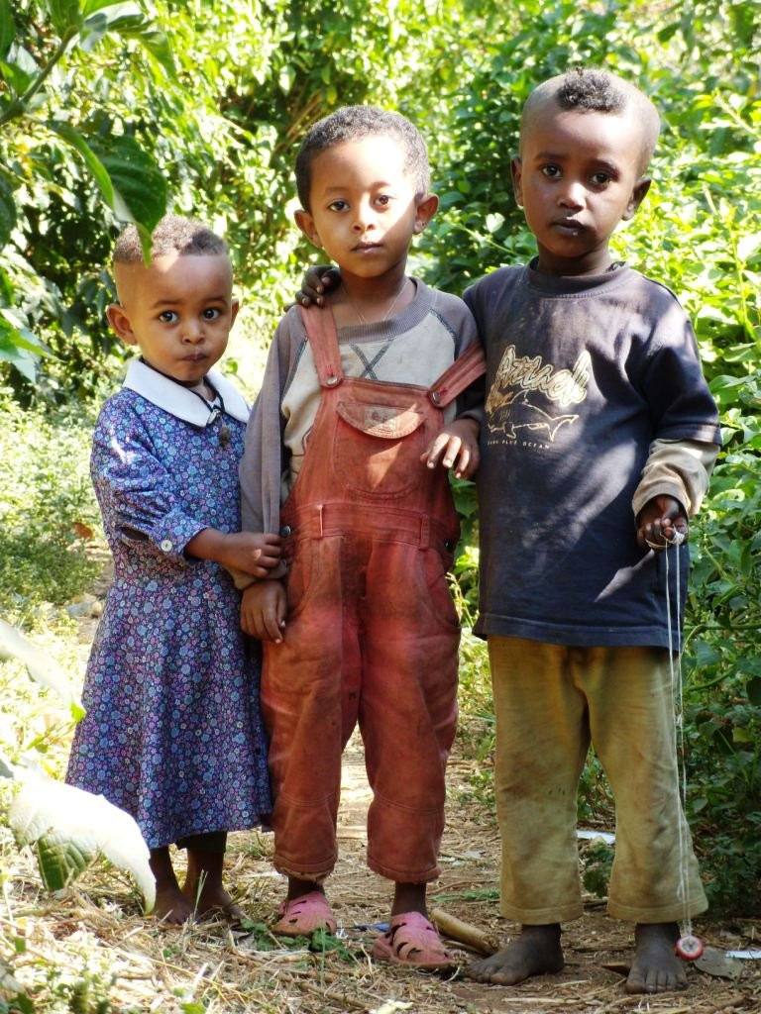
"She has done too many mean things to me," I said. "And to lots of other kids too. I just did what everybody wants to do.
"Well, next time you do a trick don't use any fire." he said. "You might have caught her house on fire. If her house burned down with her in it that would be more than you wanted."
"I just wanted to play a trick on her," I said.
"I know," he said ,"But you have to think these things through."
Dad always thinks we should be nice to people no matter what. I couldn't see that, but I did agree about the fire.
[The second “3 friends” picture was 768X450px in the original.]
We thought about this a little bit, and then
Dad said, "How deep did her ankle sink into the cow patty?"
"I don't know, Dad. It was up to her ankle I guess."
He smiled. "Was it worth it," he asked.
"I don't know," I said.
"Sometimes its hard to know," he agreed.
You're not going to believe what happened next. I mean I didn't even know that grown-ups went skinny dipping. At least not near where I live. In California maybe, and foreign places like that. But not people near Elk Falls Maine. So I was amazed. I was on my way out to this place on Elk River where sometimes I go. To tell the truth., some of the guys I know and me sometimes go skinny dipping there. It was a nice warm day in September. It was still plenty warm for swimming and I had the idea I might just cool off a bit if nobody else was around. So I was kind of disappointed when I caught sight of somebody right at the edge of the pool I swim in. It was a grown-up so I stood there a minute where I couldn't be seen and spied. I was pretending to be sneaking up on enemy troops you know.
The enemy troop was Ms. Dwinnel. She glanced around like she thought maybe enemy troops was looking for her, but she didn't see me cause I dropped down low and hid. But I could see her. Now you can imagine how surprised I was at what happened next. She began to take off her clothes. I don't just mean some of her clothes. She took them all off. Honest she did. She was kind of tall and bony. I never seen a naked woman before and I thought it was interesting. Then she jumped into the water just like a boy might and she whooped. That "whoop" was even more amazing to me than her taking all her clothes off. I mean I never thought of Ms. Dwinnel as the sort who would whoop. Not in a million years.

Well, after she splashed around a while she climbed out on the ground and started putting her clothes back on. I sneaked away before she was finished and she never saw me.
Soon as I got back to my house a got on the phone and called my best friend, Tim. I could hardly wait to tell him what I saw. Wow, would he be green with envy! And wouldn't we have fun telling all the kids about Ms. Dwinnel! Everybody would be laughing at her. That would really be getting even. That would be even better that the cow manure trick.
When I got Tim on the phone I said, "Guess what I saw Tim?"
"What did you see?" he asked.
I thought for a minute and then said, "I saw a river nymph."
"A what?" he asked.
"A river nymph."
"Ain't no such thing," he said.
"Tis so," I said.
"No," he said."You must of just only dreamed it."
"Maybe you're right," I said.
Truth is I just couldn't tell on Ms. Dwinnel. I mean anybody who could whoop like that had to have a good side to them.
That night I had to do a theme for Ms. Dwinnel. It was supposed to be on what we did on our vacation. Every fall she has the kids do that theme. This is how my theme went.

My Vacation
On my vacation I saw a water nimf. I saw her in Elk River. She was swimming without no clothes on. She was nakid. She was very nakid. She was so nakid you could see everything. I hid behind rocks and things and looked. It was nice. This is a true story.
Seems like she must of liked my theme cause she asked to see me after school. Mostly it seemed like she wanted to know what that nimf looked like.
"Truth is," I said, "it looked a lot like you."
She seemed to think about this for a bit and then said, " Did you tell anybody else about this water nymph?"
"Yes," I said. I let her think about that a bit. Then I said, "But I didn't tell them it looked just like you."
"Why did you not tell them that?"
"Well I thought it might kind of embarrass you, looking like a water nimf and all."
"That was very thoughtful of you, Eric,"she said.
"Way I see it is we are sort of friends," I said.
"Glad you see it that way," she said.
"I wouldn't tell anything that might embarrass you," I said.
She seemed to think about this a long time. Then she said, "One more thing I'd like to ask, Eric."
"Yes?" I said.
"This water nimf you saw, was she... very...very... ah...pretty?" She sort of looked down at some papers on the desk when she said this.
"The prettiest nimf I ever seen," I told her.
"You have seen lots of them?" she asked.
"Hundreds," I said. "Maybe thousands."
Well, it seems like she talked to my parents. Said I was doing better in school and maybe they was being too hard on me. So I got to go to the Halloween party after all. I came as a Vampire and won second place for the scariest. She came as a witch. She looked real scary and mean and ugly as a witch. But I knew underneath all that costume she was pretty, cause I had seen her.
Funny thing is that ever since Halloween she has been real nice. We really are like friends. I work real good for her. I never would of believed it. And its not just me she's nice to either. She's really different this year. Everybody says so.

