I am new to Calibre and experimenting with moving a AZW4 book "Elements of Algebra" by Euler to MOBI or ePub format to use with the Marvin reader on an iPad.

The conversion from AZW4 to PDF using KindleUnpack worked fine - all formatting and text characters transferred correctly. However, the conversion from PDF to either MOBI or ePub produces issues of 1) change in line spacing and 2) loss of characters.

The line spacing is annoying but not critical but the loss of characters is a show stopper.

I'm at a loss as to how to proceed next. The strange thing is that the html files produced by debug show no loss of formatting or characters when viewed in Firefox but the viewer in Calibre doesn't display the characters. In addition, when loading the original PDF file into the Calibre viewer, it too doesn't display some characters.

Here are screen shots:

PDF in PDF viewer:
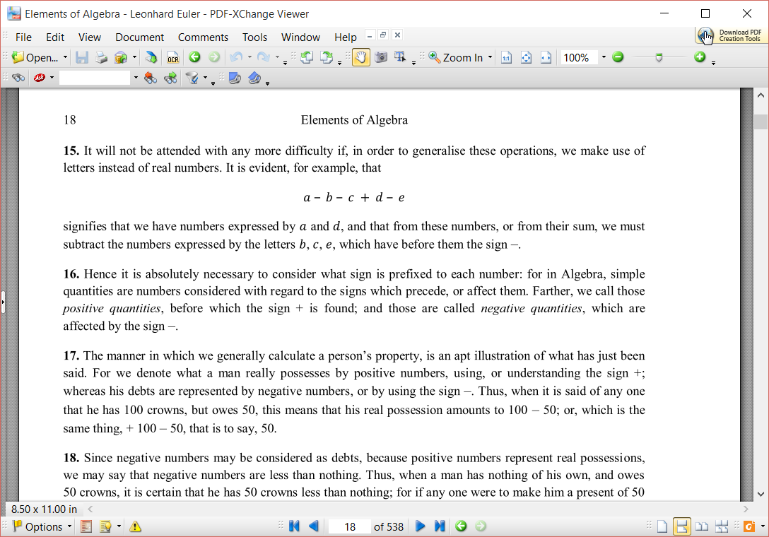

Same PDF section viewed in Calibre viewer:
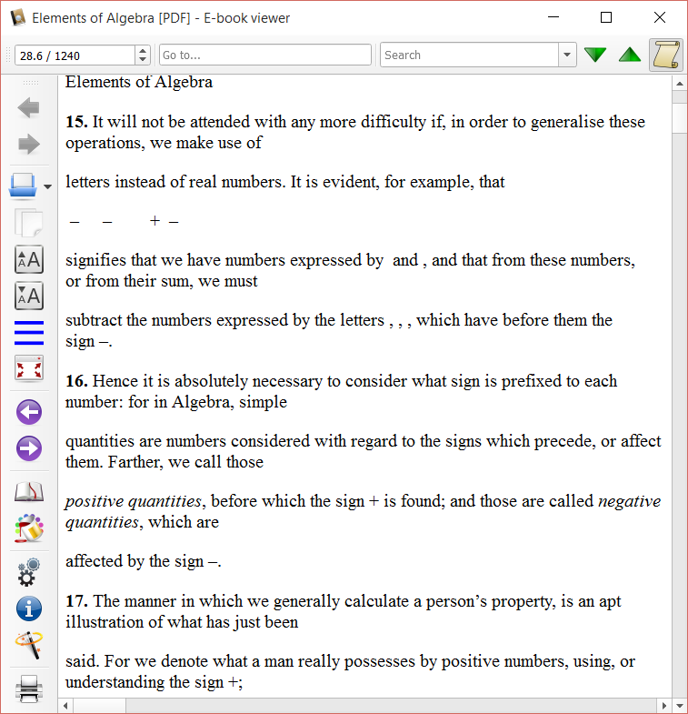

Firefox of HTML same section from Input section of debug
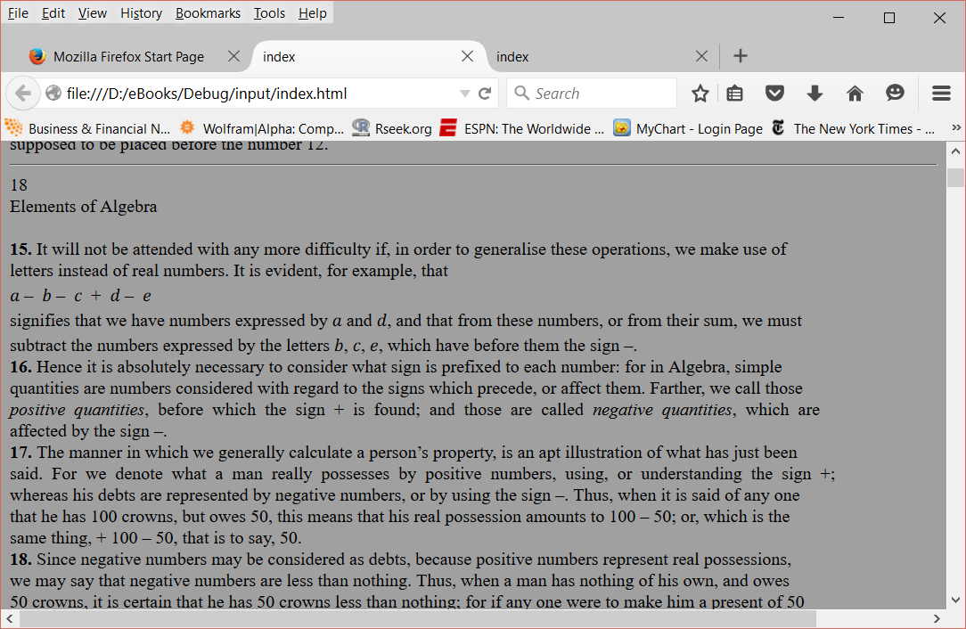

Firefox of stucture part of debug:
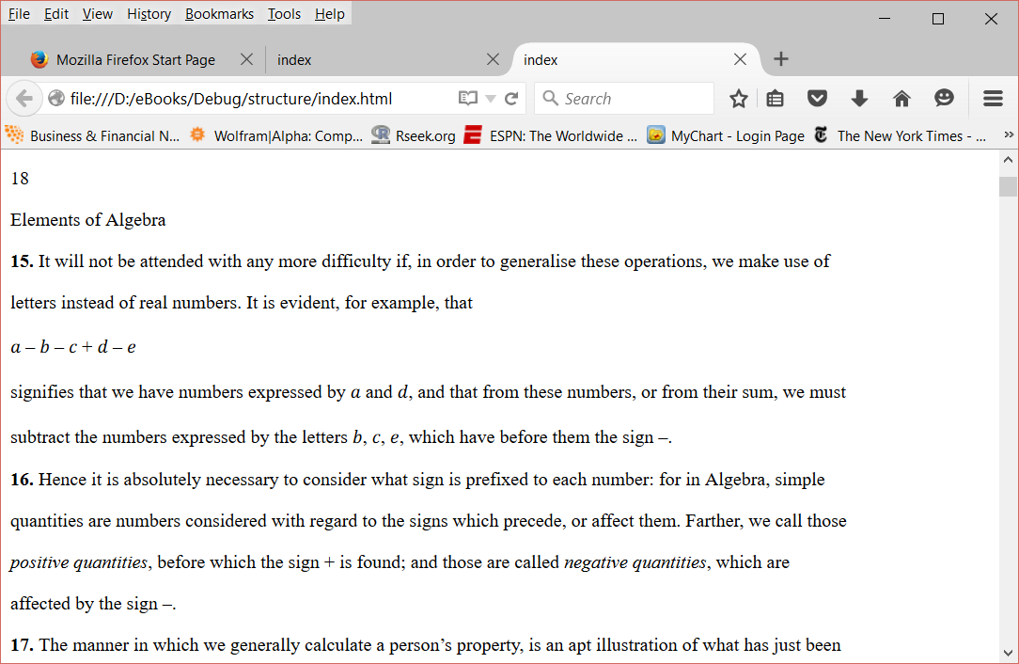

The following is the job detail from the conversion to Epub
Convert book 1 of 1 (Elements of Algebra)
Resolved conversion options
calibre version: 2.35.0
{'asciiize': False,
'author_sort': None,
'authors': None,
'base_font_size': 0.0,
'book_producer': None,
'change_justification': u'original',
'chapter': u"//*[((name()='h1' or name()='h2') and re:test(., '\\s*((chapter|book|section|part)\\s+)|((prolog|prologue|epilogue)(\\s+|$))', 'i')) or @class = 'chapter']",
'chapter_mark': u'pagebreak',
'comments': None,
'cover': None,
'debug_pipeline': u'D:/eBooks/Debug',
'dehyphenate': True,
'delete_blank_paragraphs': True,
'disable_font_rescaling': False,
'dont_split_on_page_breaks': False,
'duplicate_links_in_toc': False,
'embed_all_fonts': True,
'embed_font_family': None,
'enable_heuristics': False,
'epub_flatten': False,
'epub_inline_toc': False,
'epub_toc_at_end': False,
'expand_css': False,
'extra_css': None,
'extract_to': None,
'filter_css': u'',
'fix_indents': True,
'flow_size': 140,
'font_size_mapping': None,
'format_scene_breaks': True,
'html_unwrap_factor': 0.4,
'input_encoding': None,
'input_profile': <calibre.customize.profiles.KindleInput object at 0x000000000555D908>,
'insert_blank_line': False,
'insert_blank_line_size': 0.5,
'insert_metadata': False,
'isbn': None,
'italicize_common_cases': True,
'keep_ligatures': False,
'language': None,
'level1_toc': None,
'level2_toc': None,
'level3_toc': None,
'line_height': 0.0,
'linearize_tables': False,
'margin_bottom': 5.0,
'margin_left': 5.0,
'margin_right': 5.0,
'margin_top': 5.0,
'markup_chapter_headings': True,
'max_toc_links': 50,
'minimum_line_height': 120.0,
'new_pdf_engine': False,
'no_chapters_in_toc': False,
'no_default_epub_cover': False,
'no_images': False,
'no_inline_navbars': False,
'no_svg_cover': False,
'output_profile': <calibre.customize.profiles.iPadOutput object at 0x000000000555DC50>,
'page_breaks_before': u"//*[name()='h1' or name()='h2']",
'prefer_metadata_cover': False,
'preserve_cover_aspect_ratio': False,
'pretty_print': True,
'pubdate': None,
'publisher': None,
'rating': None,
'read_metadata_from_opf': u'C:\\Users\\Dan\\AppData\\Local\\Temp\\calibre_inkxx5\\1fgezy.opf',
'remove_fake_margins': False,
'remove_first_image': False,
'remove_paragraph_spacing': False,
'remove_paragraph_spacing_indent_size': 1.5,
'renumber_headings': True,
'replace_scene_breaks': u'',
'search_replace': '[]',
'series': None,
'series_index': None,
'smarten_punctuation': False,
'sr1_replace': None,
'sr1_search': None,
'sr2_replace': None,
'sr2_search': None,
'sr3_replace': None,
'sr3_search': None,
'start_reading_at': None,
'subset_embedded_fonts': False,
'tags': None,
'timestamp': None,
'title': None,
'title_sort': None,
'toc_filter': None,
'toc_threshold': 6,
'toc_title': None,
'unsmarten_punctuation': False,
'unwrap_factor': 0.62,
'unwrap_lines': True,
'use_auto_toc': False,
'verbose': 2}
InputFormatPlugin: PDF Input running
on C:\Users\Dan\AppData\Local\Temp\calibre_inkxx5\exldzy.pdf
Converting file to html...
Retrieving document metadata...
Generating manifest...
Rendering manifest...
Input debug saved to: D:\eBooks\Debug\input
Parsing all content...
Parsing index.html ...
Generating default TOC from spine...
Parsed HTML written to: D:\eBooks\Debug\parsed
Merging user specified metadata...
Detecting structure...
Maximum TOC links reached, stopping.
Auto generated TOC with 50 entries.
Structured HTML written to: D:\eBooks\Debug\structure
Flattening CSS and remapping font sizes...
Source base font size is 16.00000pt
Cleaning up manifest...
Trimming unused files from manifest...
Processed HTML written to: D:\eBooks\Debug\processed
Creating EPUB Output...
Splitting markup on page breaks and flow limits, if any...
Splitting on page-break at id=calibre_pb_0
Looking for large trees in index.html...
Found large tree #0
Splitting...
Split point: {http://www.w3.org/1999/xhtml}p /*/*[2]/*[16664]
Split tree still too large: 1062 KB
Splitting...
Split point: {http://www.w3.org/1999/xhtml}p /*/*[2]/*[8332]
Split tree still too large: 549 KB
Splitting...
Split point: {http://www.w3.org/1999/xhtml}p /*/*[2]/*[4166]
Split tree still too large: 324 KB
Splitting...
Split point: {http://www.w3.org/1999/xhtml}p /*/*[2]/*[2083]
Split tree still too large: 175 KB
Splitting...
Split point: {http://www.w3.org/1999/xhtml}p /*/*[2]/*[1042]
Committed sub-tree #1 (117 KB)
Committed sub-tree #2 (57 KB)
Split tree still too large: 150 KB
Splitting...
Split point: {http://www.w3.org/1999/xhtml}p /*/*[2]/*[1043]
Committed sub-tree #3 (66 KB)
Committed sub-tree #4 (84 KB)
Split tree still too large: 225 KB
Splitting...
Split point: {http://www.w3.org/1999/xhtml}p /*/*[2]/*[2084]
Committed sub-tree #5 (110 KB)
Committed sub-tree #6 (115 KB)
Split tree still too large: 513 KB
Splitting...
Split point: {http://www.w3.org/1999/xhtml}p /*/*[2]/*[4167]
Split tree still too large: 252 KB
Splitting...
Split point: {http://www.w3.org/1999/xhtml}p /*/*[2]/*[2084]
Committed sub-tree #7 (125 KB)
Committed sub-tree #8 (127 KB)
Split tree still too large: 261 KB
Splitting...
Split point: {http://www.w3.org/1999/xhtml}p /*/*[2]/*[2084]
Committed sub-tree #9 (136 KB)
Committed sub-tree #10 (125 KB)
Split tree still too large: 1157 KB
Splitting...
Split point: {http://www.w3.org/1999/xhtml}p /*/*[2]/*[8333]
Split tree still too large: 573 KB
Splitting...
Split point: {http://www.w3.org/1999/xhtml}p /*/*[2]/*[4167]
Split tree still too large: 276 KB
Splitting...
Split point: {http://www.w3.org/1999/xhtml}p /*/*[2]/*[2084]
Committed sub-tree #11 (135 KB)
Split tree still too large: 141 KB
Splitting...
Split point: {http://www.w3.org/1999/xhtml}p /*/*[2]/*[1043]
Committed sub-tree #12 (77 KB)
Committed sub-tree #13 (64 KB)
Split tree still too large: 296 KB
Splitting...
Split point: {http://www.w3.org/1999/xhtml}p /*/*[2]/*[2084]
Split tree still too large: 169 KB
Splitting...
Split point: {http://www.w3.org/1999/xhtml}p /*/*[2]/*[1043]
Committed sub-tree #14 (70 KB)
Committed sub-tree #15 (99 KB)
Committed sub-tree #16 (127 KB)
Split tree still too large: 584 KB
Splitting...
Split point: {http://www.w3.org/1999/xhtml}p /*/*[2]/*[4167]
Split tree still too large: 275 KB
Splitting...
Split point: {http://www.w3.org/1999/xhtml}p /*/*[2]/*[2084]
Committed sub-tree #17 (136 KB)
Committed sub-tree #18 (138 KB)
Split tree still too large: 310 KB
Splitting...
Split point: {http://www.w3.org/1999/xhtml}p /*/*[2]/*[2084]
Split tree still too large: 157 KB
Splitting...
Split point: {http://www.w3.org/1999/xhtml}p /*/*[2]/*[1043]
Committed sub-tree #19 (73 KB)
Committed sub-tree #20 (84 KB)
Split tree still too large: 153 KB
Splitting...
Split point: {http://www.w3.org/1999/xhtml}p /*/*[2]/*[1042]
Committed sub-tree #21 (87 KB)
Committed sub-tree #22 (66 KB)
Split into 23 parts
Generating default cover
EPUB output written to C:\Users\Dan\AppData\Local\Temp\calibre_inkxx5\qjshrm.epub

