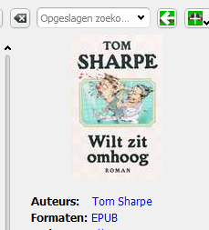
Here is an example of an image which doesn’t fill the full width.
Whereas the following does.
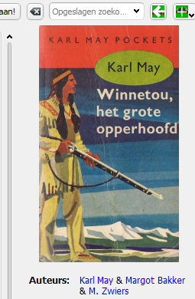
It seems unpredictable whether a copy of a cover placed will use the full width.

