This is how I usually create my yes/no drop down selection column:
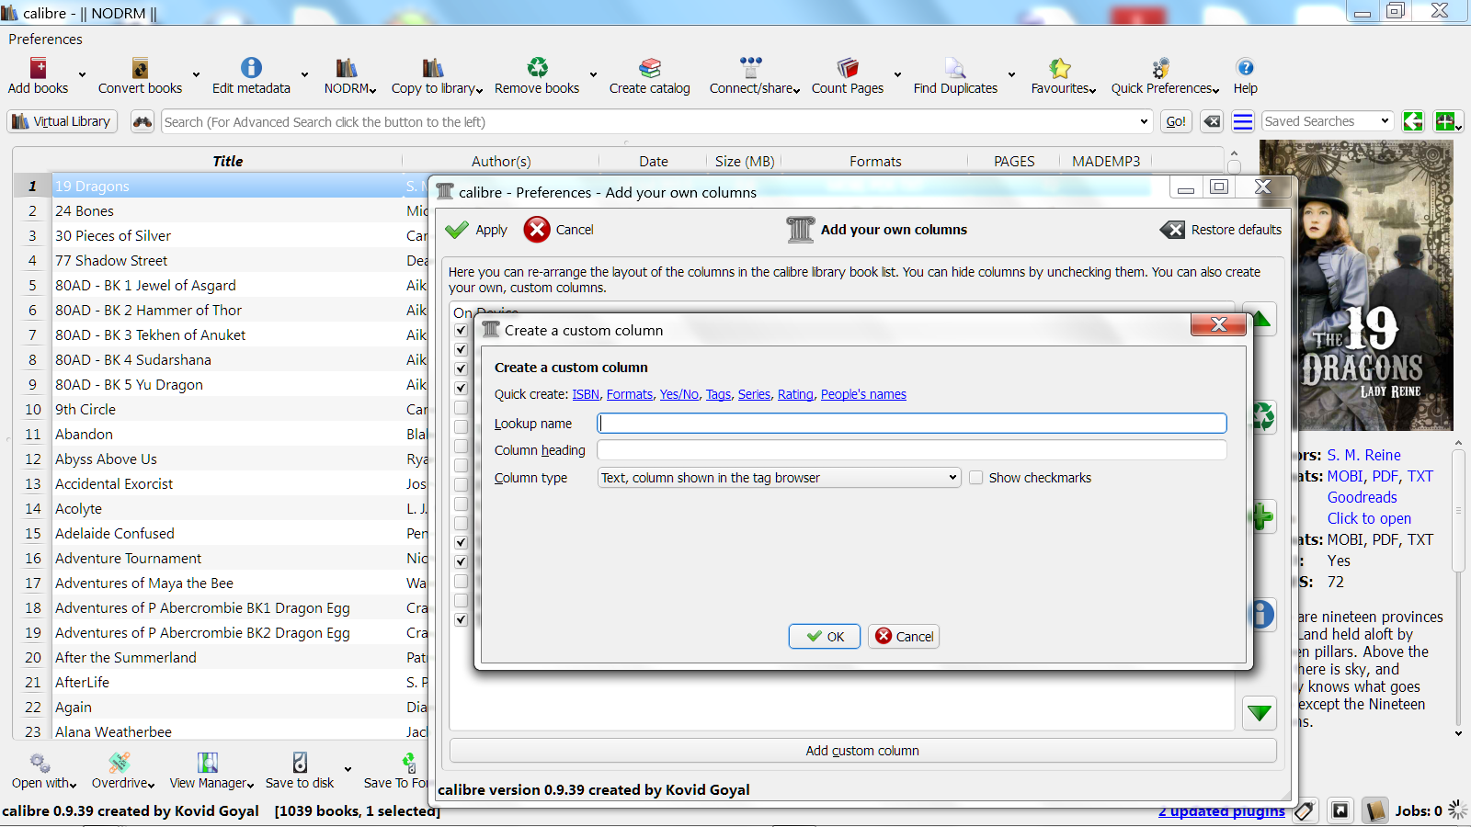
I choose the “Yes/No” quick create selection.

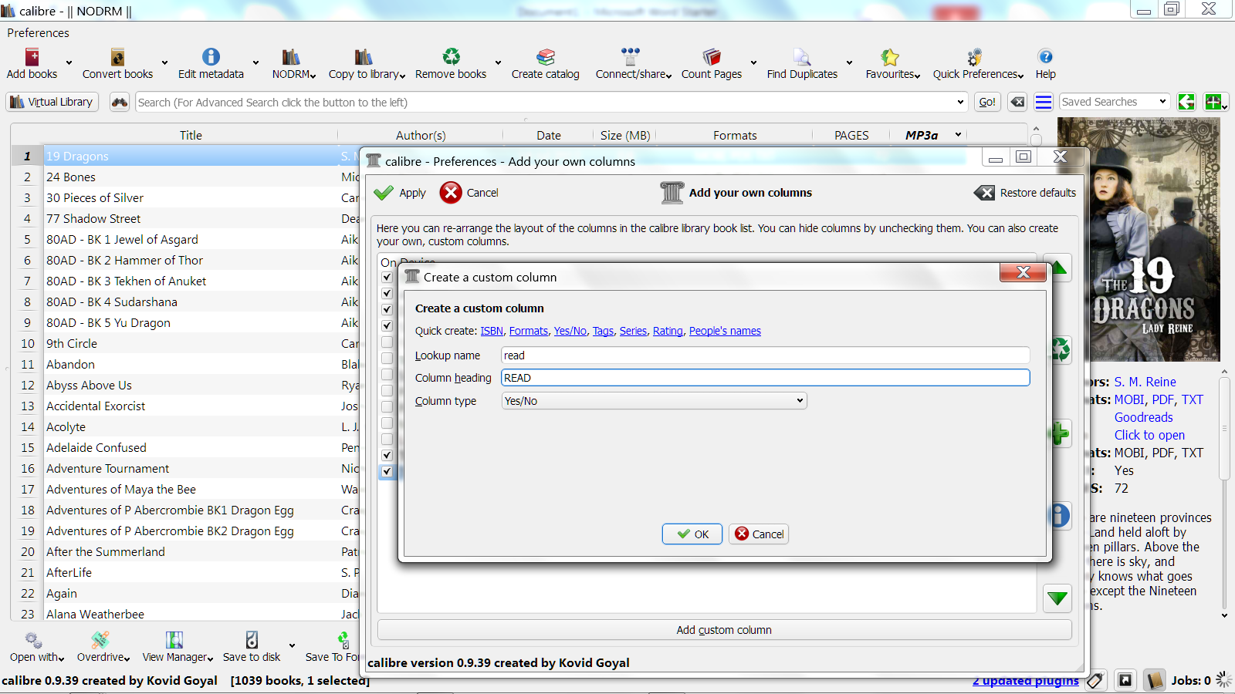
I then insert whatever name I want to use it for (in this instance
whether or not I have read a book).

It now appears on my main screen
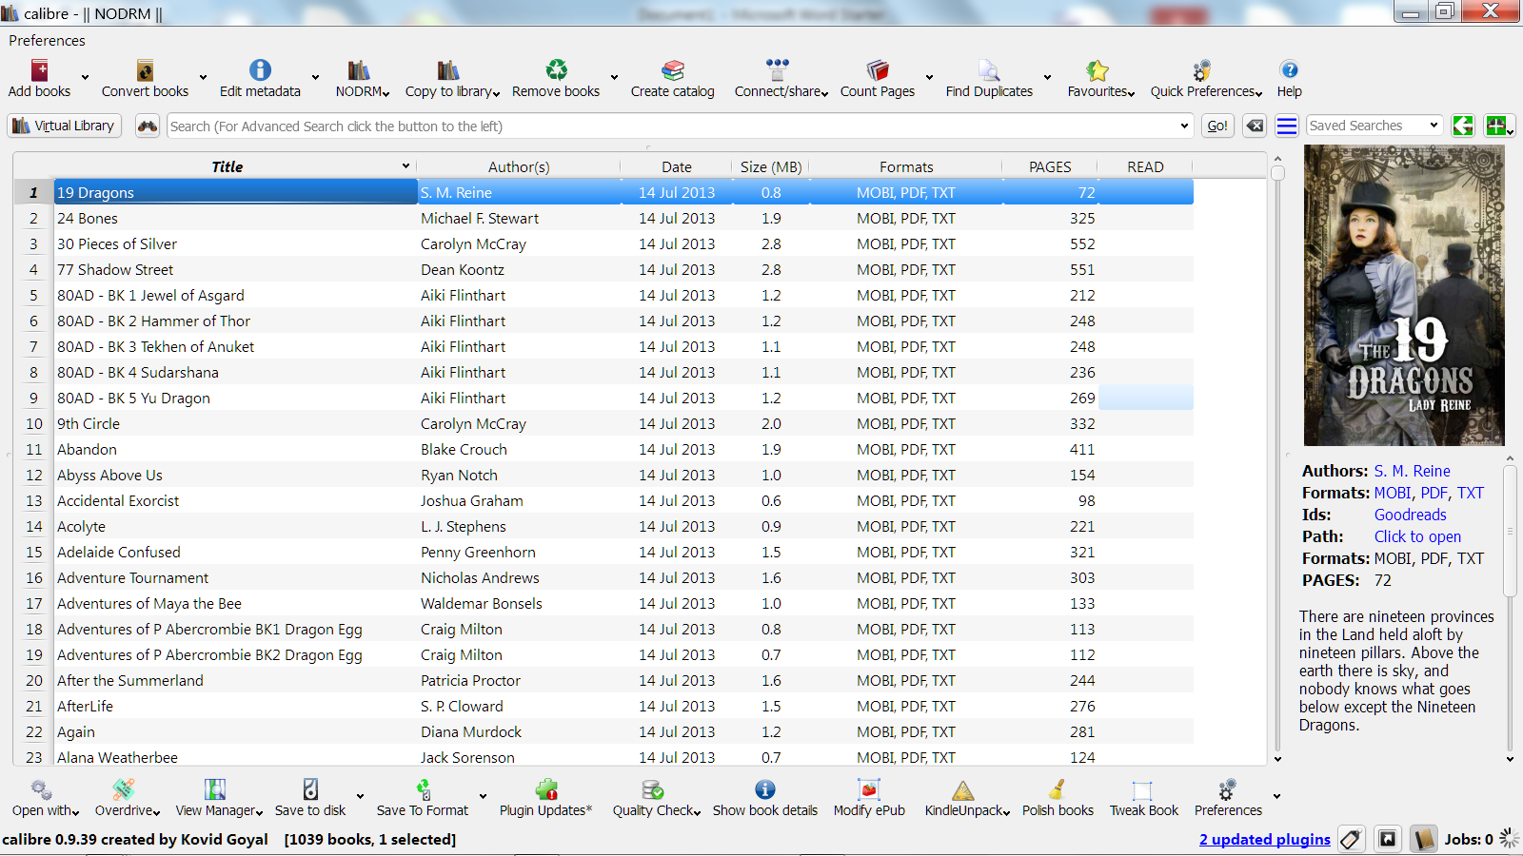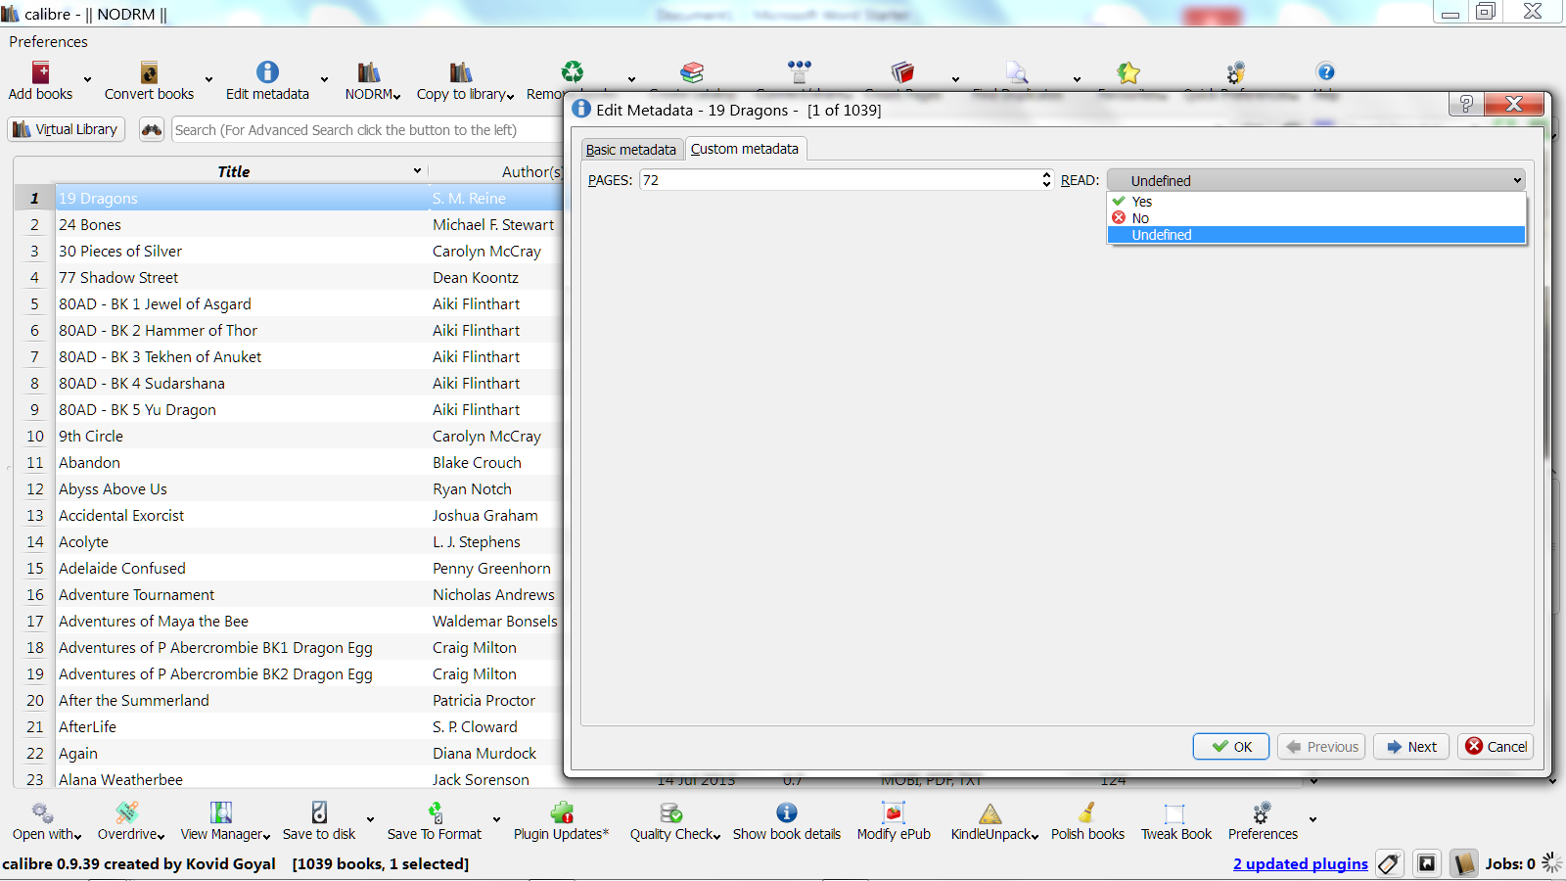
When I click in the row containing the book I am trying to select, it does nothing. If I double click, it automatically takes me to the edit metadata screen (which double click used to open the book and no longer does that) and under the custom metadata I see the “Read” selection, I can then use that drop down menu to select my choice. I never had to do this before, I could do it from the main screen. I don’t think I am doing anything different than I did before. I really don’t want to have to edit the metadata on each book. I just want to click in the yes/no space for a book and choose my option.

