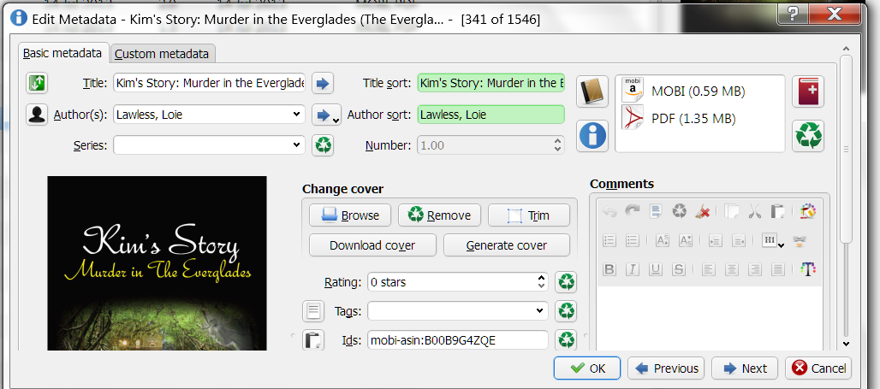
Above is how “Edit Metadata Individually” comes up.
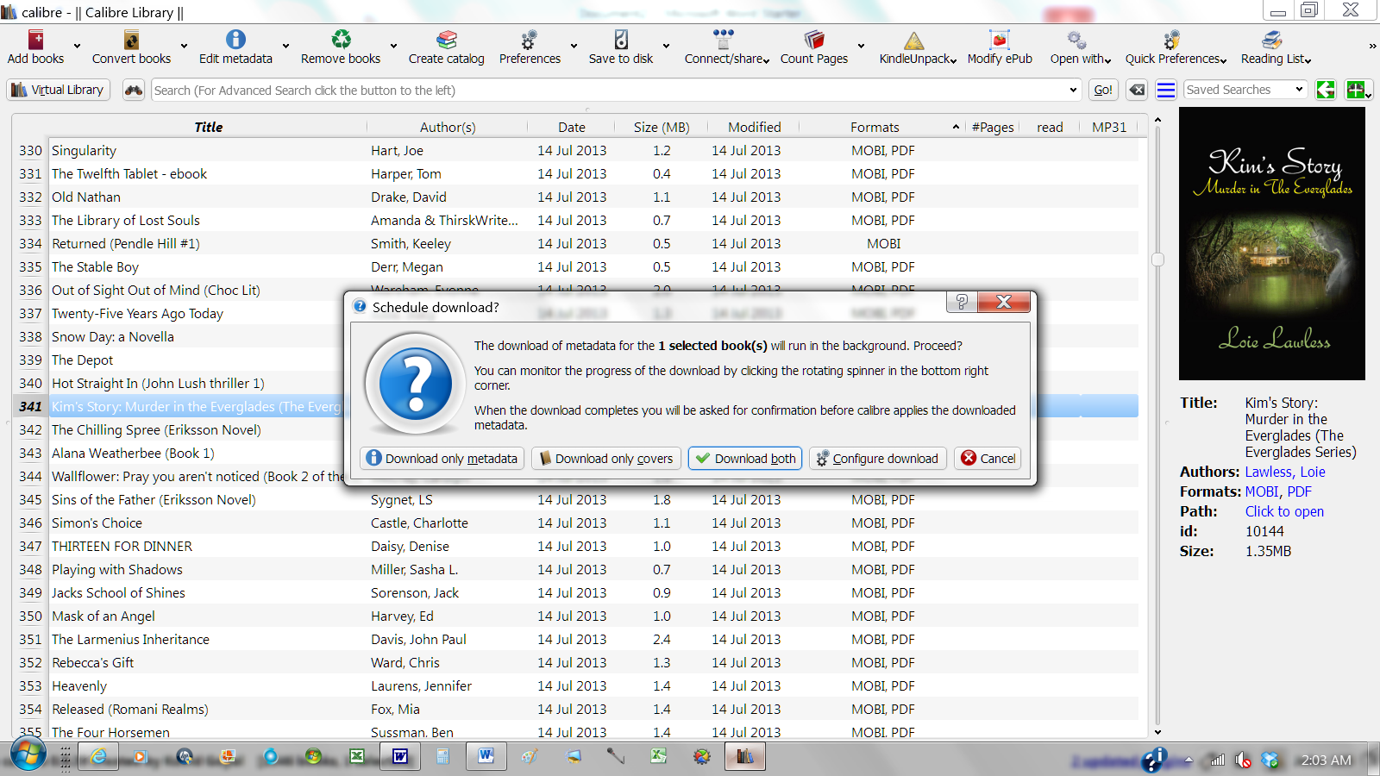
Using “Ctrl D” function instead, I then choose “download both”
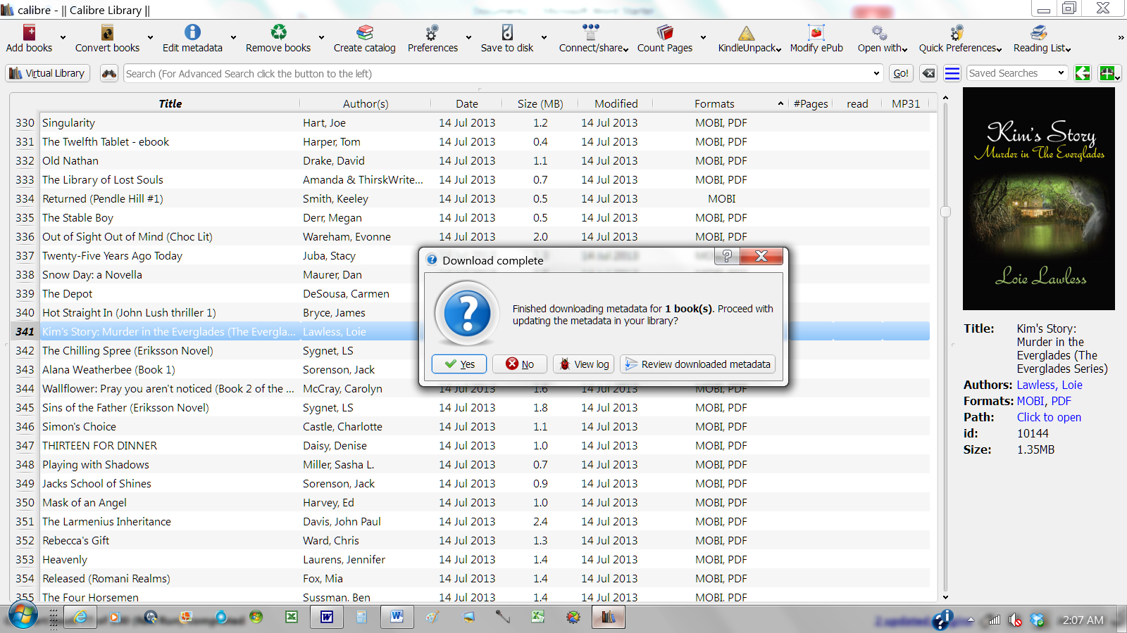
Obviously dialogue box after Calibre has completed downloading metadata.
I select “Review Downloaded Metadata” because I clicked “Yes” one time (and will never click it again), and it brought in on its own different books, different metadata or different languages. What a hugh cluster that was.
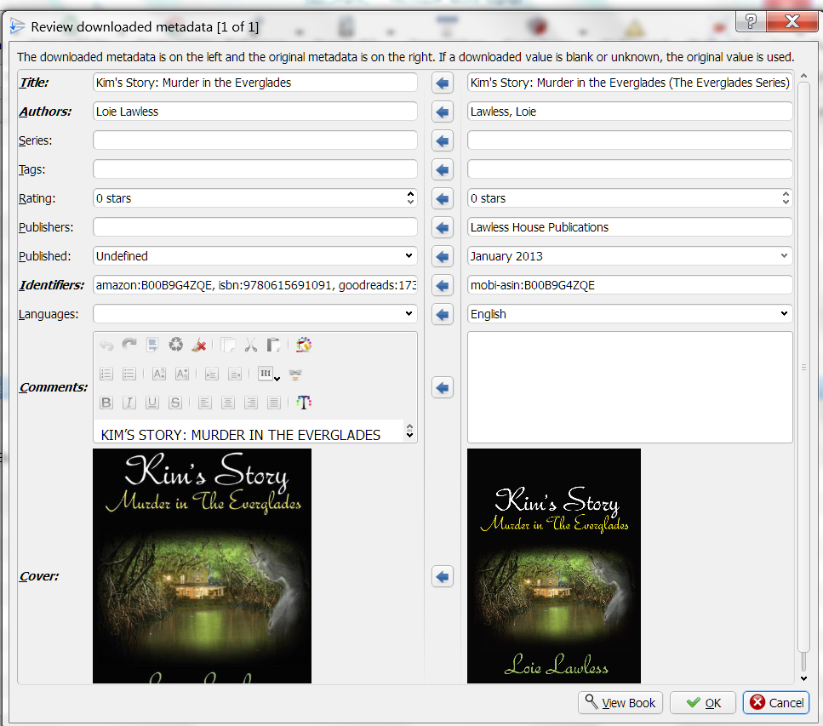
Beautiful result! (I really do love Calibre). I can change or move any of the data I want, or simply click “ok” and I am finished. Obviously can use for multiple books at one time. My Question is, do I need to just quit using the “individual” edit and use the “Ctrl D” function?

